Dyddiad/Date | 6th March
Rhif Ffôn/Direct Line | 01639 686463
7Ebost/Email | environment@npt.gov.uk
Cyswllt/Contact | Mr. Hasan Hasan
Eich cyf /Your ref
Ein cyf/Our ref | HH/DD/MEL

To the Owner/Occupier,

Re: Demolition of Primary School Buildings
Godre’rgraig Primary School, Graig Road, Godre’rgraig, SA9 2NY

I am writing to inform you of demolition work intended to be carried out in your area.

Please find enclosed a copy of the Notice served on Building Control, The Quays, Brunel Way, Baglan Energy Park, Neath, SA11 2GG under Section 80 of the Building Act 1984.

The programme of work will be as follows;

- Services will be disconnected the week commencing 25th of March 2024.
- Internal soft stripping work will start week commencing the 8th April 2024.
- External soft strip & roof removal will start week commencing 22nd April 2024.
- Removal of walls and construction of bund, work will start week commencing 29th April 2024.
The site work will be completed on the 31st May 2024.

Should you require any further assistance, please contact Hasan Hasan on (01639) 686463 or 07805013727.

Yours faithfully,
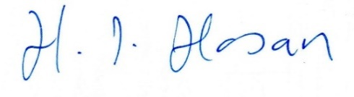
_______________________________________
On behalf of Head of Engineering & Transport

