Neath Port Talbot Council Biodiversity Duty Plan 2023 – 2026

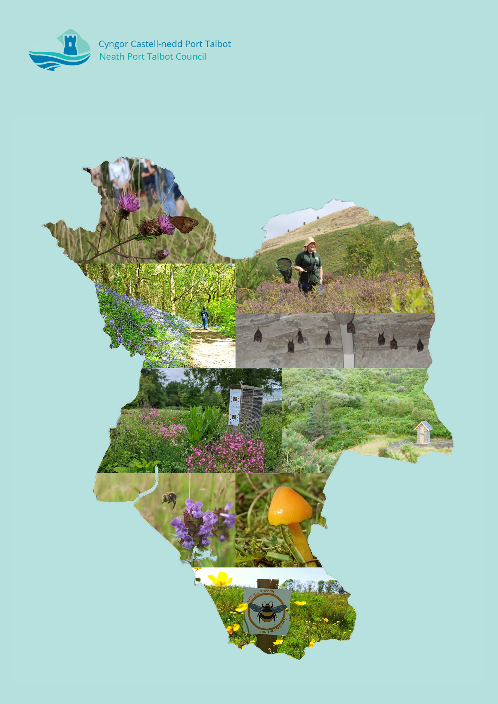

Contents
Foreword 1
Abbreviations and Acronyms 1
1. Introduction 2
2. Why do we need to support biodiversity in NPT 3
3. Environment (Wales) Act 2016 4
4. Other Legislative and Policy Context 5
4.1. Nature Recovery Action Plan for Wales 5
4.2. State of Nature and Nature Recovery Action Plan for NPT 6
4.3. Well-being of Future Generations (Wales) Act 2015 7
4.4. Neath Port Talbot Public Service Board (PSB) Local Well-being Plan (2023-2028) 7
4.5. Neath Port Talbot Corporate Plan 2022-2027 7
4.6. Area Statements 7
4.7. Neath Port Talbot Local Development Plan (2011-2026) 7
4.8. 30 by 30 7
4.9. Planning Policy Wales 11 8
4.10. The Decarbonisation and Renewable Energy Strategy 8
5. Implementation and Monitoring 9
5.1. Implementation 9
5.2. Monitoring and Reporting 9
6. Actions 10
6.1. NRAP Objective 1: Engage and support participation and understanding to embed biodiversity throughout decision making at all levels 10
6.2. NRAP Objective 2: Safeguard species and habitats of principal importance and improve their management 12
6.3. NRAP Objective 3: Increase the resilience of our natural environment by restoring degraded habitats and habitat creation 15
6.4. NRAP Objective 4: Tackle key pressures on species and habitats 16
6.5. NRAP Objective 5: Improve our evidence, understanding and monitoring 17
6.6. NRAP Objective 6: Put in place a framework of governance and support for delivery 18
7. Conclusion 20
8. Glossary 20
9. Appendices 22

Foreword
I am pleased to introduce the Neath Port Talbot Council (NPTC) Biodiversity Duty Plan (BDP) 2023-2026. This Plan has been produced following a review of the actions in the 2020-2023 plan, which can be found in the BDP (2020-2023) Implementation Report (November 2023).
Neath Port Talbot has plenty to celebrate with regards to its biodiversity, including populations of rare and vulnerable species. Our residents are within just a short walk or bus ride to some wonderful habitats, from coastal sand dunes to ancient woodlands, urban parks to wildflower grasslands. Engagement with nature has proven benefits for wellbeing, and as such, I am proud that our county can boast such easy access to nature.
However, in recent years, concerns for the future of our natural heritage has grown. In 2021, the Welsh Government declared a nature emergency, and the NPT Local Nature Partnership have confirmed that the national declines in biodiversity are reflected here in NPT. Our special habitats and species are threatened in many ways, from loss of connectivity to a decline in their condition.
NPTC is committed to protecting and enhancing biodiversity in carrying out all its functions, and in doing so, doing its part to help nature to recover.
NPTC also has a legal duty to maintain and enhance biodiversity, and in so doing, promote the resilience of ecosystems under the Environment (Wales) Act 2016.
This Biodiversity Duty Plan demonstrates how we will fulfil our legal duty under the Environment (Wales) Act 2016 and do our part to help nature in NPT to recover.
Councillor Wyndham Fryer Griffiths
Cabinet Member for Strategic Planning, Transport and Connectivity, Biodiversity Champion and Armed Forces Champion

Abbreviations and Acronyms
BDP: Biodiversity Duty Plan
C&W Team: NPT Council Countryside and Wildlife Team
ENRaW: Enabling Natural Resources and Well-being Scheme
GI: Green Infrastructure
IIA: Integrated Impact Assessment
LDP: Local Development Plan
LNR: Local Nature Reserve
LNP: Local Nature Partnership
NLHF: National Lottery Heritage Fund
NPT: Neath Port Talbot
NPTC: Neath Port Talbot Council
NRAP: Nature Recovery Action Plan
NRW: Natural Resources Wales
PSB: Public Service Board
RLDP: Replacement Local Development Plan
S6: Section 6 Duty under the Environment (Wales) Act 2016
SINC: Sites of Importance for Nature Conservation
SPG: Supplementary Planning Guidance
SSSI: Special Site of Scientific Interest
SAB: SuDS Approval Body
SuDS: Sustainable Drainage System
WG: Welsh Government
WLGA: Welsh Local Government Association

Introduction
  - NPTC is committed to protecting our natural environment for future generations, which is reflected through our Corporate Plan and other strategies.

  - Under Section 6 of the Environment (Wales) Act 2016 “the Act”, Neath Port Talbot Council (NPTC), has a statutory duty to maintain and enhance biodiversity in the exercise of its functions. As part of that duty we are required to prepare and publish a plan on how we intend to comply with this; the biodiversity and resilience of ecosystems duty.

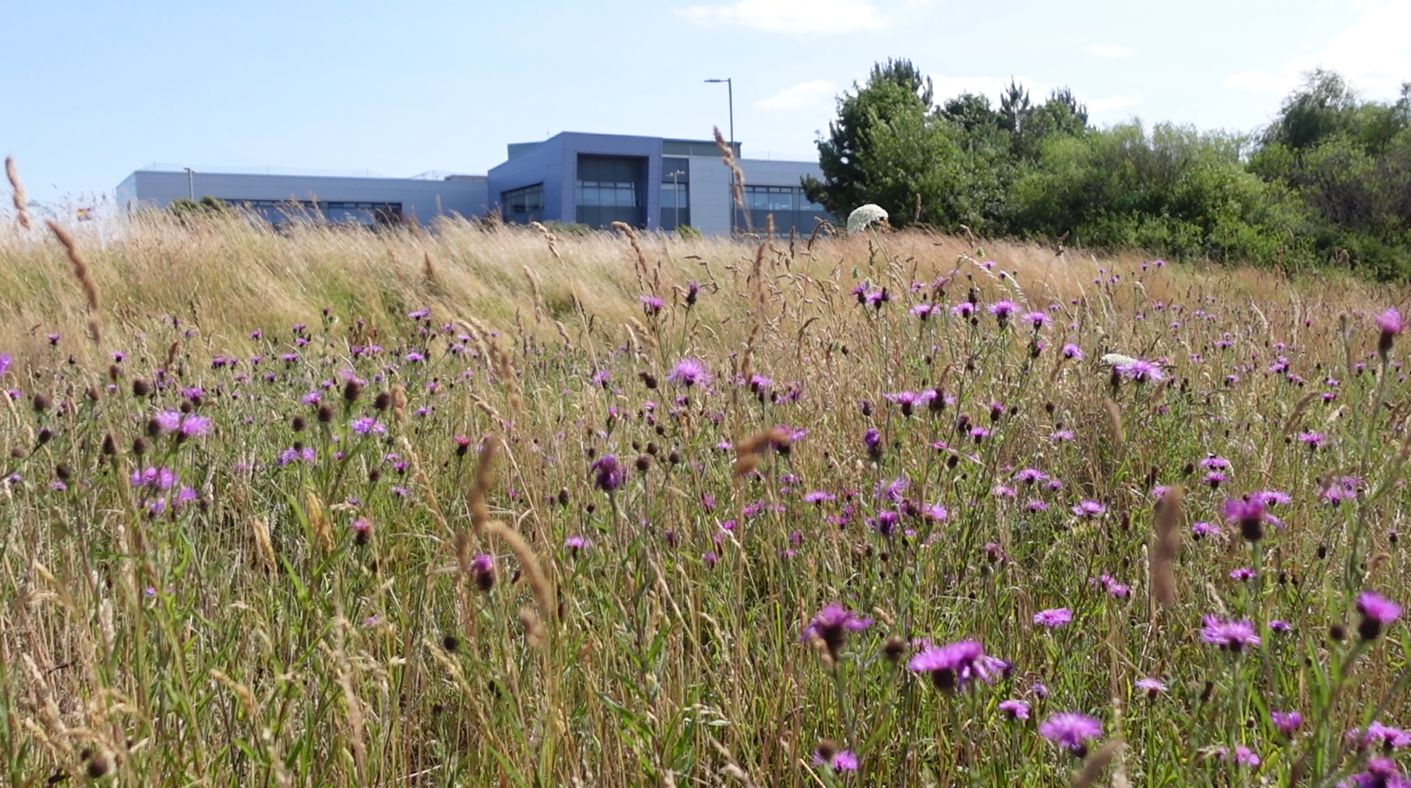
Figure 1. NPTC Offices at The Quays, with the neighbouring NPT Bee Friendly site

  - The last Biodiversity Duty Plan for Neath Port Talbot (NPT) was published in December 2020. In this there were targeted actions that would be undertaken by the Council to meet the requirements of the Act. Subsequently, a report on progress against the plan was produced in 2023, for the period from April 2020 to the end of March 2023. This report, titled the Implementation Report, is available to view on the Council’s website

  - The Implementation Report highlights the positive work undertaken by NPTC for biodiversity, demonstrating good progress against delivery of the biodiversity and resilience of ecosystems duty. The report also identified changes that should be made to the actions in development of the new, and updated Biodiversity Duty Plan 2023-2026 (BDP 2023-2026). This new Plan, covering the period April 2023 to March 2026, sets out the means by which the Council will deliver against its statutory duty for biodiversity, and consequently support global action in reversing the decline in biodiversity.

Why do we need to support biodiversity in NPT
  - There is plenty to celebrate about nature in NPT. Many sites in NPT are designated for nature conservation. These include local, national and international designations. Here you can find populations of species unique to Wales, over 70 highly protected species and good populations of some rare and vulnerable plants.
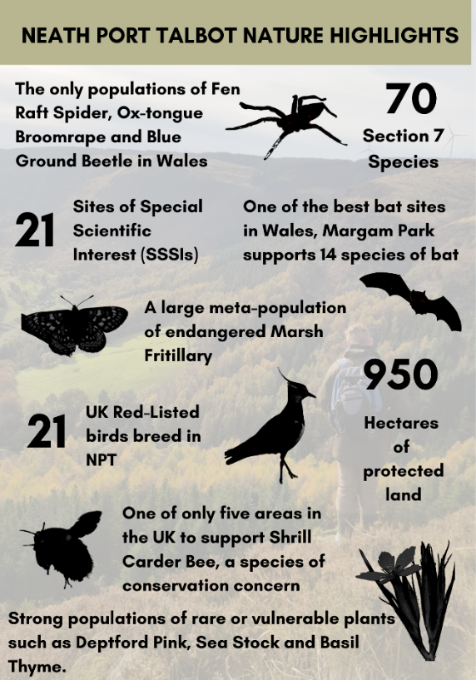
Figure 2. NPT Nature Highlights, courtesy of NPT Local Nature Partnership

  - Biodiversity and the natural environment in NPT provides us with many important ecosystem services. Our peatlands and wetlands capture and store atmospheric carbon dioxide. Floodplains in the valleys help dissipate water during high rainfall events, reducing flooding downriver. Woodlands help clean the air of pollutants, provide flood alleviation, reduce the heat island effect in urban environments, provide oxygen and timber products. The varied habitats also bring job opportunities and ways to improve health and well-being.

  - Since our natural environment provides so much for us, any decline in our natural environment has an impact on our lives.
Our economies, livelihoods and well-being all depend on our most precious asset: Nature.
The Economics of Biodiversity: The Dasgupta Review, 2021
  - Since the last BDP (2020-2023) was published, the Welsh Government has declared a nature emergency, which acknowledged the significant loss of biodiversity caused by humans. A widespread degradation of our ecosystems is taking place, due to pressures such as development, poor management, invasive non-native species and diseases.

  - On a local level, NPT Local Nature Partnership (LNP) has undertaken an assessment of the State of Nature of NPT. The habitats of NPT were grouped into 11 broad categories (e.g. woodland, coastal etc.), and sadly, of these 11 habitat categories, only two were assessed to be achieving ‘good’ ecosystem resilience.
Ecosystem resilience is the capacity of an ecosystem to deal with pressures and demands, either by resisting, recovering or adapting to them whilst retaining their ability to deliver ecosystem services and benefits now and into the future.
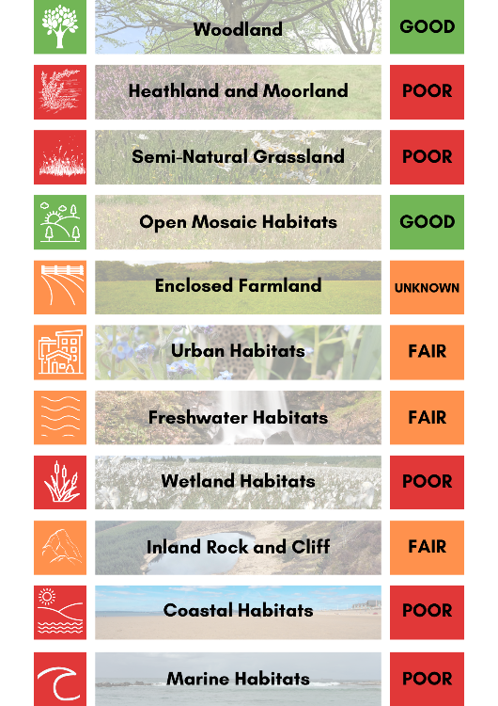
Figure 3. Ecosystem resilience of habitats in NPT, courtesy of NPT Local Nature Partnership
  - This means that habitats across NPT are not resilient enough to deal with pressures and demands such as climate change. Action needs to be taken now to improve the ecosystem resilience of our habitats across NPT.

  - Further detail about nature in NPT is available on the website of the NPT Local Nature Partnership.

Environment (Wales) Act 2016
  - The Environment (Wales) Act became law on 21st March 2016. It puts in place legislation to enable Wales’ resources to be managed in a more proactive, sustainable and joined up manner. The Act supports the Welsh Government’s wider remit under the Well-being of Future Generations (Wales) Act 2015, which allows Wales to enjoy a prosperous economy, a healthy and resilient environment and vibrant, cohesive communities.
Specifically, the Act places an enhanced biodiversity duty on public authorities (see Appendix 1 for the full text of Section 6 of the Act).
Sct. 6(1) A public authority must seek to maintain and enhance biodiversity in the exercise of functions in relation to Wales, and in so doing promote the resilience of ecosystems, so far as is consistent with the proper exercise of those functions.
If a public authority fails to meet its obligations under the Act it could ultimately be subject to judicial review and there is the potential for the Welsh Ministers to issue directions to a public body under Section 10 of the Act.
  - There are many ways in which NPTC may impact on biodiversity. For example, Neighbourhood Services such as grass cutting and flailing, building maintenance and development management. With this comes many opportunities to enhance for biodiversity, both directly e.g. by changing mowing regimes to create wildflower areas, and indirectly e.g. through education.

  - The focus of the Plan is to determine how Neath Port Talbot Council will seek to maintain and enhance biodiversity over the coming three years.

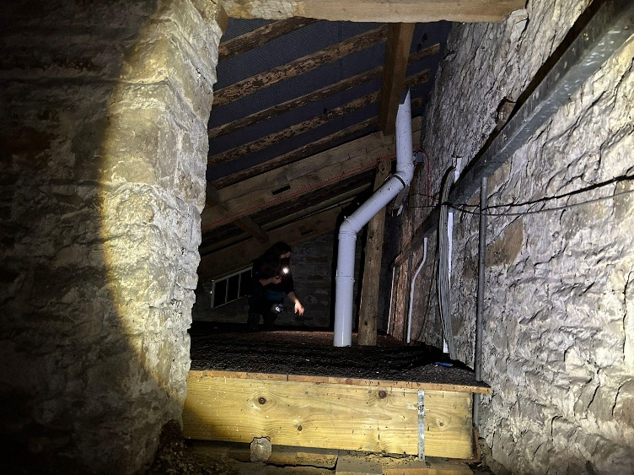
Figure 4. Countryside and Wildlife Team Ecologist undertaking a bat survey to inform engineering works

Other Legislative and Policy Context
There is supporting legislation, and a number of national, regional and local plans/strategies which recognise the importance of biodiversity, and the wider benefits it can provide for people and communities.

Level | Legislation, plans and strategies
National (Wales) | Well-being of Future Generations (Wales) Act 2015  Environment (Wales) Act 2016  Nature Recovery Action Plan for Wales  Climate Emergency Declaration  Edinburgh Declaration  Nature Emergency Declaration  30x30 Target  Action Plan for Pollinators  Placemaking Charter  Future Wales; the National Plan 2040  Planning Policy Wales 11
Regional | Area Statements
Local | Neath Port Talbot Public Service Board (PSB) Local Well-being Plan (2023-2028)  Neath Port Talbot Corporate Plan 2022-2027  State of Nature and Nature Recovery Action Plan for NPT  Neath Port Talbot Local Development Plan (2011-2026)  The Decarbonisation and Renewable Energy Strategy  NPT Air Quality Strategy
Figure 5. Relevant legislation, plans and strategies
Delivery of the Biodiversity Duty Plan 2023-2026 will support delivery of these wider pieces of legislation, plans and strategies. Further information on some of these are outlined below.

Nature Recovery Action Plan for Wales
    - The Nature Recovery Action Plan (NRAP) for Wales was originally published in December 2015 as the Nature Recovery Plan. It is the National Biodiversity Strategy and Action Plan for Wales. The NRAP was refreshed for 2020-21 to provide focus and prioritisation within a fast changing policy context and the emerging ecological crisis. A further update is expected soon. The ambition of the plan is:
To reverse the decline in biodiversity, for its intrinsic value, and to ensure lasting benefits to society.
    - There are 6 objectives laid out in the NRAP to achieve this ambition. The objectives are set out below with full details in Appendix 2. The actions in the BDP 2023-2026 demonstrate how they achieve against these objectives:
 | NRAP Objectives
1 | Engage and support participation and understanding to embed biodiversity throughout decision making at all levels
2 | Safeguard species and habitats of principal importance and improve their management
3 | Increase the resilience of our natural environment by restoring degraded habitats and habitat creation
4 | Tackle key pressures on species and habitats
5 | Improve our evidence, understanding and monitoring
6 | Put in place a framework of governance and support for delivery

State of Nature and Nature Recovery Action Plan for NPT
    - Associated with the NRAP for Wales, NPT Local Nature Partnership has produced a local ‘State of Nature and Nature Recovery Action Plan for NPT 2023’ (SON/ NRAP 2023), which provides an evidence-based assessment of the ecosystem resilience of each broad habitat type in NPT, linked with a plan to help nature recover in the county.

    - The habitats of NPT were grouped into 11 broad categories (e.g. woodland, coastal etc.), and sadly, of these 11 habitat categories, only two were assessed to be achieving ‘good’ ecosystem resilience. This means that habitats across NPT are not resilient enough to deal with pressures and demands such as climate change. Action needs to be taken now to improve the ecosystem resilience of our habitats across NPT.

    - There are key actions within the SON/ NRAP 2023 which NPTC, as the Local Authority, has the ability to achieve. These include actions such as tackling Invasive Non-Native Species, installing green infrastructure solutions and increasing wildflower grassland. The Council will support the NPT Nature Partnership in implementing the NPT Nature Recovery Action Plan and will also deliver against NRAP actions wherever possible when relevant to NPTC.

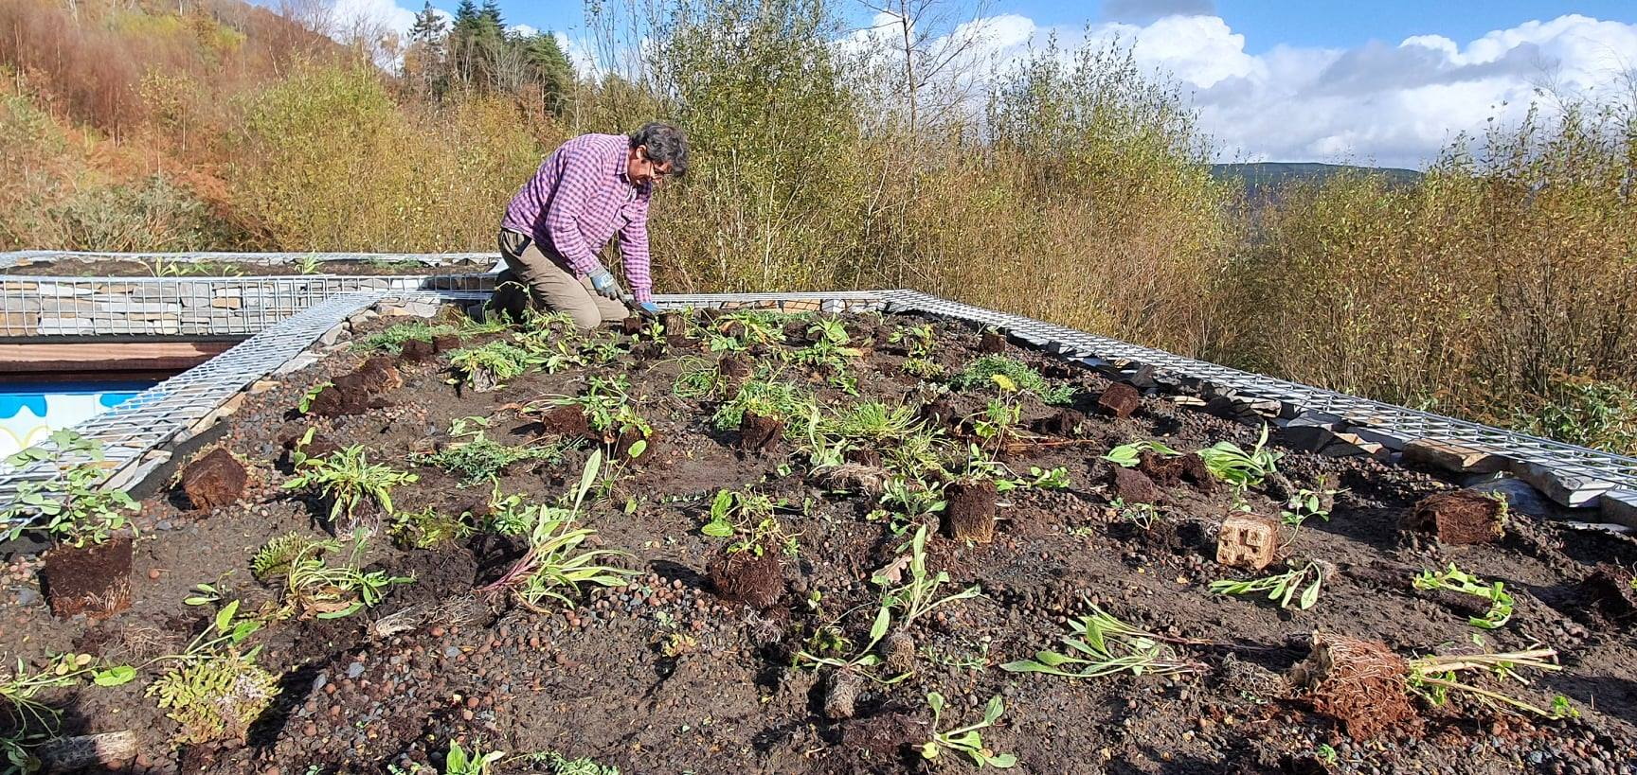
Figure 6. Green Roof creation at Craig Gwladus Country Park

Well-being of Future Generations (Wales) Act 2015
    - The Well-being of Future Generations (Wales) Act 2015 (the WBFG Act) is about improving the social, economic, environmental and cultural well-being of Wales. It sets out new ways of working where all elements of well-being are considered together. The full detail of how the BDP 2023-2026 achieves against the WBFG Act is outlined in Appendix 3.

Neath Port Talbot Public Service Board (PSB) Local Well-being Plan (2023-2028)
    - The Well-being Plan sets out the Public Service Board’s (PSB) long term vision for NPT, as required by the WBFG Act. The Well-being Plan (2023-2028) prioritises four well-being objectives. The BDP 2023-2026 achieves against all four of these objectives but particularly the following:
To ensure our local environment, culture and heritage can be enjoyed by future generations

Neath Port Talbot Corporate Plan 2022-2027
    - The Corporate plan covers the period 2022 to 2027 and sets out how the council will approach recovery from the Covid-19 pandemic in the short, medium and longer term. The council’s strategic change programme have been set in line with the WBFG Act and the PSB Well-being Plan.

    - Both the Well-being Plan and Corporate Plan have a strong focus on improving well-being, alongside valuing and protecting our local environment. Delivery of actions outlined within the BDP 2023-2026 will be an integral element of meeting the Council’s, and PSB’s, well-being priorities and goals. Furthermore, whilst this plan contributes to all of the goals set out in the legislation, in particular it can be used to demonstrate our contribution to the A Resilient Wales goal.

Area Statements
    - NRW have prepared and published Area Statements. Area Statements are informed by the State of Natural Resources Report which specifies priorities, risks and opportunities to implement the priorities of the Natural Resources Policy. NPT falls within the South West Wales area. In the statement NRW have identified 4 main themes. Many of our actions contribute to these themes.

Neath Port Talbot Local Development Plan (2011-2026)
    - Adopted in January 2016, the Local Development Plan guides the future development of the county. It is an important tool in biodiversity conservation. Policies help protect important habitats and species. This includes sites that have international to local designations. Undesignated but important natural features such as trees, woodlands or ponds are also protected.

    - Details on how to design a development to achieve this protection is found in the Biodiversity and Geodiversity Supplementary Planning Guidance (May 2018). The Countryside and Wildlife Team (C&WT) screen and, where appropriate, comment on planning applications to ensure the policies are met.

30 by 30
    - At COP15, the UN Biodiversity Summit, held in Montreal, Canada, from 7 to 19 December 2022, a new global framework was agreed with a suite of measures which aim to address the global loss of biodiversity and restore natural ecosystems. A key target of this framework is the ‘30x30’ target, which looks to protect 30% of terrestrial, inland water and coastal and marine areas by 2030:
Ensure that at least 30 per cent globally of land areas and of sea areas, especially areas of particular importance for biodiversity and its contributions to people, are conserved through effectively and equitably managed, ecologically representative and well-connected systems of protected areas and other effective area-based conservation measures (OECMs), and integrated into the wider landscapes and seascapes [by 2030]
Convention on Biological Diversity 2021
    - The Welsh Government, along with 100 other countries, has committed to support the 30x30 target and has completed a Biodiversity Deep Dive to identify recommendations in order to achieve this. The BDP 2023-2026 includes action to determine how NPTC can work towards the 30 x 30 target.

Figure 7. Swift boxes installed on NPTC-owned building in Resolven

Planning Policy Wales 11
    - In February 2021, Planning Policy Wales 11 came into force. PPW 11 sets out that “planning authorities must seek to maintain and enhance biodiversity in the exercise of their functions. This means that development should not cause any significant loss of habitats or populations of species, locally or nationally and must provide a net benefit for biodiversity”.

    - A letter from Welsh Government dated 23/10/2019 makes it clear that where biodiversity enhancement is not proposed as part of an application, significant weight will be given to its absence, and unless other significant material considerations indicate otherwise, it will be necessary to refuse permission.

    - Planning Policy Wales 11 is incorporated into the BDP 2023-2026 through actions such as Action 2.1.

The Decarbonisation and Renewable Energy Strategy
    - The Decarbonisation and Renewable Energy Strategy sets out how we will lead by example and reduce our carbon footprint when carrying out our operations and functions. It recognises the importance of ecosystems for carbon sequestration. Actions in the strategy commit us to explore green infrastructure and habitat solutions to tackle climate change.

Implementation and Monitoring

Implementation
    - Delivery of the Plan is the responsibility of the Council as a whole. Coordination and reporting is undertaken by the Council’s Countryside and Wildlife Team, with a dedicated Ecologist (Plans & Projects) in place to oversee this function.

    - The Biodiversity Duty Actions (as detailed in Section 6) of this BDP 2023-2026 set out specifically what the Authority intends to do to meet its legal requirements of the biodiversity and ecosystem resilience duty. In accordance with Welsh Government guidance on reporting, the actions of the Plan have been drawn up in line with the NRAP objectives. The actions allocated to Local Authorities in the NRAP are also incorporated into this plan.

    - The actions are organised into the most appropriate NRAP Objective. As actions often deliver against more than one objective, the table below each action highlights all objectives relevant to that action. The reporting mechanisms and the next 3 year milestones are also set out against each action.

    - Where there are fundamental changes to terminology, or advancements in our understanding of ecosystems, this plan may be updated to reflect those changes at any time.

Monitoring and Reporting
    - A report on progress against the plan was produced in 2023, for the period from April 2020 to end of March 2023 (Years 3, 4 and 5). This report, titled the Implementation Report, is available to view on the Council’s website.

    - Monitoring of the Plan will continue to be undertaken by the Countryside and Wildlife Team, aligning with financial years and allowing us to monitor actions in line with grant funding. Monitoring will be carried out to the following timetable:
Year 6 = April 2023– March 2024
Year 7 = April 2024 – March 2025
Year 8 = April 2025 - March 2026 etc.

    - Delivery of the Plan will be reported as an Implementation Report every 3 years, in line with the requirements of the Environment Wales Act. The implementation report will be undertaken by early September in any reporting year to allow sufficient time to follow the political reporting process aiming for the report to be taken to Cabinet and Full Council towards the end of the year. Reporting will be for monitoring Years 6-8 at the end of 2026.

    - The Implementation Report, alongside the most up to date Plan, will be submitted to the Welsh Government and made publicly available on the Council’s website.

    - The preceding plan will remain in force until the new one is formally agreed.

    - Delivery of the Plan is also integrated into the Council’s Corporate Plan, with key outcomes reported as part of the Corporate Plan’s monitoring and reporting process. This includes a key performance indicator for the extent of council owned land being managed for biodiversity. Progress reports are published on an annual basis.

Actions

NRAP Objective 1: Engage and support participation and understanding to embed biodiversity throughout decision making at all levels

1.1 | BIODIVERSITY ADVISORY SERVICE
Action | The Council currently considers biodiversity in a wide range of functions, including through implementing the policies of the LDP when making decisions through the development management process and as part of the SuDS (Sustainable Drainage Systems) Approving Body.
Reporting mechanism | C&WT planning spreadsheet
Milestone year 6 | All advice recorded in the spreadsheet followed
Milestone year 7 | All advice recorded in the spreadsheet followed
Milestone year 8 | All advice recorded in the spreadsheet followed
NRAP Objectives | 1,6

1.2 | SERVICE ASSESSMENT
Action | Complete service assessment and provide reports with recommendations to each service. All services to follow recommendations as outlined in their reports.
Reporting mechanism | C&W Team to keep a spreadsheet recording action against recommendations. Internal Audit team to assist with collecting this information.
Milestone year 6 | Service assessments completed
Milestone year 7 | Action against recommendations taking place.
Milestone year 8 | Action against recommendations taking place.
NRAP Objectives | 1

1.3 | C&WT EARLY ENGAGEMENT
Action | The C&WT are regularly consulted by other service areas and give appropriate advice and services.
Reporting mechanism | C&WT Consultancy Spreadsheet /STiR (time recording database)
Milestone year 6 | Retain internal consultancy function and continue to provide early advice to service areas throughout the Authority. All advice followed.
Milestone year 7 | Retain internal consultancy function and continue to provide early advice to service areas throughout the Authority. All advice followed.
Milestone year 8 | Retain internal consultancy function and continue to provide early advice to service areas throughout the Authority. All advice followed.
NRAP Objectives | 1,2,3,4,5,6,

1.4 | DECISION MAKING PROCESS
Action | The Integrated Impact Assessment (IIA) that accompanies all committee reports includes an appropriately evidenced assessment of the impact on biodiversity in line with the Environment (Wales) Act 2016. Where necessary, training for staff and officers is undertaken to support this.
Reporting mechanism | Committee reports all containing a report on outcomes of the impact assessment. An annual IIA review is undertaken by C&W Team and reported back to relevant service areas, with follow-up training if necessary.
Milestone year 6 | All committee reports to contain an appropriately-evidenced report on outcomes of the impact assessment.
Milestone year 7 | All committee reports to contain an appropriately-evidenced report on outcomes of the impact assessment.
Milestone year 8 | All committee reports to contain an appropriately-evidenced report on outcomes of the impact assessment.
NRAP Objectives | 1,2,3,4,5,6

1.5 | TRAINING
Action | Ensure that staff and Elected Members receive appropriate training and are aware of where to access further guidance.
Reporting mechanism | Attendance at training
Milestone year 6 | Deliver training
Milestone year 7 | Deliver training
Milestone year 8 | Deliver training
NRAP Objectives | 1,6

1.6 | BIODIVERSITY SPG
Action | Implement the Biodiversity Supplementary Planning Guidance (SPG) in line with LDP policies and develop a mechanism for habitat banking to ensure we have compensation sites ready to go when needed.
Reporting mechanism | C&WT Planning spreadsheet
Milestone year 6 | Implement SPG
Milestone year 7 | Implement SPG
Milestone year 8 | Implement SPG
NRAP Objectives | 1,2,3,4,5,6

1.7 | WELL-BEING PROCESS
Action | Deliver and support others to deliver against ‘Recover, Reset, Renew’, the Council Corporate Plan and the Public Service Board’s Well-being Plan ‘Well-being Objective 3; To ensure our local environment, culture and heritage can be enjoyed by future generations’, as well as relevant actions under the other three Well-being Objectives.
Reporting mechanism | Via the Corporate Plan and PSB annual reports.
Milestone year 6 | As required by the Corporate Plan and PSB reporting mechanisms
Milestone year 7 | As required by the Corporate Plan and PSB reporting mechanisms
Milestone year 8 | As required by the Corporate Plan and PSB reporting mechanisms
NRAP Objectives | 1,2,3,4,5,6

1.8 | NEW COUNCIL STRATEGIES
Action | C&WT to collaborate where appropriate with other sections to aid in the development of strategies or plans that contribute towards biodiversity conservation, and respond to consultations and reviews of existing plans.
Reporting mechanism | BDP Reporting Spreadsheet
Milestone year 6 | N/A
Milestone year 7 | N/A
Milestone year 8 | N/A
NRAP Objectives | 1,2,3,4,6

1.9 | SUDS (SUSTAINABLE DRAINAGE SYSTEMS) APPROVAL BODY (SAB)
Action | Maximise the biodiversity potential of SuDS in NPT.
Reporting mechanism | Through SAB processes
Milestone year 6 | Work with SAB team to determine the knowledge gaps and what is required to help maximise the biodiversity potential of SuDS in NPT.
Milestone year 7 | TBC
Milestone year 8 | TBC
NRAP Objectives | 1, 5, 6

1.10 | PROCUREMENT
Action | Include biodiversity/ sustainability impacts as a consideration in the procurement process, with appropriate weighting in tender evaluation.
Reporting mechanism | To be agreed with procurement.
Milestone year 6 | Work with Procurement team to determine appropriate considerations for biodiversity/ sustainability to include in the procurement process.
Milestone year 7 | Impacts on biodiversity / sustainability considered through the procurement process.
Milestone year 8 | Impacts on biodiversity / sustainability considered through the procurement process.
NRAP Objectives | 1,6

1.11 | CURRENT ISSUES
Action | Keep policies and steering statements up to date in light of current issues.
Reporting mechanism | Through appropriate council processes
Milestone year 6 | Policies and steering statements adopted or updated as necessary
Milestone year 7 | Policies and steering statements adopted or updated as necessary
Milestone year 8 | Policies and steering statements adopted or updated as necessary
NRAP Objectives | 1, 5, 6

NRAP Objective 2: Safeguard species and habitats of principal importance and improve their management

2.1 | DEVELOPMENT MANAGEMENT PROCESS
Action | NPTC currently consider biodiversity (including species and habitats of principal importance, designated sites, sites of importance for nature conservation (SINC), habitats and species that meet the SINC criteria, and important natural features) through the development management process, in line with the Local Development Plan. Losses of protected/priority habitat/species (where known) are recorded.
Reporting mechanism | C&WT planning spreadsheet
Milestone year 6 | Achieve net benefit for biodiversity through the planning process.
Milestone year 7 | Achieve net benefit for biodiversity through the planning process.
Milestone year 8 | Achieve net benefit for biodiversity through the planning process.
NRAP Objectives | 1,2,3,4,5,6

2.2 | NPT NATURE PARTNERSHIP
Action | The Council will support the NPT Nature Partnership in implementing the NPT Nature Recovery Action Plan. The Action Plan is a key mechanism for species and habitat conservation in the County.
Reporting mechanism | Action to be recorded and reviewed annually in the first LNP meeting of the new year.
Milestone year 6 | Progress against relevant actions as outlined in the NRAP
Milestone year 7 | Progress against relevant actions as outlined in the NRAP
Milestone year 8 | Progress against relevant actions as outlined in the NRAP
NRAP Objectives | 1,2,3,4,5,6

2.3 | AWARENESS RAISING
Action | The C&WT raise awareness of biodiversity through a variety of methods; training, public engagement (walks/talks), interpretation panels, leaflets, web pages, social media.
Reporting mechanism | Project delivery and ongoing upkeep of the NPTC web pages and NPT Wildlife Facebook page
Milestone year 6 | 2 awareness raising projects per year and year on year increase in followers on the Facebook page
Milestone year 7 | 2 awareness raising projects per year and year on year increase in followers on the Facebook page
Milestone year 8 | 2 awareness raising projects per year and year on year increase in followers on the Facebook page
NRAP Objectives | 1,2,3,5

2.4 | BIODIVERSITY AUDIT
Action | Undertake a biodiversity audit on land within our ownership and control, to identify where we have protected/S7 habitats and species on our land. Priority will then be given to those areas / sites where priority Section 7 habitats / species have been identified which offer the greatest benefit to biodiversity, considering one of the following options:  1) The status quo – with no further action being taken.  2) Be brought into appropriate management for the benefit of biodiversity. This may be through:  The Authority and, where necessary, suitable revenue sources can be secured by way of external funding to support and manage the identified sites.  Lease to external parties.  NB Any notional financial loss to the Authority needs to be reported and agreed before any lease is granted.  3) Any future disposal of a site will include relevant information from the audit so that the purchaser / tenant can comply with the relevant requirements.  4) In advance of undertaking any works and / or any material changes in land use on sites owned and controlled by the Authority, it will take into consideration the findings of the audit, taking steps to conserve and where possible enhance the biodiversity value
Reporting mechanism | First report will be results of audit
Milestone year 6 | Assessment ongoing
Milestone year 7 | Advice provided as part of assessment followed
Milestone year 8 | Ongoing communications. Advice followed.
NRAP Objectives | 1,2,3,5

2.5 | NATIONAL GUIDANCE
Action | Implement any national/regional guidance on enhancing biodiversity and ecosystems resilience through the planning system. Any new guidance will be taken into account and integrated into the system.
Reporting mechanism | C&WT Planning spreadsheet
Milestone year 6 | All national/regional guidance to be integrated into the planning system within 3 months of its release
Milestone year 7 | All national/regional guidance to be integrated into the planning system within 3 months of its release
Milestone year 8 | All national/regional guidance to be integrated into the planning system within 3 months of its release
NRAP Objectives | 1,2,3,4,5,6

2.6 | FUNDING
Action | Apply for funding as opportunities arise to continue to deliver for biodiversity, or as part of strategic, multi-functional projects delivering multiple benefits.
Reporting mechanism | As funding requirements
Milestone year 6 | As opportunities arise
Milestone year 7 | As opportunities arise
Milestone year 8 | As opportunities arise
NRAP Objectives | 1,2,3,4,5,6

2.7 | 30x30
Action | Examine the potential to increase the amount of protected or ‘other effective area based conservation measures (OECMs)’ land in NPT, in line with the 30x30 target and the Biodiversity Deep Dive recommendations. This can be completed for both NPTC land and for the county of NPT as a whole, working with the LNP.
Reporting mechanism | TBC (Welsh Government are yet to define how to measure other effective area based conservation measures (OECMs))
Milestone year 6 | Complete biodiversity audit
Milestone year 7 | Use the information from the biodiversity audit to identify the maximum percentage of NPTC land holdings which have the potential to be protected for biodiversity or classified as OECMs i.e. not in other use etc.
Milestone year 8 | Feasibility study to determine what would need to happen in order to achieve 30% of council land holdings protected for biodiversity / OECMs
NRAP Objectives | 1,2,3,4,5,6

NRAP Objective 3: Increase the resilience of our natural environment by restoring degraded habitats and habitat creation

3.1 | CURRENT MANAGEMENT
Action | NPTC areas are being managed for biodiversity and to ensure their resilience.
Reporting mechanism | Extent of area under management reported through the Key Performance Indicators (KPI) within the Corporate Plan.
Milestone year 6 | Agree an amended KPI as part of the Corporate Plan.
Milestone year 7 | As set by the KPI
Milestone year 8 | As set by the KPI
NRAP Objectives | 1,2,3,4,5,6

3.2 | HABITAT MANAGEMENT THROUGH DEVELOPMENT MANAGEMENT
Action | Through the development management process habitat management plans are put in place increasing the resilience of our natural environment and improving the management of S7 habitats
Reporting mechanism | C&WT Planning spreadsheet
Milestone year 6 | Appropriate assessments of ecosystems resilience submitted through the planning process and appropriate measures to deliver improvements taken
Milestone year 7 | Appropriate assessments of ecosystems resilience submitted through the planning process and appropriate measures to deliver improvements taken
Milestone year 8 | Appropriate assessments of ecosystems resilience submitted through the planning process and appropriate measures to deliver improvements taken
NRAP Objectives | 1,2,3,4,5,6

3.3 | AREA STATEMENTS
Action | NPTC will assist NRW in implementing Area Statements as required.
Reporting mechanism | As required
Milestone year 6 | As appropriate
Milestone year 7 | As appropriate
Milestone year 8 | As appropriate
NRAP Objectives | 1,2,3,4,5,6

3.4 | GREEN INFRASTRUCTURE ASSESSMENT
Action | The Council will undertake a Green Infrastructure Assessment (GIA) in line with the requirements of Planning Policy Wales (PPW) for Neath Port Talbot.
Reporting mechanism | Planning & Environment Decisions Wales (PEDW) and Welsh Government approval as part of the evidence base that will underpin the LDP.
Milestone year 6 | Engagement, participation and contribution in partnership with the LDP Team to produce a GIA for the Authority.
Milestone year 7 | GIA complete but updated as necessary.
Milestone year 8 | GIA complete but updated as necessary.
NRAP Objectives | 3,4,5

3.5 | HABITAT CREATION ON BUILDINGS
Action | NPTC buildings are reviewed to determine where there are to continue the work in relation to habitat creation on council buildings, as appropriate for the use of the building. Opportunities are pursued where possible.
Reporting mechanism | Report on opportunities.
Milestone year 6 | Building review ongoing
Milestone year 7 | Building review ongoing
Milestone year 8 | Building review completed
NRAP Objectives | 1,2,3,4,5,6

3.6 | REVIEW OF OPPORTUNITIES FOR NATURE IN PUBLIC SPACES AND PUBLIC REALM
Action | Review and assess opportunities to change and/or add features to public spaces and the public realm that deliver benefits for nature alongside existing necessary functions/benefits
Reporting mechanism | Report on opportunities.
Milestone year 6 | Review/assessment started
Milestone year 7 | Review/assessment ongoing.
Milestone year 8 | Review/assessment ongoing.
NRAP Objectives | 1,3,4,6

NRAP Objective 4: Tackle key pressures on species and habitats

4.1 | INVASIVE NON-NATIVE SPECIES (INNS)
Action | A proactive approach is taken to dealing with INNS including Development Management Process and treatment on Council land.
Reporting mechanism | C&WT Planning spreadsheet and BDP Spreadsheet.
Milestone year 6 | As appropriate
Milestone year 7 | As appropriate
Milestone year 8 | As appropriate
NRAP Objectives | 1,3,4,5,6

4.2 | AIR QUALITY
Action | The air quality implications of plans and projects are fully assessed for their potential effects on sensitive habitats and species through the HRA process
Reporting mechanism | C&WT Planning spreadsheet
Milestone year 6 | All development proposals assessed as appropriate
Milestone year 7 | All development proposals assessed as appropriate
Milestone year 8 | All development proposals assessed as appropriate
NRAP Objectives | 1,2,3,4,5,6

4.3 | STATE OF NATURE IN NPT
Action | Support the Local Nature Partnership to review all of the local information and evidence and review the State of Nature of NPT in 2028.
Reporting mechanism | State of Nature in NPT reviewed and updated report on local pressures produced.
Milestone year 6 | No milestone until Year 10
Milestone year 7 | No milestone until Year 10
Milestone year 8 | No milestone until Year 10
NRAP Objectives | 4,5

NRAP Objective 5: Improve our evidence, understanding and monitoring

5.1 | DATA CAPTURE
Action | NPT uses a range of data capture tools and techniques. This has led to a large number of species records which are passed on to the Local Records Centre and, therefore, shared with the wider community.
Reporting mechanism | Metadata from MapMate
Milestone year 6 | Maintenance of the MapMate database and Biodiversity GIS layers.
Milestone year 7 | Maintenance of the MapMate database and Biodiversity GIS layers. If necessary, change to alternative database system.
Milestone year 8 | Maintenance of the MapMate database and Biodiversity GIS layers. If necessary, change to alternative database system.
NRAP Objectives | 2,4,5

5.2 | SITES OF IMPORTANCE FOR NATURE CONSERVATION
Action | NPTC have a programme of identifying sites that qualify as Sites of Importance for Nature Conservation (SINC). This allows us to assess the quality of a site against national guidelines. Sites will be reviewed periodically through surveys and the development management process.  The GIS layer will be updated and shared with SEWBReC as required.
Reporting mechanism | Update GIS layer periodically and report updates to SEWBReC
Milestone year 6 | Update periodically through surveys and the development management process
Milestone year 7 | Update periodically through surveys and the development management process
Milestone year 8 | Update periodically through surveys and the development management process
NRAP Objectives | 1,2,3,4,5,6

5.3 | SURVEYS
Action | NPTC provides secretariat for the NPT Nature Partnership which includes a number of specialist surveyors and SEWBReC. We utilise this expertise by organising surveys for targeted sites and species.
Reporting mechanism | Reports of surveys
Milestone year 6 | Work with the Local Nature Partnership to take forward specialist surveys where most appropriate
Milestone year 7 | Work with the Local Nature Partnership to take forward specialist surveys where most appropriate
Milestone year 8 | Work with the Local Nature Partnership to take forward specialist surveys where most appropriate
NRAP Objectives | 1,2,3,4,5,6

5.4 | RECORD CENTRE SEARCHES
Action | All planning applications containing biodiversity information must be accompanied by a SEWBReC search undertaken by/on behalf of the applicant, unless agreement is reached with the C&WT that sufficient justification exists to negate this need.
Reporting mechanism | C&WT Planning spreadsheet
Milestone year 6 | All biodiversity information contained in a planning application must be accompanied by a SEWBReC search, unless agreed otherwise
Milestone year 7 | All biodiversity information contained in a planning application must be accompanied by a SEWBReC search, unless agreed otherwise
Milestone year 8 | All biodiversity information contained in a planning application must be accompanied by a SEWBReC search, unless agreed otherwise
NRAP Objectives | 1,2,3,4,5,6

5.5 | BIODIVERSITY COMPENSATION SCHEME
Action | Implement the compensation scheme as set out in the Biodiversity SPG.
Reporting mechanism | C&WT Planning spreadsheet
Milestone year 6 | Implement SPG via the development management process
Milestone year 7 | Implement SPG via the development management process
Milestone year 8 | Implement SPG via the development management process
NRAP Objectives | 1,2,3,4,5,6

5.6 | BIODIVERSITY PLAN EVIDENCE
Action | Evidence to be collected to ensure compliance with this plan.
Reporting mechanism | All reporting to be gathered and collated to report on this plan
Milestone year 6 | Ongoing
Milestone year 7 | Ongoing
Milestone year 8 | Ongoing
NRAP Objectives | 1,2,3,4,5,6

NRAP Objective 6: Put in place a framework of governance and support for delivery

6.1 | COUNTRYSIDE AND WILDLIFE TEAM RESOURCES
Action | Maintain enough skills and capacity in the C&WT to co-ordinate the work needed to comply with the legislation and in response to increasing investment by WG and other funders.
Reporting mechanism | The duty report
Milestone year 6 | Maintain / increase current core staff levels and retain / employ additional project staff to deliver grant funded projects as and when funding becomes available.
Milestone year 7 | Maintain / increase current core staff levels and retain / employ additional project staff to deliver grant funded projects as and when funding becomes available.
Milestone year 8 | Maintain / increase current core staff levels and retain / employ additional project staff to deliver grant funded projects as and when funding becomes available.
NRAP Objectives | 1,2,3,4,5,6

6.2 | NPT LOCAL NATURE PARTNERSHIP
Action | Continue to support the NPT Local Nature Partnership, providing the secretariat, steering the objectives and collating information on member activities through the C&WT.
Reporting mechanism | Partnership minutes
Milestone year 6 | Continue to provide secretariat for the NPT Local Nature Partnership
Milestone year 7 | Continue to provide secretariat for the NPT Local Nature Partnership
Milestone year 8 | Continue to provide secretariat for the NPT Local Nature Partnership
NRAP Objectives | 6

6.3 | BIODIVERSITY CHAMPION
Action | A NPTC Councillor is appointed Biodiversity Champion and attends events/meetings as appropriate.
Reporting mechanism | Attendance at regular meetings
Milestone year 6 | Continued engagement as appropriate
Milestone year 7 | Continued engagement as appropriate
Milestone year 8 | Continued engagement as appropriate
NRAP Objectives | 1,6

6.4 | BIODIVERSITY CONTACT
Action | Each service area has a point of contact for biodiversity matters.
Reporting mechanism | Key Contacts spreadsheet
Milestone year 6 | Engagement as appropriate
Milestone year 7 | Engagement as appropriate
Milestone year 8 | Engagement as appropriate
NRAP Objectives | 1,6

6.5 | NATURE RECOVERY ACTION PLAN
Action | Through the NPT Nature Recovery Action Plan, maximise opportunities to deliver priorities via volunteers and partners. NPTC delivers against any relevant actions in agreement with relevant departments. Please see the list of potential relevant actions in Appendix 4.
Reporting mechanism | Delivery against actions to be reported to the LNP in first LNP meeting of the new year.
Milestone year 6 | Delivery against actions to be reported to the LNP in first LNP meeting of the new year.
Milestone year 7 | Delivery against actions to be reported to the LNP in first LNP meeting of the new year.
Milestone year 8 | Delivery against actions to be reported to the LNP in first LNP meeting of the new year.
NRAP Objectives | 1,2,3,4,5,6

6.6 | NPT BEE FRIENDLY / NATURE CONSERVATION SITES SCHEME
Action | Implement the NPT Bee Friendly scheme, increasing sites included in the scheme each year. Review and update the Conservation Sites Scheme to include sites which are not managed under NPTBF.
Reporting mechanism | Hectarage of sites or kilometres of linear features reported through Corporate Reporting.
Milestone year 6 | Hectarage/ km of sites included in these schemes increases year on year
Milestone year 7 | Hectarage / km of sites included in these schemes increases year on year
Milestone year 8 | Hectarage/ km of sites included in these schemes increases year on year
NRAP Objectives | 1,2,5,6

6.7 | MOTION FOR THE OCEAN
Action | Investigate the Motion for the Ocean and potential deliverables for NPT.
Reporting mechanism | TBC
Milestone year 6 | Feasibility for Motion for the Ocean
Milestone year 7 | Start process of declaring a Motion for the Ocean if considered feasible
Milestone year 8 | Motion for the Ocean declared, if feasible
NRAP Objectives | 1,2,5,6

Conclusion
  - In light of the nature emergency declared by the Welsh Government, and the declines in ecosystem resilience noted on a local level in the State of Nature for NPT, it has never been more important for NPT Council to play its part in nature recovery.

  - Neath Port Talbot Council will deliver the above actions to meet its legal duties under the Environment (Wales) Act 2016.
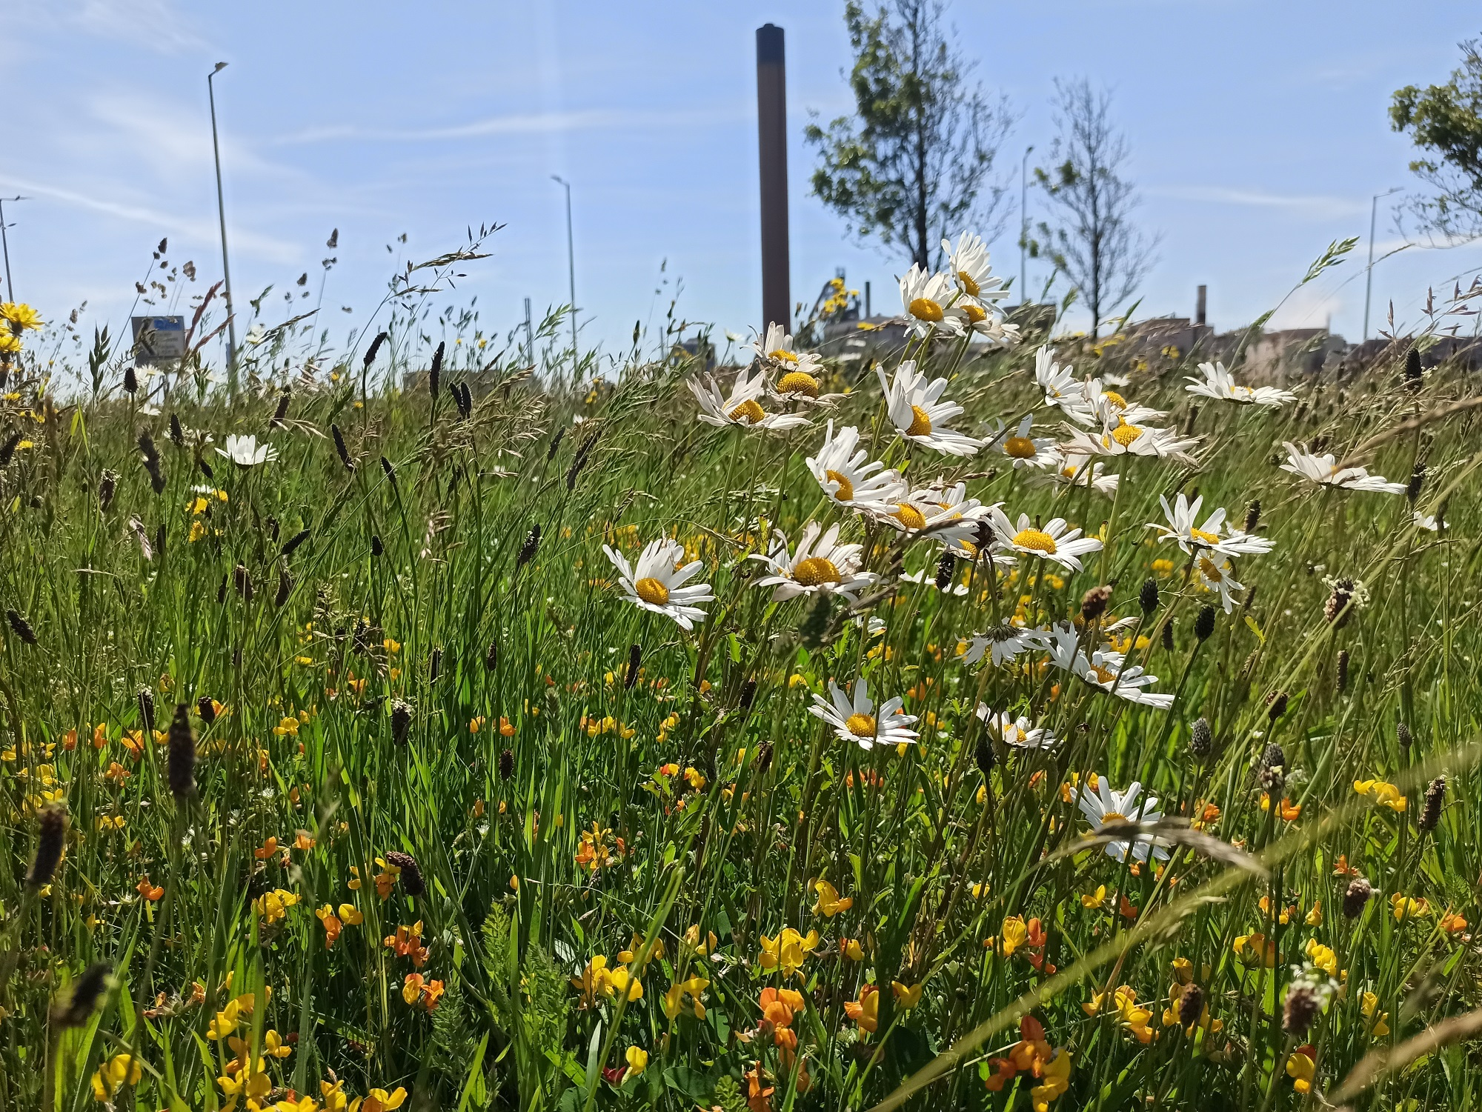
Figure 8. NPT Bee Friendly site by TATA Steel works

Glossary

Word | Definition
Biodiversity | Biodiversity is defined in the Environment (Wales) 2016 Act as: “the diversity of living organisms, whether at the genetic, species or ecosystem level”  Biodiversity drives the functioning and resilience of our ecosystems.
Habitat | A habitat is a place where an organism makes its home. A habitat meets all the environmental conditions an organism needs to survive.
Ecology | The study of relationships between living organisms  and their physical environment
Ecosystem | The UN Convention on Biological Diversity (CBD) defined ecosystems as:  “a dynamic complex of plant, animal and micro-organisms and their non-living environment interacting as a functional unit”
Ecosystem Services | Some sort of benefit to people which is provided by the natural environment.  Supporting – underpins all other services and includes nutrient cycling, soil formation and primary production  Provisioning – all our food, fresh water, wood and fibre, fuel  Regulating – cleaning air and water, flood control, carbon sequestration  Cultural – aesthetic, spiritual, educational, recreational
Ecosystem resilience | Ecosystem resilience is the capacity of an ecosystem  to deal with pressures and demands, either by  resisting, recovering or adapting to them whilst  retaining their ability to deliver ecosystem services  and benefits now and into the future. Usually assessed using the DECCA scale (Diversity, Extend, Condition and Connectivity).
Local Records Centre | Centres for the collation, management and dissemination of biodiversity data. The Local Records Centre for NPT is South East Wales Biodiversity Records Centre (SEWBReC)
MapMate | Biological Recording Software
Natural resources | a) Animals, plants and other organisms.  b) Air, water and soil.  c) Minerals.  d) Geological features and processes.  e) Physiographical features.  f) Climatic features and processes
NPT Local Nature Partnership (LNP) | A group of individuals and organisations working collectively to enhance biodiversity in NPT www.naturenpt.cymru/about-us
Sustainable development | The process of improving the economic, social, environmental and cultural well-being of Wales by taking action, in accordance with the sustainable development principle, aimed at achieving the well-being goals.
Sustainable development principle | Acting in a manner which seeks to ensure that the needs of the present are met without compromising the ability of future generations to meet their own needs.

Appendices

  - Appendix 1; The Environment (Wales) Act Duties
6 The Biodiversity and Resilience of Ecosystems Duty
(1) A public authority must seek to maintain and enhance biodiversity in the exercise of functions in relation to Wales, and in so doing promote the resilience of ecosystems, so far as consistent with the proper exercise of those functions.

(2) In complying with subsection (1), a public authority must take account of the resilience of ecosystems, in particular the following aspects—

(a) diversity between and within ecosystems;
(b) the connections between and within ecosystems;
(c) the scale of ecosystems;
(d) the condition of ecosystems (including their structure and functioning);
(e) the adaptability of ecosystems.

(3) Subsection (1) does not apply to—

(a) the exercise of a function by Her Majesty’s Revenue and Customs, or
(b) the exercise of a judicial function of a court or tribunal.

(4) In complying with subsection (1)—

(a) the Welsh Ministers, the First Minister for Wales, the Counsel General to the Welsh Government, a Minister of the Crown and a government department must have regard to the United Nations Environmental Programme Convention on Biological Diversity of 1992, and
(b) any other public authority must have regard to any guidance given to it by the Welsh Ministers.

(5) In complying with subsection (1), a public authority other than a Minister of the Crown or government department must have regard to—

(a) the list published under section 7;
(b) the state of natural resources report published under section 8;
(c) any area statement published under section 11 for an area that includes all or part of an area in relation to which the authority exercises functions.

(6) A public authority other than a Minister of the Crown or government department must prepare and publish a plan setting out what it proposes to do to comply with subsection (1).

(7) A public authority must, before the end of 2019 and before the end of every third year after 2019, publish a report on what it has done to comply with subsection (1).

(8) A public authority that has published a plan under subsection (6)—

(a) must review the plan in the light of each report that it publishes under subsection (7), and
(b) may revise the plan at any time.

  - Appendix 2: The Nature Recovery Action Plan for Wales objectives
  - Objective 1: Engage and support participation and understanding to embed biodiversity throughout decision making at all levels;
Placing nature at the centre of decision making is essential to address the underlying cause of biodiversity loss. In 2011, the UK National Ecosystems Assessment (UK NEA) identified the underlying cause of biodiversity loss and ecosystem degradation

‘The natural world, its biodiversity and its constituent ecosystems are critically important to our well-being and economic prosperity, but are consistently undervalued in conventional economic analyses and decision making.’

A lack of awareness, and subsequent valuation of the critical contribution that our nature makes to our well-being and livelihoods, means we often do not account for that contribution in decision making, at all levels of society, from individuals through local authorities, to businesses. This can lead to damage or overexploitation of our nature. There is also a lack of mechanisms to support this accounting. For example, ‘income foregone’ does not adequately account for the value of ecosystem services provided by a farm habitat.
  - Objective 2: Safeguard species and habitats of principal importance and improve their management
Species and habitats are wonderful and awe-inspiring and we have a moral obligation to protect them and their genetic variety for future generations. They are the building blocks of our ecosystems and their functioning from which we derive many services and benefits, and we need to ensure we have resilient populations of species to support these.
Sites designated for nature conservation play an important role: they are a key mechanism for maintaining natural diversity required for resilience, and disproportionately contribute to a wide range of ecosystem services and benefits.
Sites are designated for nature conservation purposes to protect and enhance our rarest habitats and species, and the best examples of our natural biodiversity and geo-diversity in Wales. These environments are complex, often ancient, systems with great richness and genetic reserves of plants and animals.
The traditional approaches to nature conservation based on designated sites and the protection of species and habitats have notable successes and we will continue to use these approaches. Our protected sites and species are a core resource, but they can become isolated, and outside pressures on sites can make management challenging.
  - Objective 3: Increase the resilience of our natural environment by restoring degraded habitats and habitat creation
Degraded habitats are ones which no longer support the full potential of our native wildlife In order to safeguard our protected species and to improve the resilience of more widespread species and habitats, we need to restore networks of habitats to a healthy condition across Wales, both on land and in the sea.
Restoration of degraded habitats and habitat creation will build the resilience of our natural environment through taking action on the four attributes of resilience
Increasing diversity
Increasing ecosystem extent through reducing fragmentation
Increasing connectivity within and between ecosystems
Improving habitat condition
This resilience will also increase the ability of species and habitats to adapt to other pressures including climate change.
  - Objective 4: Tackle key pressures on species and habitats
The UK NEA identified changing land management practices, through agriculture and urbanisation, pollution and invasive non-native species as key pressures leading to habitat and species loss and fragmentation. This, together with acidification and eutrophication, has changed the quantity and quality of habitats and the species they can support.
In the marine environment key pressures include unsustainable human activity, climate change leading to the warming and acidification of the world's seas and oceans, and the introduction of invasive non-native species.
It is vital to anticipate, prevent and mitigate the causes of biodiversity loss at source, using both our legislation, and innovative and holistic nature-based solutions.
  - Objective 5: Improve our evidence, understanding and monitoring
To help nature to recover we need to inform the delivery of action by a better understanding of the ecology and science of our habitats and species, their status and trends, and the pressures and drivers leading to changes.
  - Objective 6: Put in place a framework of governance and support for delivery
Underpinning our action, we also need a governance structure that is fit for purpose to support and deliver action on the ground. We need to ensure we have the skills, expertise, personnel and functions in place to deliver.

  - Appendix 3; Well-being of Future Generations (Wales) Act
  - Well-being Goals
There are 7 well-being goals that have been identified by the WBFG Act. The table below sets out how the Plan contributes to the goals of the WBFG Act
Goal | Description of the Goal | NPTC Contribution to the Well-being Goals
A Prosperous Wales | An innovative, productive and low carbon society which recognises the limits of the global environment and therefore uses resources efficiently and proportionately (including acting on climate change); and which develops a skilled and well educated population in an economy which generates wealth and provides employment opportunities, allowing people to take advantage of the wealth generated through securing decent work | Building environmental resilience underpins future economic growth, especially in the context of climate change. Natural resources provide opportunities for employment and economic activity. For example, wildlife and outdoor activity, tourism is very popular in NPT, bringing in revenue for a variety of businesses.
A Resilient Wales | A nation which maintains and enhances a biodiverse natural environment with healthy functioning ecosystems that support social, economic and ecological resilience and the capacity to adapt to change (for example climate change). | NPT’s biodiversity, mountains, moorlands and heaths, semi-natural grasslands, woodlands, urban greenspaces, rivers, streams, lakes and wetlands, coastline and marine ecosystems all contribute to supporting Wales’ ability to adapt to climate change.
A Healthier Wales | A society that enables people to fulfil their potential no matter what their background or circumstances (including their socio economic background and circumstances) | Natural resources make a significant contribution to the physical health and mental well-being of people in Wales. Access to nature and greenspace through NPT’s many parks and coastline has positive impacts on physical and mental health. NPT’s Working With Nature Project provides that link.
An Equal Wales | A society in which people’s physical and mental wellbeing is maximised and in which choices and behaviours that benefit future health are understood | Equal access to ecosystems providing cultural services contributes to equality in Wales. By managing areas of our estate for biodiversity, and supporting delivery of community focused activities, we are providing better access.
A Wales of Cohesive Communities | Attractive, viable, safe and well-connected communities | Involving communities in the management of their local parks and woodlands has been shown to improve community cohesion and reduce antisocial behaviour. NPTC are supporting community and friends groups to access the biodiversity of their local sites.
A Wales of Vibrant Culture and Thriving Welsh Language | A Wales of vibrant culture and thriving Welsh language | A society that promotes and protects culture, heritage and the Welsh language, and which encourages people to participate in the arts, and sports and recreation
A Globally Responsible Wales | A nation which, when doing anything to improve the economic, social, environmental and cultural well-being of Wales, takes account of whether doing such a thing may make a positive contribution to global well-being | The environment supplies all our material resources. By looking after our natural resources, we are contributing to global wellbeing and taking a responsible approach to global challenges e.g. climate change and biodiversity loss.

  - The Sustainable Development Principle
(1) In this Act, any reference to a public body doing something “in accordance with the sustainable development principle” means that the body must act in a manner which seeks to ensure that the needs of the present are met without compromising the ability of future generations to meet their own needs.

(2) In order to act in that manner, a public body must take account of the following things—

(a) the importance of balancing short term needs with the need to safeguard the ability to meet long term needs, especially where things done to meet short term needs may have detrimental long term effect;

(b) the need to take an integrated approach, by considering how—

(i) the body’s well-being objectives may impact upon each of the well-being goals;
(ii) the body’s well-being objectives impact upon each other or upon other public bodies’ objectives, in particular where steps taken by the body may contribute to meeting one objective but may be detrimental to meeting another;

(c) the importance of involving other persons with an interest in achieving the wellbeing goals and of ensuring those persons reflect the diversity of the population of—
(i) Wales (where the body exercises functions in relation to the whole of
Wales), or
(ii) the part of Wales in relation to which the body exercises functions;

(d) how acting in collaboration with any other person (or how different parts of the body acting together) could assist the body to meet its well-being objectives, or assist another body to meet its objectives;

(e) how deploying resources to prevent problems occurring or getting worse may contribute to meeting the body’s well-being objectives, or another body’s objectives.

 | NPTC BDP; Applying the sustainable development principle
Long Term | - Through this plan the identification of areas for long term management and changes to policy and working practices will allow the safeguarding of long term needs of the people of NPT.  - The Development Management process allows us to ensure long term management of sites with mechanisms for enhancement.  - This plan is the starting point for identifying further improvements to the way we manage our land and resources which will have a long term benefit.
Integration | - NPTC have set and published our well-being objectives. Delivery of this plan will continue to form a key part of the delivery of these objectives, and in maximising the Authority’s contribution to the Well-being Goals.
Involvement | - Through supporting the NPT Local Nature Partnership, this plan allows engagement with residents of NPT in making decisions on the nature conservation priorities of the county borough.  - This plan has allowed better integration of biodiversity into other service areas priorities.
Collaboration | - By assessing the policies and working practices of different service areas of NPTC we are identifying further ways of working together.  - Through the Area Statements we will work with NRW and other partners to deliver action on the ground.  - Supporting the NPT Local Nature Partnership allows us to work in collaboration with a wide range of partners, particularly non-government organisations and community groups.
Prevention | - Early collaboration between service areas helps to identify potential issues and allows them to be addressed at an early stage.  - Working with the NPT Nature Partnership provides an opportunity for us to benefit from expertise outside the Authority, to allow us to identify issues at an early stage before they escalate.  - National and local data is being compiled to identify local pressures.

  - Appendix 4; Potential actions relevant to NPTC, from NPT LNP Nature Recovery Action Plan
Action Name | Description
Artificial Light at Night (ALAN) | Investigate where ALAN is an issue in the county and determine where improvements could be made
Nature Networks | Improve the condition, connectivity and resilience of protected sites.
Tree Planting | Prevent inappropriate tree planting in the county e.g. on important grassland habitats. Encourage natural regeneration in place of tree planting where possible
Invasive non-native species | Prevent the encroachment of INNS on important habitats in NPT
Prevent the encroachment of INNS on important habitats in NPT | Education programme to raise awareness of the damage caused by dumping garden waste and within NPTC teams to enable them to recognise INNS in fly-tipped material and deal with them appropriately.
NPT Bee Friendly | Continue to increase the area and extent of land managed as wildflower grassland, including roadside verge, on land managed by members of the partnership. Encourage similar management to take place on others' land
Burial grounds for nature | Engage with churches and cemeteries to change mowing regimes to increase the extent and area of wildflower and waxcap grasslands
Parks, Amenity Grassland and Cemeteries | Undertake an assessment of the biodiversity value of parks and amenity grassland in NPT and identify opportunities to enhance habitat, for example, through grassland management or pursuing pollinator-friendly planting in landscaping
Green Infrastructure | Increase the installation of green infrastructure e.g. green roofs, living wall
Natural Flood Management | Undertake natural flood management projects in high flood risk areas where appropriate
Sustainable Urban Drainage Systems | Encourage the use of SuDS such as swales and rain gardens, particularly in new developments and urban centres to create habitat, reduce pollution and alleviate flood risk

This Biodiversity Duty Plan is Neath Port Talbot County Borough Council’s plan required under section 6 of the Environment (Wales) Act 2016.

This Plan and the report on the previous plan are available on the Council’s website www.npt.gov.uk

In order to promote sustainability this plan is available in electronic format only.

This Plan is also available in Welsh.

A model ‘Ocean Recovery Declaration’ – or ‘Motion for the Ocean’ – seeks to help local authorities play their part in realising a clean, healthy and productive ocean and all of the direct economic, health and wellbeing benefits it will bring. The world’s Ocean is a fundamental part of climate regulation and must be considered as part of an effective climate emergency response.

