Neath Port Talbot Council

Biodiversity Duty Plan 2020-2023 Implementation Report

November 2023

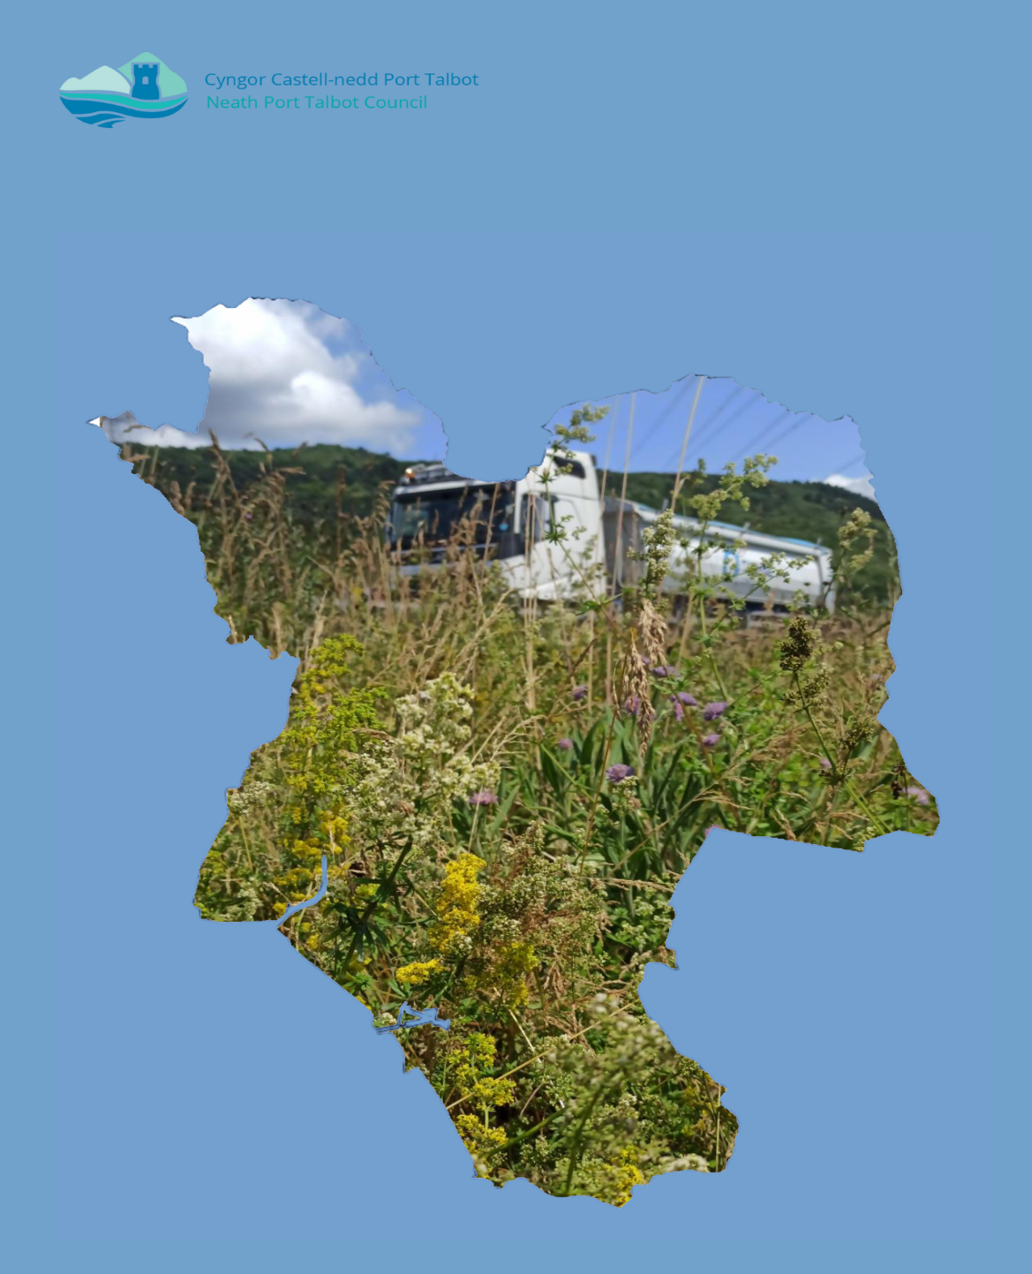
Contents
Abbreviations and Acronyms 1
1. Introduction 1
1.1. Legislative Requirements 1
1.2. Neath Port Talbot (NPT) Biodiversity Duty Plan 2020-2023 Implementation Report 2
1.3. Programme for Reporting 2
2. Background 3
2.1. Context – Neath Port Talbot Council 3
3. Highlights, Key Outcomes and Issues 4
3.1. Key Biodiversity Actions 4
3.2. Positive Outcomes for Health and Wellbeing 14
3.3. Key Enablers 14
3.4. Notable Barriers 15
4. Updates to legislation, policies and plans 17
5. Other Opportunities 20
6. Action Report 23
6.1. Nature Recovery Action Plan (NRAP) Objectives 23
6.2. NRAP Objective 1: Engage and support participation and understanding to embed biodiversity throughout decision making at all levels 24
6.3. NRAP Objective 2: Safeguard species and habitats of principal importance and improve their management 29
6.4. NRAP Objective 3: Increase the resilience of our natural environment by restoring degraded habitats and habitat creation 32
6.5. NRAP Objective 4: Tackle key pressures on species and habitats 34
6.6. NRAP Objective 5: Improve our evidence, understanding and monitoring 36
6.7. NRAP Objective 6: Put in place a framework of governance and support for delivery 38
7. Summary 42
7.1. Updated actions 42
7.2. Removal of actions 43
7.3. New actions 43
8. Conclusion 46
9. Appendices 47
9.1. Appendix 1; Service Assessments 47
9.2. Appendix 2; Potential actions relevant to NPTC, from NPT LNP Nature Recovery Action Plan 48

Abbreviations and Acronyms
BDP: Biodiversity Duty Plan
C&W Team: NPT Council Countryside and Wildlife Team
ENRaW: Enabling Natural Resources and Well-being Scheme
GI: Green Infrastructure
IIA: Integrated Impact Assessment
LDP: Local Development Plan
LNR: Local Nature Reserve
LNP: Local Nature Partnership
NLHF: National Lottery Heritage Fund
NPT: Neath Port Talbot
NPTC: Neath Port Talbot Council
NRAP: Nature Recovery Action Plan
NRW: Natural Resources Wales
PSB: Public Service Board
RLDP: Replacement Local Development Plan
S6: Section 6 Duty under the Environment (Wales) Act 2016
SINC: Sites of Importance for Nature Conservation
SPG: Supplementary Planning Guidance
SSSI: Special Site of Scientific Interest
SAB: SuDS Approving Body
SuDS: Sustainable Drainage System
WG: Welsh Government
WLGA: Welsh Local Government Association

Introduction

Legislative Requirements
    - The Environment (Wales) Act 2016 (the Act) introduced an enhanced Biodiversity and Resilience of Ecosystems Duty (the section 6 or S6 duty) for public authorities (including the Council), which must seek to maintain and enhance biodiversity in the exercise of their functions, so far as is consistent with the proper exercise of those functions, and in so doing promote the resilience of ecosystems.

    - To comply with the S6 duty the Council should embed the consideration of biodiversity and ecosystems into their early thinking and business planning, including any policies, plans, programmes and projects, as well as their day-to-day activities.

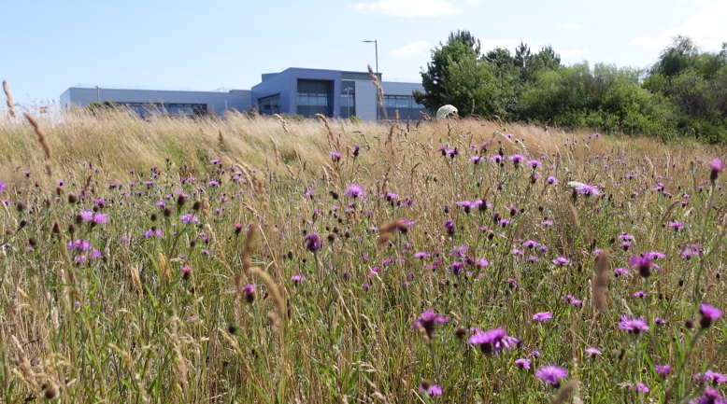
Figure 1. NPTC Offices at The Quays, with the neighbouring NPT Bee Friendly site

Neath Port Talbot (NPT) Biodiversity Duty Plan 2020-2023 Implementation Report
    - The second Biodiversity Duty Plan 2020-2023 was published in December 2021, following on from BDP 2017-2020, and adopting recommended changes as laid out in the BDP 2017-2020 Implementation Report.

    - BDP 2020-2023 outlines how NPTC intended to comply with the S6 duty, with targeted actions that would be undertaken by the Council to meet the requirements of the Act for the period of 2020-2023. It outlines what natural resources NPT has, why they are special and some of the activities already underway to protect them. It explains the legislative background; the mechanisms for delivery; detailed actions to be achieved and milestones for reporting.

    - This BDP 2020-2023 Implementation Report provides an overview of highlights, key outcomes and issues presented during delivery of the BDP 2020-2023. It reports on progress against actions and suggests recommendations for updates or new actions to be included in the next iteration of the BDP, BDP 2023-2026.

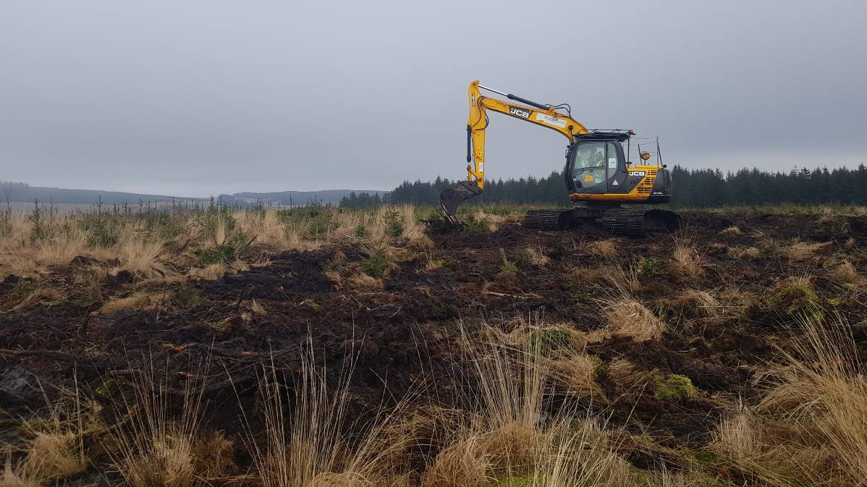
Figure 2. Peatland restoration taking place as part of the Lost Peatlands project. NPTC is lead partner on this project.

Programme for Reporting
    - Under section 6 (7) of the Act, the Council must, before the end of 2019 and before the end of every third year thereafter, publish a report on what they have done to comply with the S6 duty.

    - In order for the Council to monitor the actions within the BDP in line with grant funding streams and to allow for political reporting the monitoring timeline aligns with financial years.

    - This implementation report is dated November 2023 as this is the date at which it gained approval at full Council, however, the report monitors the actions from initial publication up to financial year end 2023– i.e. 1st April 2020 to 31st March 2023.

    - Accordingly, the Council will monitor the actions of the next BDP 2023-2026, from 1st April 2023 to 31st March 2026.

    - The Implementation Report will be submitted to WG and placed on the Council’s website.

    - The S6 duty guidance states that the Council can amend the BDP at any time. If such circumstances arise, this report will appear as an appendix to the new BDP and will identify the reasons for the changes. Any changes made during that time will be documented within the 3 year implementation report and submitted to WG.

Background

Context – Neath Port Talbot Council
    - The County Borough of Neath Port Talbot (NPT) is located on the coast between the counties of Swansea and Bridgend. NPT also shares boundaries with Carmarthenshire, Powys, Rhondda Cynon Taf (RCT) and the Brecon Beacons National Park. The population is over 140,000 and the administrative area covers 44,217 hectares.

    - NPT has a wide variety of habitats and species, from marshy grassland in the valleys supporting marsh fritillary butterfly to ancient woodlands providing home to the rare honey buzzard and blue ground beetle; and lowland wetlands and canals attracting fen raft spiders. Whilst the coastal dunes and saltmarsh border Swansea Bay, NPT’s upland peat bogs extend right across the plateau into Rhondda Cynon Taf. Brownfield land such as coal tips scattered throughout the county support rare plants and invertebrates.

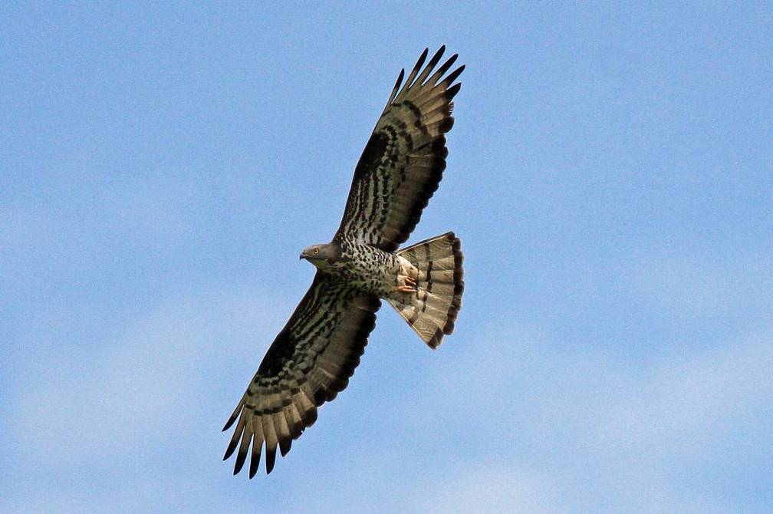
Figure 3. Honey Buzzard (c) Steve Roberts

    - As a Local Authority, Neath Port Talbot Council has the ability and opportunity to influence the amount and extent of biodiversity within the County Borough through management of its land / assets, strategies, policies and project delivery. The Authority implements and enforces national policy and legislation, works in partnership with a wide variety of stakeholders and engages with the public to achieve wider benefits.

    - Delivery of the S6 Duty and implementation of the BDP is the responsibility of the Council as a whole. As of 2017, the coordination and monitoring of the BDP has been embedded into a staff post. Following a restructure of the Countryside and Wildlife Team in 2021, the Ecologist (Plans and Projects) of the Countryside and Wildlife Team is now lead officer for the BDP.

Highlights, Key Outcomes and Issues
This section sets out the positive outcomes that have been achieved to-date from the progress made on the Actions set out within the Report (Section 6). It also highlights key enablers and barriers that have or are continuing to influence action.

Key Biodiversity Actions

Governance / Corporate Processes
      - The Countryside and Wildlife Team continue to provide an advisory service to enable the council to consider biodiversity in a wide range of functions. This includes through the development management process, as part of the SuDS (Sustainable Drainage Systems) Approving Body and for casual queries e.g. regarding land management.

      - Service assessments to determine their potential impact on biodiversity and opportunities for best practice have taken place for a number of council service areas. These have had the added benefit of establishing new contacts between the Countryside and Wildlife Team and other service areas, who are now aware of the advisory and consultancy services provided to enable them to achieve their biodiversity duty.

CASE STUDY: Service Assessments
Under Action 1.2. of BDP 2020-2023, all services were required to be risk assessed to determine their potential impact on biodiversity and opportunities for best practice. These service assessments were started in Year 5 (1st April 2022- 31st March 2023), beginning with the Environment and Regeneration Directorate. These service assessments have identified impact pathways of each service, any risks and opportunities for enhancement. They have also been valuable for raising awareness of the Biodiversity Duty amongst Accountable Managers. Some key opportunities for improvements to processes and achievable enhancements for service areas have been identified and are in progress as a result of these service assessments:
- Passenger Transport Unit are now helping to promote nature information and nature events and activities through video screens in transport hubs e.g. Neath Bus Station;
- Highways and Drainage now have in place a protocol for checking utility companies and others undertaking works on Local Authority land to ensure that the works do not negatively impact biodiversity;
- SAB and Highway Development Control are working with the Countryside and Wildlife Team to identify how SUDS can reach its full potential for biodiversity; and
- Officers from across the Environment directorate will be attending training on the BDP, how they recognise wildlife interest on site and when to involve the Countryside and Wildlife Team.

The service assessments are ongoing but expected to be completed in Year 6 (1st April 2023 – 31st March 2024) of BDP 2023-2026.
      - The Countryside and Wildlife Team have continued to provide a key service to other departments through consultancy. The Ecologists work closely with other departments from the start of project to completion, to ensure that works result in an enhancement for biodiversity.

CASE STUDY: Glynneath Flood Alleviation Scheme
The Highways and Drainage department were undertaking a Flood Alleviation Scheme in Glynneath in order to protect over two hundred properties from flooding. In order for works to take place, a number of trees were required to be felled and disturbance was caused to a Site of Importance for Nature Conservation (SINC).
The Highways and Drainage team secured the assistance of the Countryside and Wildlife Team early in the project to help minimise negative impact on biodiversity and design enhancements.
In order to mitigate and enhance for the works, a nature conservation management plan has been agreed for the SINC, which prior to these works, was not being routinely managed for nature and so was degrading. In addition, in order to replace the trees that were felled, the Woodland Officer in the Countryside and Wildlife Team will be strategically planting trees and hedgerows in locations that have a proven need for increased tree cover.
      - Elected Members and officers have undergone biodiversity training on a number of subjects including the Biodiversity Duty Plan, NPT Bee Friendly and Green Infrastructure. Regular training sessions are now programmed for officers, to increase understanding of the Biodiversity Duty, and to enable relevant staff members to recognise wildlife interest on site.

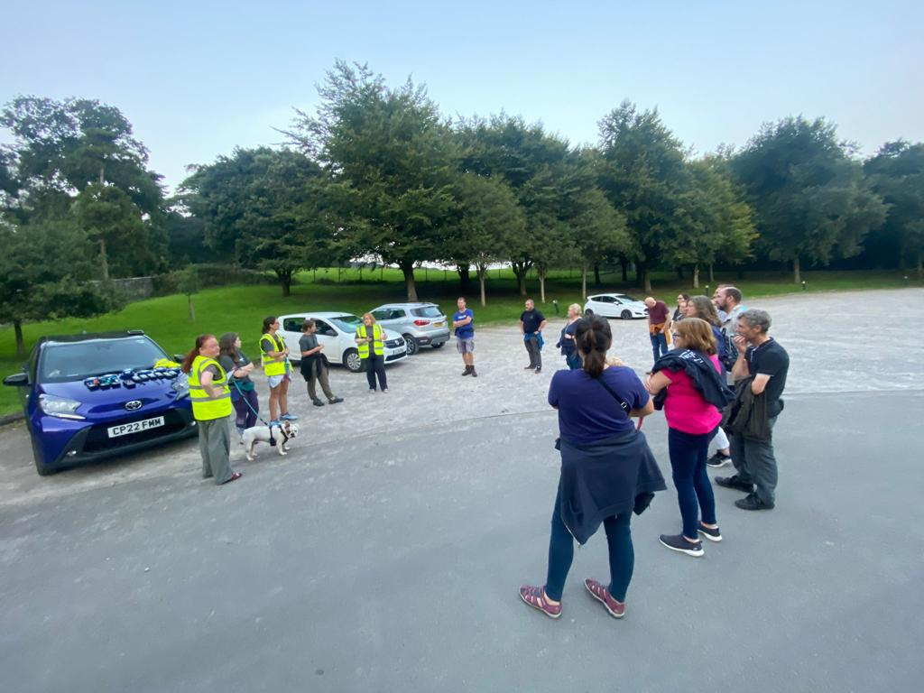
Figure 4. NPTC Staff Bat training walk at Margam Park

      - The Countryside and Wildlife Team have continued to collaborate, where appropriate, with other sections to aid in the development of strategies or plans that contribute towards biodiversity conservation or may impact on biodiversity.

CASE STUDY: NPT Bee Friendly
Action 6.5. of the BDP 2020-2023 placed a responsibility on NPTC to undertake a review of the Nature Conservation Sites scheme to include management of all verges and of key council owned sites.
In September 2020, a working group made up of members from the Countryside and Wildlife Team and Neighbourhood Services team was established. This group worked together to look specifically at management of grassland sites from the Nature Conservation Sites scheme.
In July 2021, the NPT Bee Friendly scheme was adopted, with the key aim to increase the extent of wildflower grassland across NPT.
Approximately 32 hectares are now under management as meadows through the NPT Bee Friendly scheme. A map of these sites is available online here.
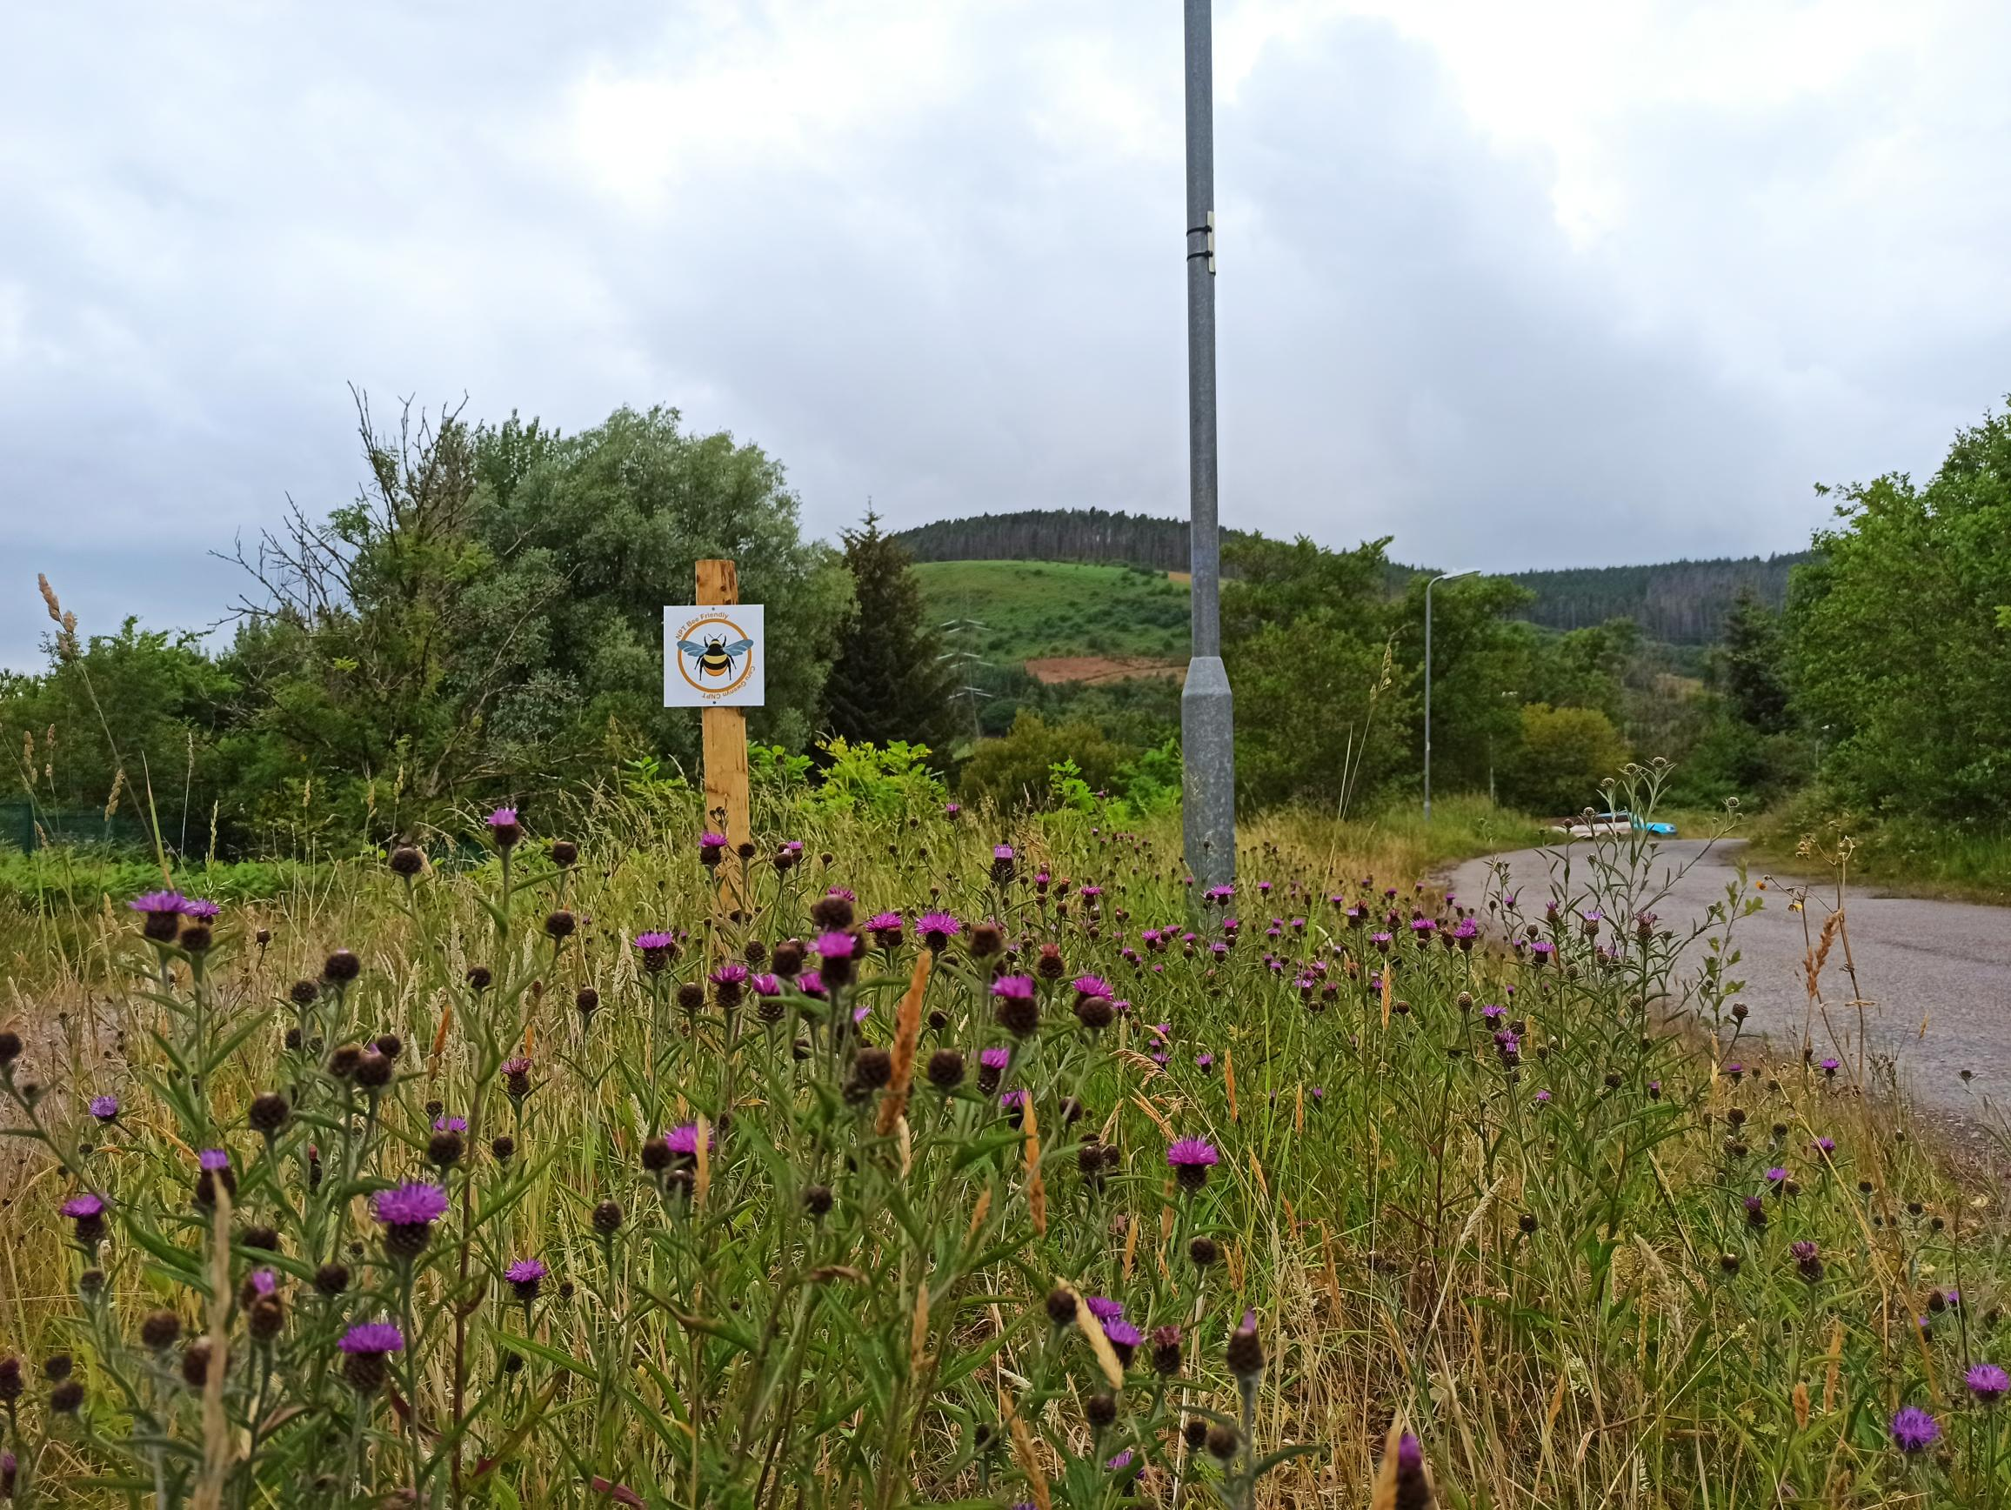
Figure 5. NPT Bee Friendly site in Tonmawr

      - The NPTC Corporate Plan 2022-2027 commits to delivering key actions against the objective ‘To ensure our local environment, culture and heritage can be enjoyed by future generations’; including to further develop the NPT Nature Partnership and implement the BDP. The Public Service Board’s Well-being Plan (2023-2028) has recognised the threat presented by the nature crisis and therefore has strengthened its ambitions for nature and the environment.

      - NPTC Countryside and Wildlife Team has continued to provide the Secretariat for the NPT Local Nature Partnership and has supported the development of a State of Nature of NPT, combined with a Nature Recovery Action Plan (NRAP). The Action Plan is a key mechanism for species and habitat conservation in the County. NPTC is supporting implementation of the NRAP on its own land and through support for other partners e.g. through securing funding for an LNP Grant Fund.

CASE STUDY: NPT for Nature
NPT for Nature is a sub-group for the NPT Local Nature Partnership, which is aimed at engaging with enthusiastic community groups and individuals that want to make a difference for nature in NPT, but perhaps need a hand to get going.
The group has met once every 3 months since January 2022 to discuss the important species and habitats in NPT, provide advice to anyone looking to start a project, and give ideas for activities and events that can be organised or participated in with local communities.
The group is facilitated by project staff funded by Welsh Government Local Places for Nature Fund and hosted by NPTC Countryside and Wildlife Team.
      - NPTC Countryside and Wildlife Team have continued to raise awareness of biodiversity through a variety of methods, including social media, interpretation panels on sites, leaflets and walks and talks.

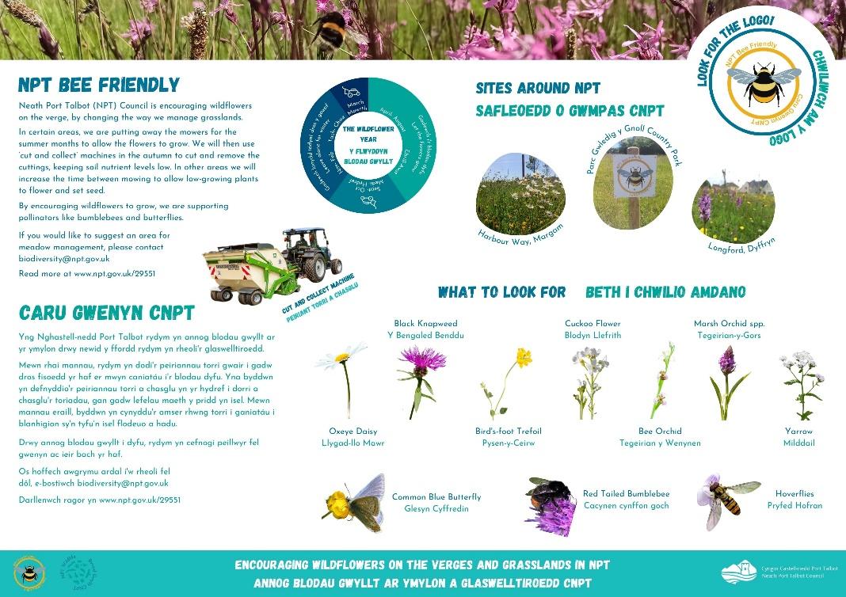
Figure 6. NPT Bee Friendly Interpretation Panel

CASE STUDY: Wales Nature Week 2020
Wales Nature Week 2020 was held from the 30th May to 7th June 2020. Due to the pandemic, the usual programme of events and activities was unable to take place. A programme of virtual events was planned instead, with a number of these being hosted by NPTC on the NPT Wildlife social media channels. These events included:
- Garden Bee Q&A – 622 views
- Moth Trap Live – 2800 views ‘Brilliant session from Barry- learnt so much, thank you NPT for arranging’
- Garden Dragons Q&A – 506 views
- Virtual Bat Walk – 1600 views ‘‘Thanks Richard it’s been really interesting and thank you NPT wildlife for organising!’
- Feathered Friends Q&A with Laura Palmer NPTC Countryside and Wildlife Team – 372 views

      - A biodiversity audit on land within our ownership and control is underway, to identify where we have protected habitats and species on our land. The potential for managing this land for the benefit of biodiversity is determined on a case-by-case basis. Key biodiversity information for NPTC land holdings is now available to our Estates department, informing any decisions for the future of those land holdings. The audit started with protected and priority sites for biodiversity.

      - The Countryside and Wildlife Team have a proven track record of success of applying for and securing funding to undertake vital nature conservation work in the county. Over the period we are reporting on in this report, the Countryside and Wildlife Team drew down over £2million in funding from external sources.

      - As a result of said funding and of new NPTC strategies (e.g. NPT Bee Friendly) an increased area of NPTC land is managed for biodiversity. This now stands at 287 hectares, an increase of 127 hectares since the Key Performance Indicators (KPI) within the Corporate Plan were agreed in May 2022.

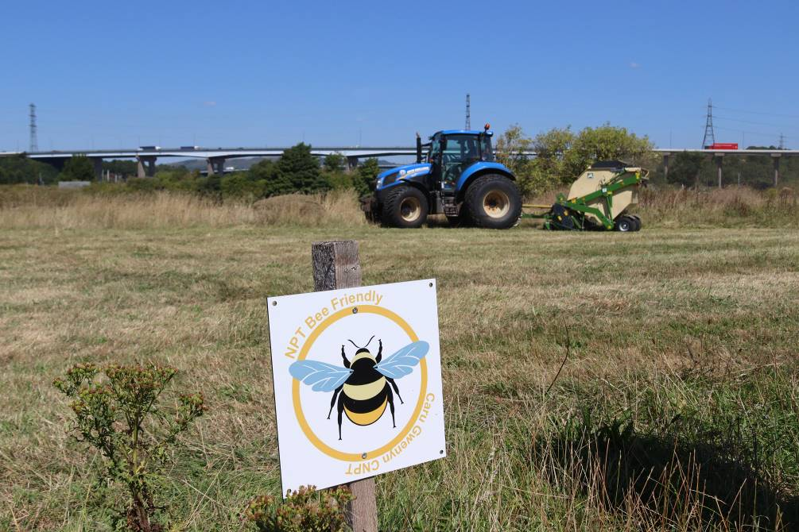
Figure 7. Cut and Collect management taking place under the NPT Bee Friendly scheme

      - NPTC considers biodiversity through the development management process, and through this process, habitat management plans are put in place increasing the resilience of our natural environment and improving the management of priority habitats.

CASE STUDY: Habitat Management through the Development Management Process
NPTC has continued to consider biodiversity (including species and habitats of principal importance, designated sites, Sites of Importance for Nature Conservation (SINC), habitats and species that meet the SINC criteria, and important natural features) through the development management process, in line with the Local Development Plan.
In October 2022, a planning application was approved for a new glass-processing factory on Baglan Way. The land in question is a SINC, designated for its post-industrial habitats and associated protected species. Post-industrial habitats such as these require management in order to retain the important features. Unfortunately, the site had been unmanaged for many years and as a result, the designating features were slowly being lost.
Although the proposed glass-processing factory would result in a loss of some of this SINC, a 50-year habitat management plan was agreed for the remainder of the site, safeguarding the important features of this site for 50 years into the future. As it is likely that without management these important features would have been lost in that time, this represents a net benefit for biodiversity. In addition, the factory will have a ‘green roof’ incorporating new habitat features such as bare ground, wildflowers and tussocky grassland of value to birds and invertebrates.

Surveying and Data

      - The Countryside and Wildlife Team continues to maintain and update species records for NPT through a MapMate database. The Countryside and Wildlife Team has also established a ‘Biodiversity Master Map’ to record any relevant information relating to biodiversity in the county. This is proving to be an invaluable tool for the Countryside and Wildlife Team for protecting and enhancing biodiversity.

      - In order to inform the State of Nature and Nature Recovery Action Plan for NPT, NPTC secured funding to commission a new Phase 1 habitat map for NPT, drawn to a high degree of accuracy and precision. The resulting Phase 1 habitat map has provided key evidence for the assessment of ecosystem resilience of each habitat group in NPT (based on an assessment of diversity, extent, condition and connectivity of each habitat).

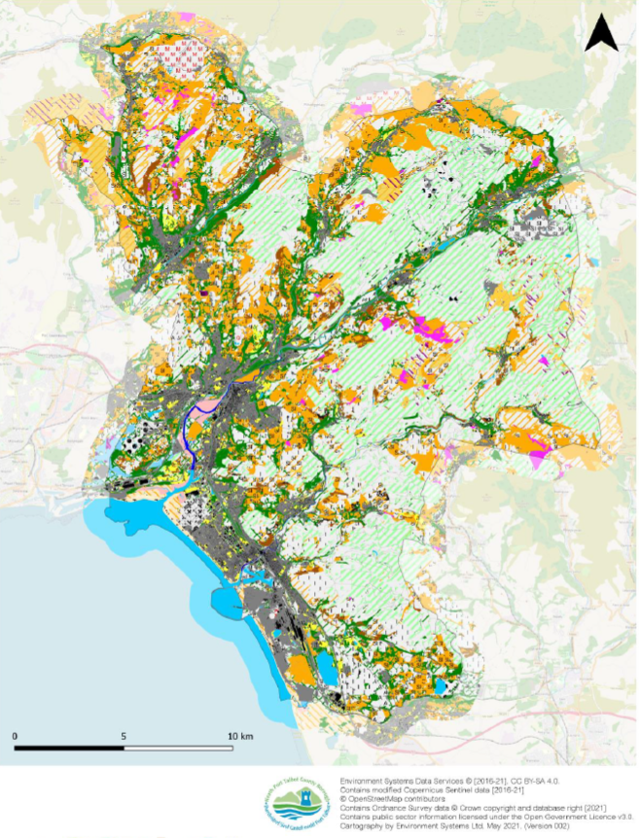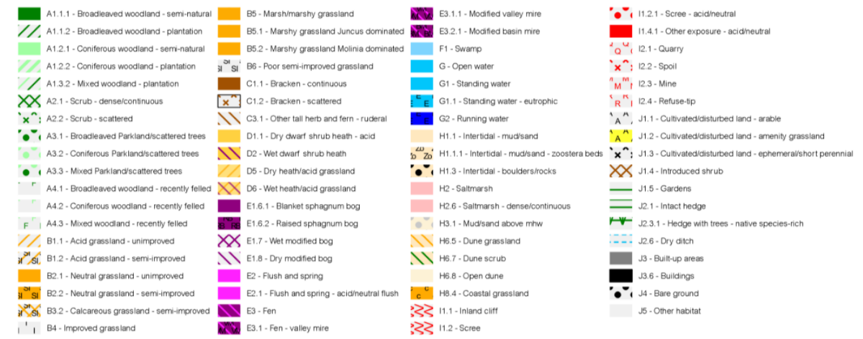
Figure 8. Phase 1 Habitat Map of NPT and legend

      - NPTC has undertaken regular species and habitat surveys, through core work or funded projects. For example, annual monitoring of NPT Bee Friendly sites and nest box monitoring across our land holdings. The resulting records have been recorded in MapMate and submitted to the Local Records Centre SEWBReC.

CASE STUDY: Wildblitz
Through the Lost Peatlands Project, regular Wildblitzes are held at Community Wild Spaces (local community greenspaces managed for nature). The aim of a Wildblitz is to collect as many species records as possible for the site. A programme of guided walks and surveys are also held on the day to help local people to explore nature.
Hundreds of new species records have been captured at the Wildblitzes so far, helping to inform the habitat management and nature conservation priorities for the sites going forward.
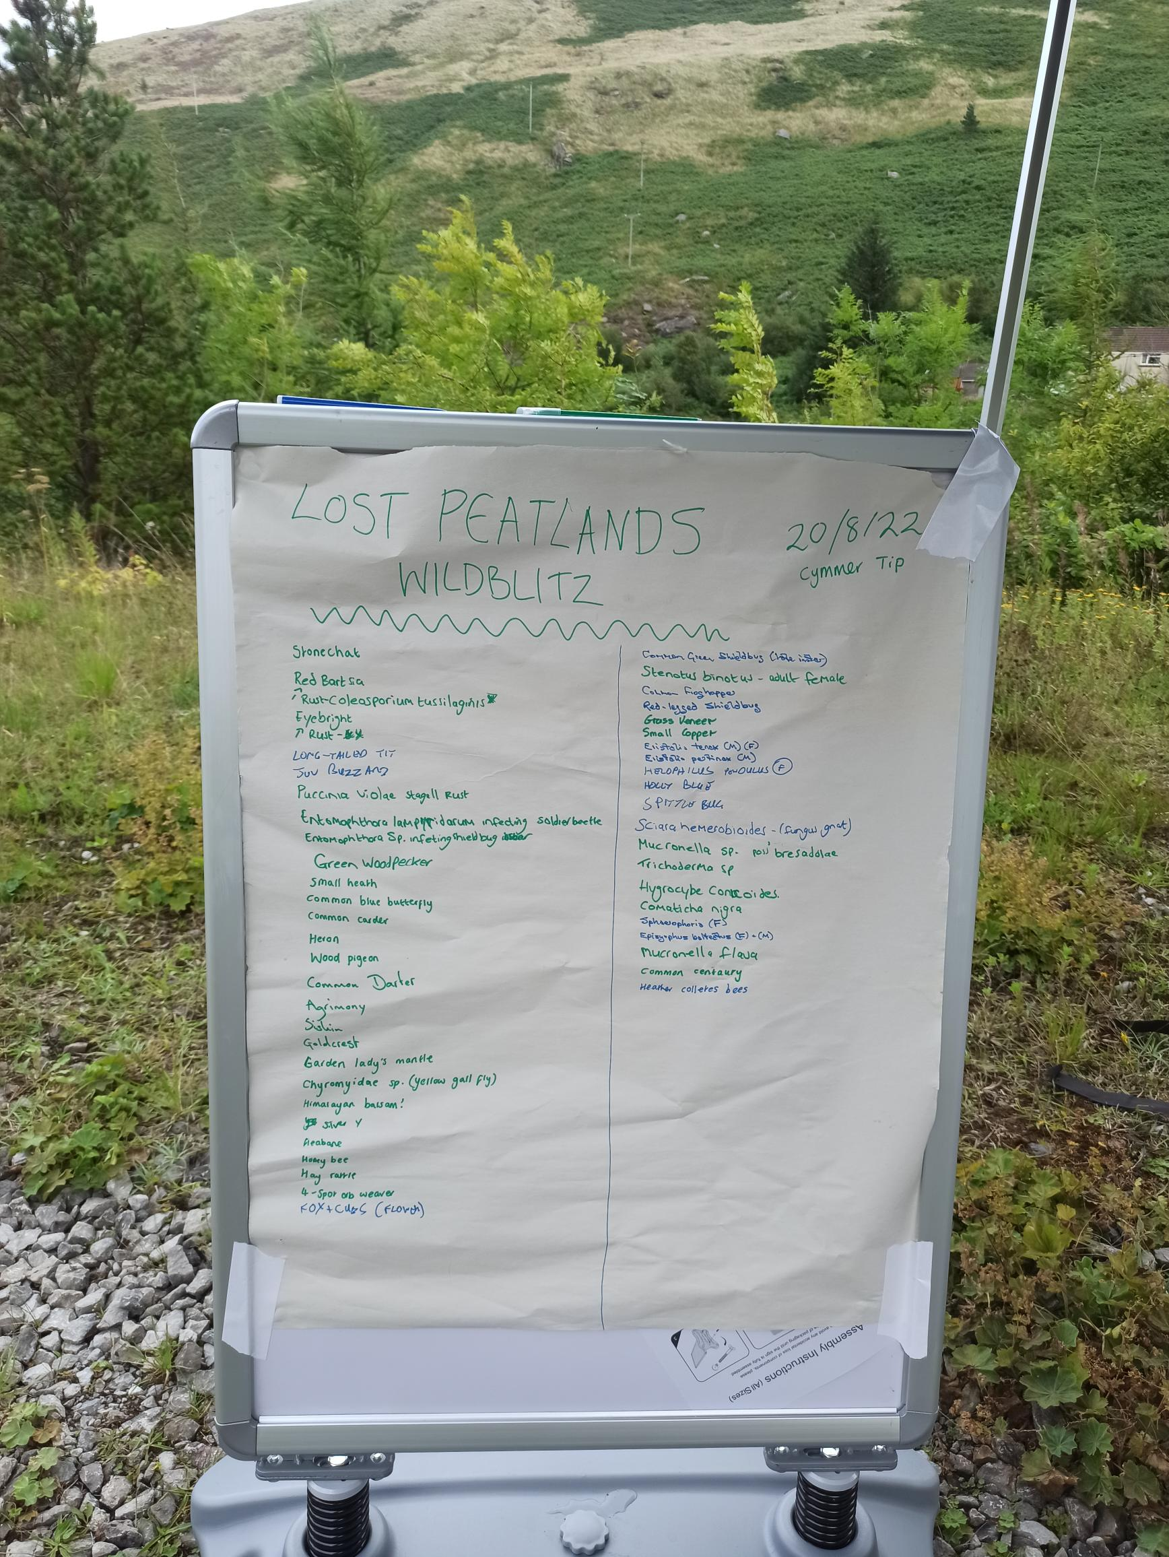
      - All relevant planning applications containing biodiversity information require a Local Environmental Records Centre search for biological data, undertaken by/on behalf of the applicant. This information is used to inform planning decisions and any proposed mitigation and enhancements.

Projects

      - As of 2020, Welsh Government have allocated annual funding to NPTC and NPT LNP to undertake projects that create or enhance local places for nature. Through this funding, we have purchased machinery to allow us to appropriately manage our NPT Bee Friendly sites and transformed five defunct playground sites from grey to green through our Stepping Stones Nature Reserve Projects.

CASE STUDY: Stepping Stones Nature Reserves
Using funding from Welsh Government Local Places for Nature fund, NPTC has created 'Stepping Stones Nature Reserves' around the county. These sites were abandoned playgrounds, with bare patches of tarmac providing little benefit to people or nature. As part of this project, we have ripped out the grey to make way for some green.
Three pioneer sites at Vivian Park, off the cycle track between Velindre and Cwmafan and between Wood Street and Alba Avenue in Port Talbot were chosen due to their potential and accessibility. The tarmac has been lifted and piled up to create hibernation sites for reptiles, making way for publicly accessible native wildflower meadows. These patches will only get more diverse each year, encouraging more invertebrates and helping our pollinators as time goes on. Bat and bird boxes have also been installed.
Following this, four more sites have been improved for nature through this project, including Talbot Memorial Park and a defunct tarmac area in Goytre.
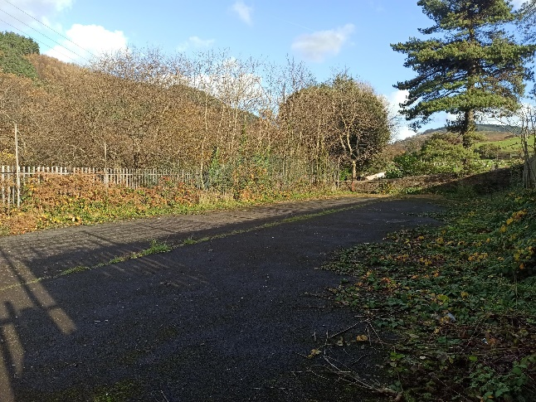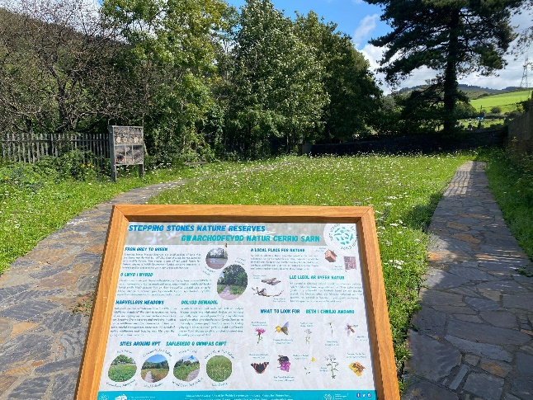
Figure 9. Goytre Stepping Stones Site before (Left) and after (Right)

      - In July 2021, the Lost Peatlands Project secured £2.8m of funding from National Lottery Heritage Fund, Pen y Cymoedd Wind Farm and other partners for a partnership project comprising Neath Port Talbot Council (Lead), Rhondda Cynon Taf Council, Natural Resources Wales, Swansea University and Coed Lleol (Small Woods). Between 2021 and 2025, the project will restore and manage more than 490 hectares of this historic landscape and habitats, including heathland, grassland and native woodland. Of particular focus is the direct restoration of 256 hectares of previously afforested peat bogs and pools. As part of the project, an extensive series of volunteer sessions and events are taking place to help local people discover and enjoy the Lost Peatlands of South Wales.

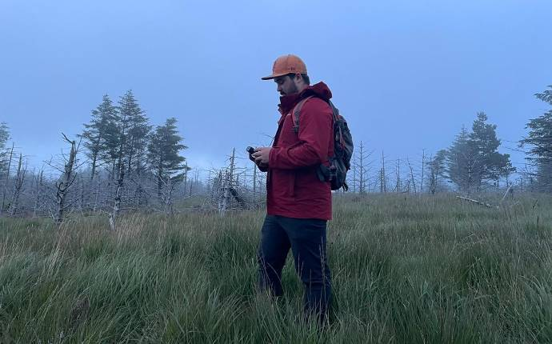
Figure 10. Surveys taking place as part of the Lost Peatlands project

      - In 2021, the Countryside and Wildlife Team secured funding from Welsh Government through the Enabling Natural Resources and Well-being (ENRaW) Grant to deliver the South West Wales Green Infrastructure Project, a partnership project with Swansea Council, Carmarthenshire County Council, Coed Lleol and Cwmaman Town Council. This is a multi-disciplinary project, taking a strategic approach to the maintenance, enhancement and creation of green infrastructure and biodiversity resource, for the benefit of people, the economy and wildlife. The project has achieved many positive outcomes, including workshops for key officers to define ‘Green Infrastructure’ (GI), determine why GI is important and to discuss what potential barriers we face as a local authority or public service board to deliver and maintain sustainable GI. The project has also resulted in installation of best practice examples of GI in the county, including a green roof bin store at the Gnoll Estate Country Park and a green roof bus stop in Aberavon.

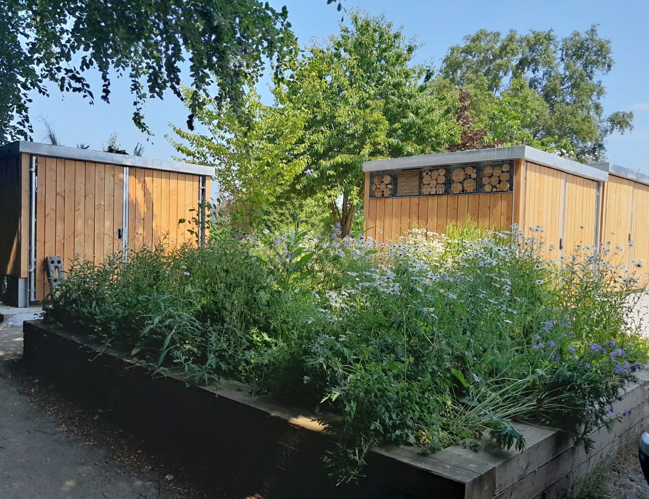
Figure 11. Green Roof Bin Shelters at Gnoll Country Park
      - The Countryside and Wildlife Team has secured further grant funding from National Lottery Heritage Fund, Swansea University and Welsh Government to continue to maintain Craig Gwladus Country Park for wildlife and people, with key activities including nature conservation volunteering, establishment of nature and heritage trails and training.

      - The Countryside and Wildlife Team has secured grant funding for a variety of other small projects from a wide variety of funding streams. Some projects delivered directly and some in partnership with other organisations. Some of the projects have included: Greenspace Mapping, Biodiversity in the Welsh Government Woodland Estate and Developing our Coast and Marine Environment 4 Nature and Climate.

Positive Outcomes for Health and Wellbeing
    - The Lost Peatland Project’s community outreach programme is a great example of how nature is intrinsically linked to our own health and mental wellbeing. Through a variety of events that offer outdoor activities such as bush craft and nature bathing, around two hundred community members over a two year period benefitted from this council led initiative, in partnership with Coed Lleol/Small Woods. 100% of participants in these sessions agreed or strongly agreed that the sessions made them feel happy (and contributed to their overall wellbeing) and 62% evidenced increased wellbeing using the Warwick Edinburgh Mental Wellbeing Scale (WEMWBS) as a measure of change.

‘These sessions have resulted in me feeling more relaxed when outdoors, feeling more optimistic when it comes to outdoor activities / group events and tackling my social anxiety’
Participant, Glyncorrwg Adults Group

Key Enablers

Good Internal Working Relationships
There are numerous examples of how good internal working relationships have led to achievements against the Biodiversity Duty. Some examples of these are:
      - Neighbourhood Services and the Countryside and Wildlife Team working together to increase the area and extent of wildflower grassland (i.e. roadside verges and larger meadow areas which are managed to encourage wildflowers and pollinating insects) through the NPT Bee Friendly Scheme.

      - Development Management Team and the Countryside and Wildlife Team working together to secure strong mitigation and enhancement for biodiversity through development.

      - Countryside and Wildlife Team supporting Engineering Team Projects to minimise negative impacts on biodiversity and maximise opportunities for enhancement through these projects.

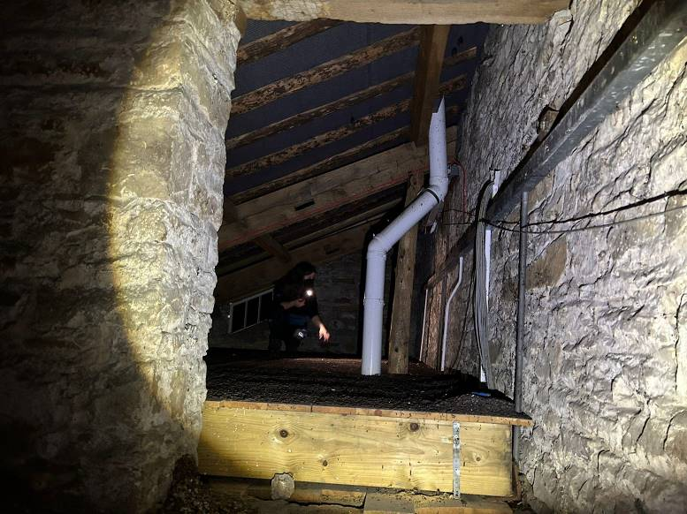
Figure 12. Countryside and Wildlife Team Ecologist undertaking a bat survey to inform engineering works

      - The Countryside and Wildlife Team have helped to shape the objectives in the NPT Council Corporate Plan and contributed to the evidence base of the Replacement Local Development Plan, along with other strategies and policies.

External Funding
      - A key enabler of the work of the Wildlife Team has been external funding. The Wildlife Team (not including staff undertaking a Countryside function) only has 3.5 core full-time equivalent members of staff but supports an additional 10.6 full-time equivalent members of staff through project funding. As a result of the Biodiversity Deep Dive recently completed by WG, for the first time since the S6 Duty was introduced, WG are now providing temporary funding to public bodies to support action which promotes and disseminates best practice for the undertaking of S6.

      - External funding greatly increases the capacity of the Countryside and Wildlife Team to support action against the BDP.

Notable Barriers

Capacity of the Countryside and Wildlife Team
      - Although the team has increased in size through externally-funded project staff, there has been increased pressure on core staff undertaking core functions e.g. from the development management process. The need to apply for project funding adding continual increased pressure on these staff. This presents a capacity issue for the Countryside and Wildlife Team and is reflected in the Service Recovery Plan for the section.

Longevity of funding
      - As demonstrated above, external funding is a key enabler of action against the BDP. However, this funding is temporary, with the large majority of projects covering periods of a year or less. This represents a lack of security for the Countryside and Wildlife Team and a risk of further loss of capacity if further external funding is not secured at the end of projects. This also has impacts upon the sustainability of project outcomes. A particular concern is the ability to provide consistency in Local Nature Reserve/green space management and support for volunteer groups and schools.

Figure 13. Cwm Du Glen Local Nature Reserve

Countryside and Wildlife Team Early Engagement
      - Although a number of service areas work closely with the Countryside and Wildlife Team, there is still a lack of awareness within some service areas of the Countryside and Wildlife Team and the BDP. This is evident in reviewing some of the past Integrated Impact Assessments (IIA) in Cabinet and Council Reports, which fail to show engagement with the Countryside and Wildlife Team in order to evidence the biodiversity section of the IIA. Another barrier to the Council meeting its biodiversity duty is a failure to involve the Countryside and Wildlife Team from the start of projects. This can lead to project delays if surveys are required or problems if biodiversity impacts are identified too far down the line. This has highlighted the need for further training that will be overseen by the Corporate Governance Group.

Lack of suitable sites
      - Availability of sites for biodiversity conservation and compensation purposes is limited due to other land uses, including economic development, taking priority. This has been limiting for implementing the biodiversity compensation scheme as set out in the Biodiversity Supplementary Planning Guidance (SPG). The SPG aims for ‘Habitat Banking’; ‘To enable development and reduce delays, the process aims to bank ('habitat banking') a number of sites in readiness to deliver necessary compensation works. This will reduce significant delays currently experienced whilst a compensation site is being identified / located e.g. biodiversity compensation scheme is limited by lack of sites.’ Habitat Banking has not been possible due to a lack of available sites and lack of support to invest in the purchase of sites.

Updates to legislation, policies and plans
Since the last BDP 2020-2023 was published, there have been a number of updates and changes to legislation, policies and plans, which we have considered when reviewing the actions throughout this Implementation Report. Some of these are summarised below. Other national policies and plans such as Future Wales and the Placemaking Charter have also strengthened the environmental and biodiversity requirements and expectations. We have recommended that additional actions are included in BDP 2023-2026, to achieve against these updated or new legislation, policies and plans. These new actions are listed in Section 7.3.

State of Nature and Nature Recovery Action Plan for NPT
    - We are entering the planet’s sixth mass extinction event, the first linked to human activity. Research suggests the average rate of vertebrate species loss over the last century is up to 100 times higher than pre-human extinction rates. Since biodiversity provides ‘ecosystem services’, such as pollination and flood prevention, its loss causes risks to human safety and well-being.

    - On June 30th 2021, the Welsh Government declared a nature emergency, in recognition of the dramatic human-induced declines in biodiversity. The motion also recognised that there should be parity between actions taken to tackle climate change and those taken to tackle biodiversity loss.

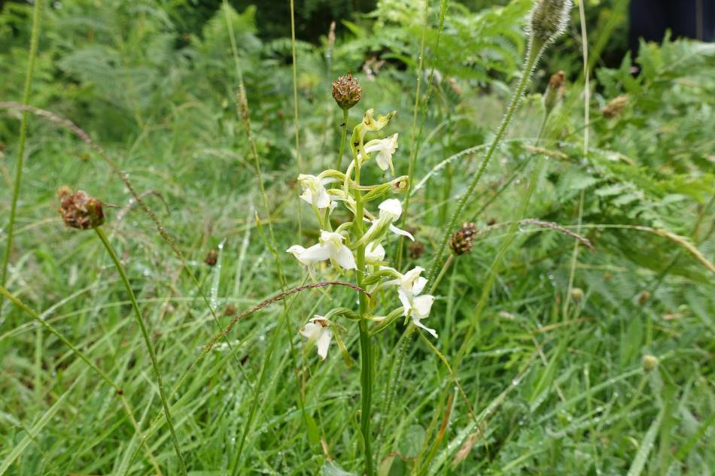
Figure 14. Greater Butterfly Orchid at Hafod Wennol SSSI, currently only found in two locations in Neath Port Talbot and threatened with extinction if management on these sites were to change

    - On a local level, this decline has also been noted. Since the adoption of the BDP 2020-2023, NPT Local Nature Partnership has produced a local ‘State of Nature and Nature Recovery Action Plan for NPT 2023’ (SON/ NRAP 2023), which provides an evidence-based assessment of the ecosystem resilience of each broad habitat type in NPT, linked with a plan to help nature recover in the county.

    - The habitats of NPT were grouped into 11 broad categories (e.g. woodland, coastal etc.), and sadly, of these 11 habitat categories, only two were assessed to be achieving ‘good’ ecosystem resilience. This means that habitats across NPT are not resilient enough to deal with pressures and demands such as climate change. Action needs to be taken now to improve the ecosystem resilience of our habitats across NPT.
Ecosystem resilience is the capacity of an ecosystem to deal with pressures and demands, either by resisting, recovering or adapting to them whilst retaining their ability to deliver ecosystem services and benefits now and into the future.
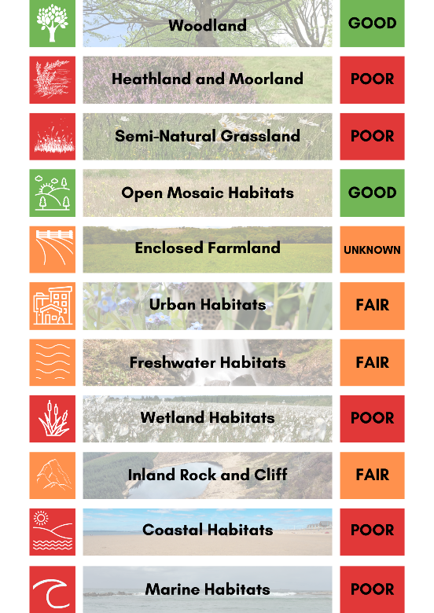
Figure 15. The assessment of ecosystem resilience for each broad habitat type in NPT (c) NPT LNP
    - When adopting the BDP 2020-2023, NPTC signed up to the Edinburgh Declaration on post-2020 global biodiversity framework, recognising the key role that subnational governments have in achieving global biodiversity goals and targets.

    - There are key actions within the SON/ NRAP 2023 which NPTC, as the Local Authority, has the ability to achieve. These include actions such as tackling Invasive Non-Native Species, installing green infrastructure solutions and increasing wildflower grassland. The Council will support the NPT Nature Partnership in implementing the NPT Nature Recovery Action Plan and an action is included in this BDP 2023-2026 to deliver against NRAP actions, where possible when relevant to NPTC (Actions 2.2 and 6.4) .

Neath Port Talbot Public Service Board (PSB) Local Well-being Plan (2023-2028)
    - The Well-being Plan sets out the Public Service Board’s (PSB) long term vision for NPT, as required by the WBFG Act. This updated Well-being Plan (2023-2028) prioritises four well-being objectives. The BDP achieves against all four of these objectives but particularly the following:
To ensure our local environment, culture and heritage can be enjoyed by future generations
    - Action 1.7. commits NPTC to deliver and support others to deliver the Public Service Board’s Well-being Plan ‘Well-being Objective 3; To ensure our local environment, culture and heritage can be enjoyed by future generations’, as well as relevant actions under the other three Well-being Objectives.

Neath Port Talbot Corporate Plan 2022-2027
    - The updated NPTC Corporate Plan covers the period 2022 to 2027 and sets out how the council will approach recovery from the Covid-19 pandemic in the short, medium and longer term. The council’s strategic change programme have been set in line with the WBFG Act and the PSB Well-being Plan.

    - Both the Well-being Plan and Corporate Plan have a strong focus on improving well-being, alongside valuing and protecting our local environment. Delivery of actions outlined within the BDP 2023-2026 will be an integral element of meeting the Council’s, and PSB’s, well-being priorities and goals. Furthermore, whilst this plan contributes to all of the goals set out in the legislation, in particular it can be used to demonstrate our contribution to the A Resilient Wales goal.

    - Action 1.7. commits NPTC to deliver and support others to deliver against ‘Recover, Reset, Renew’, the Council Corporate Plan’s ‘Well-being Objective 3; To ensure our local environment, culture and heritage can be enjoyed by future generations’, as well as relevant actions under the other three Well-being Objectives.

30 by 30
    - At COP15, the UN Biodiversity Summit, held in Montreal, Canada, from 7 to 19 December 2022, a new global framework was agreed with a suite of measures which aim to address the global loss of biodiversity and restore natural ecosystems. A key target of this framework is the ‘30x30’ target, which looks to protect 30% of terrestrial, inland water and coastal and marine areas by 2030:
Ensure that at least 30 per cent globally of land areas and of sea areas, especially areas of particular importance for biodiversity and its contributions to people, are conserved through effectively and equitably managed, ecologically representative and well-connected systems of protected areas and other effective area-based conservation measures (OECMs), and integrated into the wider landscapes and seascapes [by 2030]
Convention on Biological Diversity 2021
    - The Welsh Government, along with 100 other countries, has committed to support the 30x30 target and has completed a Biodiversity Deep Dive to identify recommendations in order to achieve this.

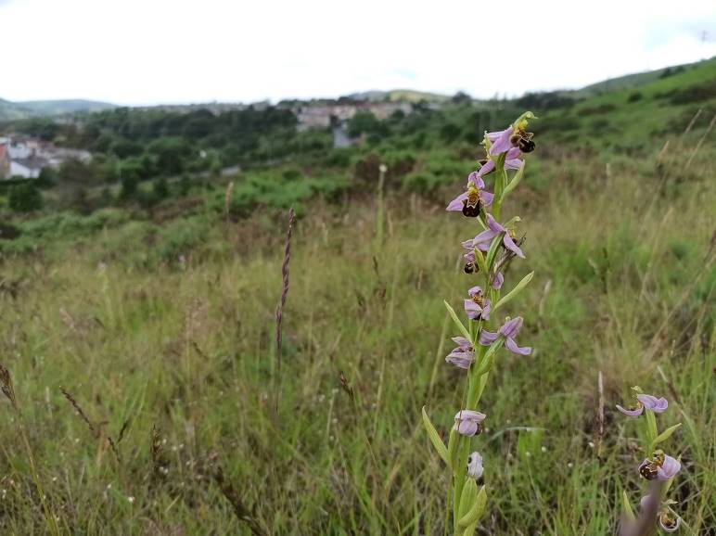
Figure 16. Bee Orchid at Bryn Tip Local Nature Reserve

    - NPTC currently protects and manages 11% of its landholdings for biodiversity. It is not clear if it is possible to increase the amount of land protected and managed for biodiversity to 30%, due to conflicting factors such as demand for housing. It should be noted that sites can have dual purpose e.g. a factory with biodiverse landscaping, nest boxes and a green roof/ walls could be considered as being managed for biodiversity, even though this is not the key purpose of the site. Sites such as these are defined as “other effective area based conservation measures” (OECM). Devised under the U.N. Convention on Biological Diversity, OECM’s are an alternative to traditional protected areas, in that they can include any geographically defined area that has a management structure and can show a long-term positive impact on biodiversity.

    - It is proposed that an action is included in the BDP 2023-2026 to examine the potential to increase the amount of land protected for biodiversity or classified as OECM, for both NPTC and the county as a whole, in line with the 30x30 target and the Biodiversity Deep Dive recommendations (Section 7.3).

Planning Policy Wales 11
    - In February 2021, Planning Policy Wales 11 came into force. PPW 11 sets out that “planning authorities must seek to maintain and enhance biodiversity in the exercise of their functions. This means that development should not cause any significant loss of habitats or populations of species, locally or nationally and must provide a net benefit for biodiversity”.

    - A letter from Welsh Government dated 23/10/2019 makes it clear that where biodiversity enhancement is not proposed as part of an application, significant weight will be given to its absence, and unless other significant material considerations indicate otherwise, it will be necessary to refuse permission.

    - Action 2.1. has been amended to reflect the changes within Planning Policy Wales 11 (as well as Future Wales: The National Plan 2040).

Other Opportunities

Integrated Impact Assessment (IIA)
    - The IIA that accompanies all committee reports includes an assessment of the impact on biodiversity in line with the Environment (Wales) Act 2016. The Countryside and Wildlife Team are available to help officers to assess the impact of their projects on biodiversity, but very few utilise this service. As a result, some IIAs submitted with committee reports have demonstrated a lack of understanding of the impact of their project on biodiversity. An update to Action 1.4 is recommended for BDP 2023-2026 in order to help address this.

SuDS Approval Body (SAB)
    - As a result of the Service Assessment undertaken to meet Action 1.2 in BDP 2020-2023, a number of opportunities for biodiversity enhancement have been identified, as well as potential risks. A key area for improvement was identified around the SuDS Approval Body.

    - Schedule 3 of the Flood and Water Management Act 2010 (FWMA) requires surface water drainage for new developments to comply with mandatory National Standards for Sustainable Drainage. The SuDS Approval Body (SAB) is a service delivered by the Local Authority to ensure that drainage proposals for all new developments of at least 2 properties OR over 100m² of construction area are fit for purpose, designed and built in accordance with the National Standards for Sustainable Drainage published by Welsh Ministers. The duty to provide a SAB falls upon the local authority as a whole. The SAB must aim to maximise the multiple benefits which SuDS can provide and directors and officers should be aligned and integrated as far as possible to support and deliver the SAB service.

    - The SAB has identified that so far, although complying with the legislation, SuDS in NPT are not reaching their full potential for biodiversity. This is due to a lack of knowledge within the SAB on SuDS design for biodiversity. The SAB requires increased support from the Countryside and Wildlife Team or more in-house knowledge on how to achieve biodiverse SuDS.

    - It is suggested that an action is included in the BDP 2023-2026 to determine how to maximise the biodiversity potential of SuDS in NPT (Section 7.3.).

Procurement
    - Through the service assessment undertaken to meet Action 1.2 in BDP 2020-2023, it was determined that some service areas place higher weighting on sustainability/ environmental impact through the procurement process than others, whilst some others do not consider sustainability at all. Procurement are currently reviewing their Tender Strategy document to include an environmental / sustainability objective(s), in line with Welsh Government guidance.

    - It is proposed that biodiversity impacts should be included as a consideration in the procurement process, with appropriate weighting in tender evaluation. This is addressed in a new action, detailed in Section 7.3.

Habitat creation on buildings
    - Through the BDP 2020-2023 service assessment and biodiversity audit of NPTC land and buildings, it has become clear that NPTC owned and managed buildings could be enhanced for nature e.g. through nest boxes and green infrastructure.

    - It is proposed that a review of buildings is undertaken to determine where there are opportunities for increasing habitat on the buildings, as appropriate for the use of the building (new action detail in Section 7.3.). Maintenance requirements will be appropriately considered.

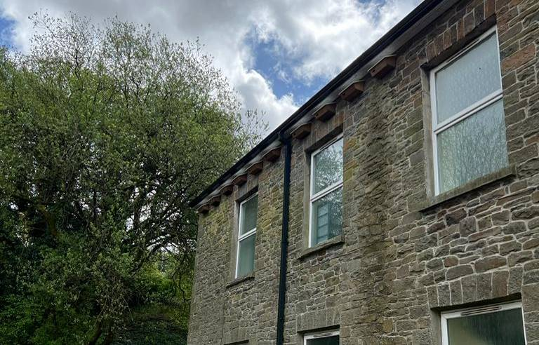
Figure 17. Swift boxes installed on NPTC-owned building in Resolven

Biodiversity Contact
    - Through the service assessment undertaken to meet Action 1.2 in BDP 2020-2023, key contacts have been made between each service area and the Countryside and Wildlife Team. However, when biodiversity issues or opportunities arise, it is still not always clear who is the appropriate person to contact for the service. A point of contact for each service area who can then direct the enquiry to the appropriate person would make lines of communication clearer and improve efficiency.

    - An action to establish Biodiversity Contacts in each service area is recommended for inclusion in BDP 2023-2026 (Section 7.3.).

Motion for the Ocean
    - The health of our ocean is inextricably linked with our climate and with human health, wellbeing and prosperity. A healthy ocean is fundamental in regulating the global climate system and is an essential ally in our fight against climate change. The ocean absorbs more than 90% of the excess heat in the climate system as well as absorbing around 20% of annual carbon dioxide (CO2) emissions generated by human activity.

    - However, decades of irresponsible marine exploitation and pollution have led to significant levels of degradation, and this together with the detrimental impacts of our changing climate on marine ecosystems has led to national and global recognition that the world ocean is in crisis. An unhealthy ocean does not absorb or store carbon as effectively as a healthy one, further worsening the impacts of the climate crisis.

    - To help start the process of ocean recovery, the Local Government Association Coastal Special Interest Group is promoting a ‘Motion for the Ocean’ to help local authorities play their part in realising a clean, healthy and productive ocean and all of the direct economic, health and wellbeing benefits it will bring.

    - It is proposed that an action to investigate the Motion for the Ocean and potential deliverables for NPT is incorporated into the BDP 2023-2026 (Section7.3.).

Artificial grass
    - Artificial grass has become increasingly popular in recent years, due to the perceived notion that it is easier to maintain. Artificial grass is made of plastic and although it doesn’t require mowing, it does require regular cleaning and only has a life span of 8 to 15 years, after which it is not currently possible to dispose of it sustainably. Research has also shown that artificial grass has negative impacts on biodiversity, as well as leaching micro-plastics into the environment. Artificial grass also reaches significantly greater temperatures than those reached by natural grass under the same weather conditions, contributing to the urban heat island effect.

    - In recognition of this, Swansea Council has committed to discontinue the use of artificial turf in the public realm, even on a temporary basis.

    - In line with neighbouring councils, it is proposed that NPTC adopts a policy to prevent the use of artificial grass on its public estate (with the exception of sports fields). A new action for BDP 2023-2025, to respond to current issues such as this, is detailed in Section 7.3.

Honeybees
    - Whilst honeybees are wonderful for food production or wellbeing, unfortunately, under some circumstances, managed hives can have a harmful effect on local biodiversity. The honeybee is not an endangered species and in NPT we have small populations of endangered wild pollinators, such as the Shrill Carder Bee (Bombus sylvarum) and Brown-banded Carder Bee (Bombus humilis). There is increasing concern that declines in wild pollinators may be exacerbated by unnaturally high densities of honeybees, associated with some forms of beekeeping.

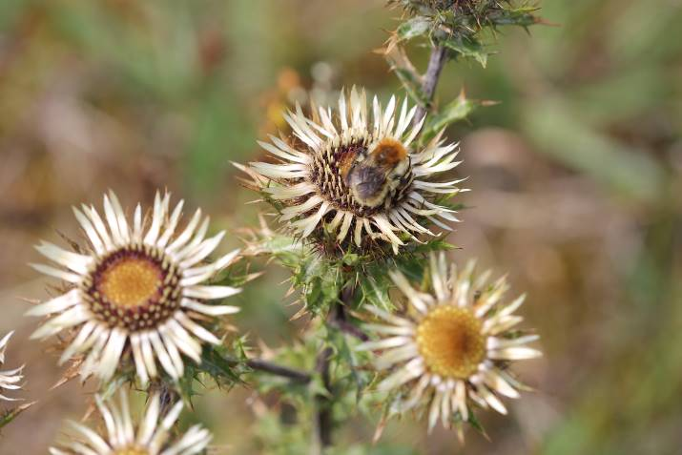
Figure 18. Brown-banded Carder Bee

    - Managed honeybees are known to affect wild pollinators in two main ways: competition for floral resources, and the spread of diseases. Each hive introduces an extra 35-40,000 honeybees to the area, and therefore beekeepers should create significant floral resources for each hive in order to reduce the pressure on wild bees already present in the locality of the hive.

    - It is proposed that, going forward, NPTC will no longer grant permission for hives through leases, except perhaps for sites with historic or heritage history of bee keeping or if wanted for food production (with the caveat that they need to provide suitable habitat to support the hive). A new action for BDP 2023-2025, to respond to current issues such as this, is detailed in Section 7.3.

Opportunities for nature in public spaces/public realm
    - To ensure we make the most of public spaces and realms to deliver benefits for nature. Small changes over the whole county will provide additional connections and habitats for nature, where they did not exist previously, improving the county’s nature network. These small changes could be as simple as changing planting regimes to include pollinator friendly perennials or native species in flowerbeds, native woodland bulbs added to green spaces, rain gardens instead of standard planters. An example of a change of approach to flower beds has already been successful at the Gnoll Country Park and the flowerbed next to the underpass near Port Talbot Civic Centre, where native perennials produce dramatic flower displays as well providing important habitat for wildlife. With the urban heat island effect being a concern, particularly for Port Talbot, additional greenery would also help provide shade and reduce temperatures. A change in approach towards more nature-based planting and features in the public realm also provides opportunities to engage and educate local people. Use of signage and educational PR, building on the existing NPT bee-friendly scheme, would enhance our ability to encourage local people to make changes in their garden for example.

    - An action for inclusion in BDP 2023-2026 (set out in section 7.3) is recommended for a review and assessment to be undertaken by the Countryside and Wildlife Team, in collaboration with other depts. (Streetcare, Regeneration, Estates), to identify opportunities for change/ additional features and to incorporate these into ‘business as usual’ as well as project planning and funding bids. It is also noted that the proposed new procurement action will also support a change in approach.

Action Report

Nature Recovery Action Plan (NRAP) Objectives
    - This section reports on actions in the Biodiversity Duty Plan 2020-2023, which were based on the objectives in the Nature Recovery Action Plan (NRAP) for Wales. The NRAP outlines how Wales will meet the commitments of the Convention on Biological Diversity, which is the key international agreement on biodiversity to which the UK Government is the signatory.

    - Progress against the milestones in the BDP 2020-2023 are given, with recommendations on future action to be included in BDP 2023-2026. Amendments are explained and proposed new actions are suggested in Section 7.3.

    - Identification of new milestones for years 6 to 8 will be undertaken for the new BDP 2023-2026. Where relevant in relation to amended actions, some of these milestones are included within this implementation report.

    - Actions are categorised by Nature Recovery Action Plan for Wales objectives (shown below). Some actions deliver against a range of objectives, however to avoid duplication, the actions are organised into the most appropriate NRAP objective with any additional relevant objectives (that they contribute to) listed in the final row of the table.
 | NRAP Objectives
1 | Engage and support participation and understanding to embed biodiversity throughout decision making at all levels
2 | Safeguard species and habitats of principal importance and improve their management
3 | Increase the resilience of our natural environment by restoring degraded habitats and habitat creation
4 | Tackle key pressures on species and habitats
5 | Improve our evidence, understanding and monitoring
6 | Put in place a framework of governance and support for delivery

NB. Year 3 = April 2020 – March 2021, Year 4 = April 2021 – March 2022 and Year 5 = April 2022 – March 2023.

NRAP Objective 1: Engage and support participation and understanding to embed biodiversity throughout decision making at all levels

1.1 | BIODIVERSITY ADVISORY SERVICE
Action | The Council currently considers biodiversity in a wide range of functions, including through implementing the policies of the LDP when making decisions through the development management process and as part of the SuDS (Sustainable Drainage Systems) Approving Body.
Reporting mechanism | C&WT planning spreadsheet
Milestone year 3 | All advice recorded in the spreadsheet followed
Progress | All applications that required a response after 1st April and before 31st March inclusive and have been approved or refused on biodiversity grounds have been checked. 70% of application decisions/requests for further information were followed.
Milestone year 4 | All advice recorded in the spreadsheet followed
Progress | All applications that required a response after 1st April and before 31st March inclusive and have been approved or refused on biodiversity grounds have been checked. 81% of application decisions/requests for further information were followed.
Milestone year 5 | All advice recorded in the spreadsheet followed
Progress | All applications that required a response after 1st April and before 31st March inclusive and have been approved or refused on biodiversity grounds have been checked. 86% of application decisions/requests for further information were followed.
Recommendation | Keep
NRAP Objectives | 1, 6

1.2 | SERVICE ASSESSMENT
Action | All services to be risk assessed to determine their potential impact on biodiversity and opportunities for best practice. Training provided as appropriate
Reporting mechanism | Standard reports by the C&WT for each service
Milestone year 3 | Service assessments ongoing
Progress | Service assessments not yet begun
Milestone year 4 | Service assessments ongoing
Progress | Service assessments not yet begun
Milestone year 5 | Service assessments completed
Progress | Service assessments started. 74% of assessments for the Environment and Regeneration Directorate are completed. Each service area is assessed and given a RAG (Red/ Amber / Green) rating demonstrating their progress towards meeting their biodiversity duties:  RED – Non-compliance with Biodiversity Duty. Current activity could be damaging with no mitigation or enhancement sought. Potential for offences to be committed by normal working practices.  AMBER – Some steps towards maintenance and enhancement but improvement is required.  GREEN – Considering biodiversity appropriately and delivering enhancement.  6 service areas are Green, 8 are Amber and unfortunately one service has been assessed as Red. The full breakdown of service assessment results are in Appendix 1.  All assessments expected to be completed by the end of Milestone year 6.
Recommendation | Amend text of action and reporting mechanism as set out below:  Action – Complete service assessment and provide reports with recommendations to each service. All services to follow recommendations as outlined in their reports.  Reporting Mechanism – Countryside and Wildlife Team to keep a spreadsheet recording action against recommendations. Internal Audit team to assist with collecting this information.
NRAP Objectives | 1

1.3 | C&WT EARLY ENGAGEMENT
Action | The C&WT are regularly consulted by other service areas and give appropriate advice and services.
Reporting mechanism | C&WT Consultancy GIS layer / STiR (time recording database)
Milestone year 3 | Retain internal consultancy function and continue to provide early advice to service areas throughout the Authority. All advice followed.
Progress | Internal consultancy function retained and utilised.
Milestone year 4 | Retain internal consultancy function and continue to provide early advice to service areas throughout the Authority. All advice followed.
Progress | Internal consultancy function retained and utilised.
Milestone year 5 | Retain internal consultancy function and continue to provide early advice to service areas throughout the Authority. All advice followed.
Progress | Internal consultancy function retained and utilised.
Recommendation | Keep
NRAP Objectives | 1, 2, 3, 4, 5, 6

1.4 | DECISION MAKING PROCESS
Action | The Integrated Impact Assessment (IIA) that accompanies all committee reports includes an assessment of the impact on biodiversity in line with the Environment (Wales) Act 2016.
Reporting mechanism | Standard section in committee reports.
Milestone year 3 | All committee reports to contain a report on outcomes of the impact assessment.
Progress | Committee reports all contained a report on outcomes of the impact assessment.
Milestone year 4 | All committee reports to contain a report on outcomes of the impact assessment.
Progress | Committee reports all contained a report on outcomes of the impact assessment.
Milestone year 5 | All committee reports to contain a report on outcomes of the impact assessment.
Progress | Committee reports all contained a report on outcomes of the impact assessment. A review of submitted IIAs has shown that some IIAs demonstrated a lack of understanding of the impact of their project on biodiversity.
Recommendation | - Training for officers to ensure they understand how to evidence their assessment of biodiversity impacts of projects.  - Training for cabinet members to ensure they can recognise when an IIA does not provide appropriate evidence for the biodiversity impact of the proposal OR a protocol is set in place to send IIAs to Countryside and Wildlife Team to assess prior to cabinet.  Amend text of action and reporting mechanism as set out below:  Action - The Integrated Impact Assessment (IIA) that accompanies all committee reports includes an appropriately evidenced assessment of the impact on biodiversity in line with the Environment (Wales) Act 2016. Where necessary, training for staff and officers is undertaken to support this.  Reporting Mechanism - Committee reports all containing a report on outcomes of the impact assessment. An annual IIA review is undertaken by Countryside and Wildlife Team and reported back to relevant service areas, with follow-up training if necessary.
NRAP Objectives | 1, 2, 3, 4, 5, 6

1.5 | TRAINING
Action | Opportunities are taken to integrate biodiversity into any Elected Member or officer training (where appropriate) being delivered to raise awareness of S6 Duty / Biodiversity.
Reporting mechanism | Attendance at training.
Milestone year 3 | Investigate training options.
Progress | Members Seminar held on ‘NPT Bee Friendly; A new approach to managing verges and grasslands in NPT’. 19 attendees and recording circulated to full Member list.
Milestone year 4 | Deliver training.
Progress | NPT Bee Friendly training held for Neighbourhood Services Supervisors and Operators. 15 attendees in total.
Milestone year 5 | Deliver training.
Progress | 191 Elected Members and officers trained through a variety of training courses including;  - Members Seminar ‘Biodiversity Duty; our responsibility to care for nature as a Local Authority’;  - Members Seminar ‘ Green Infrastructure’;  - Green Infrastructure workshop and training for officers from architecture team, Neighbourhood Services, Engineers, Estates and Planning;  - Nature-wise NPT training for Margam Country Park Staff and Engineering team; and  - 1to1 training on Biodiversity Duty for accountable managers.  Mandatory online training for all staff being planned as part of Well-being Objective 3 Training Offer.
Recommendation | Keep
NRAP Objectives | 1, 6

1.6 | BIODIVERSITY SPG
Action | Implement the Biodiversity Supplementary Planning Guidance (SPG) in line with LDP policies.
Reporting mechanism | C&WT Planning spreadsheet.
Milestone year 3 | Implement SPG.
Progress | SPG being used to assess planning applications.
Milestone year 4 | Implement SPG.
Progress | SPG being used to assess planning applications.
Milestone year 5 | Implement SPG.
Progress | SPG being used to assess planning applications.
Recommendation | Amend text of action as set out below:  Implement the Biodiversity Supplementary Planning Guidance (SPG) in line with LDP policies and develop a mechanism for habitat banking to ensure we have compensation sites ready to go when needed. Ensure that the Replacement LDP considers nature appropriately within its key issues, objectives, strategy and policies.
NRAP Objectives | 1, 2, 3, 4, 5, 6

1.7 | WELL-BEING PROCESS
Action | Deliver against ‘Shaping NPT, the Council Corporate Plan’s Improvement Priority 3.5; protect, conserve and enhance our natural environment and increasing awareness of its value and encouraging wider participation. Support delivery of the Green Infrastructure Cross Cutting Objective of the Public Service Board’s Well-being Plan.
Reporting mechanism | Via the Corporate Plan and PSB annual reports.
Milestone year 3 | As required by the Corporate Plan and PSB reporting mechanisms.
Progress | N/A
Milestone year 4 | As required by the Corporate Plan and PSB reporting mechanisms.
Progress | New Corporate Plan 2022-2027 approved at cabinet on 28th February 2022. Now required to report against ‘Well-being Objective 3; Our local environment, culture and heritage can be enjoyed by future generations.  Inputted to Well-being Assessment to inform the new Well-being Plan. Quarterly reporting began against activities that deliver Objective 3, including a narrative on measures including the following:  - Support and encourage volunteering at council owned nature sites;  - Extend opportunities for children, young people and citizens to learn about their local environment, heritage and culture;  - Increase the engagement of the workforce and citizens in the climate change agenda;  - Further develop the NPT Nature Partnership;  - Drive the implementation of the Biodiversity Duty Plan;  - Seek external funding opportunities to conserve and enhance the local environment, culture and heritage;  - Strengthen planning and partnership arrangement so that greater weight is given to conserving and improving the local environment, heritage and culture;  - Deliver our planning programme of projects and service changes to improve access to local sport, leisure, culture and heritage; and  - Deliver planning projects to conserve our local environment.  KPI’s established for annual reporting and baseline figures submitted including following details:  - Number of Environmental Volunteers: 48.  - Area of council owned land (or within council control) used as green space, local nature reserves = 820ha.  - The extent of council owned land (or land in council control) that is protected through designation and/or is subject to appropriate management for biodiversity conservation as set out in an approved management plan = 160.8ha and 23.12km.  - The extent of council owned land (or land in council control) that is designated or meets the criteria for designation as a Site of Importance for Conservation (SINCs) =782ha.
Milestone year 5 | As required by the Corporate Plan and PSB reporting mechanisms
Progress | New Well-being Plan 2023-2028 drafted based on the same Well-being Objectives laid out in the NPTC Corporate Plan.  Annual KPI’s:  - Number of Environmental Volunteers = 79.  - Area of council owned land (or within council control) used as green space, local nature reserves (hectares) = 820ha.  - The extent of council owned land (or land in council control) that is protected through designation and/or is subject to appropriate management for biodiversity conservation as set out in an approved management plan (hectares / km) = 287ha and 30km.  - The extent of council owned land (or land in council control) that is designated or meets the criteria for designation as a Site of Importance for Conservation (SINCs) = No change 782ha.  Increase in areas managed for biodiversity, largely due to the implementation of the NPT Bee Friendly scheme.
Recommendation | Amend text of action as set out below:  Action – Deliver and support others to deliver against ‘Recover, Reset, Renew’, the Council Corporate Plan and the Public Service Board’s Well-being Plan ‘Well-being Objective 3; To ensure our local environment, culture and heritage can be enjoyed by future generations’, as well as relevant actions under the other three Well-being Objectives.
NRAP Objectives | 1, 2, 3, 4, 5, 6

1.8 | NEW COUNCIL STRATEGIES
Action | C&WT to collaborate where appropriate with other sections to aid in the development of strategies or plans that contribute towards biodiversity conservation, and respond to consultations and reviews of existing plans.
Reporting mechanism | BDP Reporting Spreadsheet.
Milestone year 3 | N/A
Progress | - Working group established with Countryside and Wildlife Team and Neighbourhood Services to create a new scheme to replace the Conservation Verges scheme.  - Countryside and Wildlife Team met regularly with Policy team to inform the development of the Replacement Local Development Plan.  - Countryside and Wildlife Team contributed to the development of the new NPTC Corporate Plan.
Milestone year 4 | N/A
Progress | - NPT Bee Friendly (NPTBF) scheme adopted. Working group with Neighbourhood Services continued to meet monthly to continue growing the NPTBF scheme and discuss other projects.  - Countryside and Wildlife Team met regularly with Policy team to inform the development of the Replacement Local Development Plan.  - Countryside and Wildlife Team contributed to the Wellbeing Assessment to inform the development of the PSB Wellbeing Plan (2023-2028).
Milestone year 5 | N/A
Progress | - NPT Bee Friendly (NPTBF) scheme adopted. Working group with Neighbourhood Services continued to meet monthly to continue growing the NPTBF scheme and discuss other projects.  - Countryside and Wildlife Team met regularly with Policy team to inform the development of the Replacement Local Development Plan.  - Countryside and Wildlife Team met regularly with Regeneration team to discuss projects.
Recommendation | Keep
NRAP Objectives | 1, 2, 3, 4, 6

NRAP Objective 2: Safeguard species and habitats of principal importance and improve their management

2.1 | DEVELOPMENT MANAGEMENT PROCESS
Action | NPTC currently consider biodiversity (including species and habitats of principal importance, designated sites, sites of importance for nature conservation (SINC), habitats and species that meet the SINC criteria, and important natural features) through the development management process, in line with the Local Development Plan. Losses of protected/priority habitat/species (where known) are recorded.
Reporting mechanism | C&WT planning spreadsheet.
Milestone year 3 | No net loss and, where possible, net gain of S7 and SINC habitats/species through the planning process. No net loss of habitat / species that are designating features of a site.
Progress | No net loss to report. The majority of approvals include some enhancement e.g. bird boxes.
Milestone year 4 | No net loss and, where possible, net gain of S7 and SINC habitats/species through the planning process. No net loss of habitat / species that are designating features of a site.
Progress | A planning decision was made which will result in the loss of S7 habitats and bird/reptile habitat. However, this was an outline permission with proposals for off-site compensation so the amount of loss may not be fully realised.
Milestone year 5 | No net loss and, where possible, net gain of S7 and SINC habitats/species through the planning process. No net loss of habitat / species that are designating features of a site.
Progress | No net loss to report. The majority of approvals include some enhancement e.g. bird boxes.
Recommendation | Due to changes in policy wording in Future Wales – The National Plan and Planning Policy Wales we will no longer use net gain/loss terminology but change this to net benefit. This is a more accurate term to use for biodiversity, for example we can get smaller but better for longer which can result in a long term net benefit for ecosystems/habitats/species.  Keep but amend milestones to ‘Achieve net benefit for biodiversity through the planning process.’
NRAP Objectives | 1, 2, 3, 4, 5, 6

2.2 | NPT NATURE PARTNERSHIP
Action | The Council will support the NPT Nature Partnership in developing and implementing the NPT Nature Recovery Action Plan. The Action Plan is a key mechanism for species and habitat conservation in the County.
Reporting mechanism | A plan will be in place and actions will be recorded and published.
Milestone year 3 | Timescale and Process will be agreed with the Nature Partnership.
Progress | Priority species list and habitat groupings drafted. These lists are dynamic and will be updated when necessary. Habitat profiling to determine ecosystem resilience of each broad habitat type complete. Structure of NRAP agreed.
Milestone year 4 | TBC
Progress | Phase 1 Habitat Map completed to inform the NRAP. Actions drafted and discussed. Drafting of NRAP ongoing.
Milestone year 5 | TBC
Progress | The State of Nature of NPT and Nature Recovery Action Plan completed by NPT LNP. This is a dynamic plan and will be reviewed and updated each year in the first LNP meeting of the new year. The State of Nature will be reviewed in 2028 to determine if the ecosystem resilience of each broad habitat type has changed.
Recommendation | Amend text of action and reporting mechanism as set out below:  Action – The Council will support the NPT Nature Partnership in implementing the NPT Nature Recovery Action Plan. The Action Plan is a key mechanism for species and habitat conservation in the County.  Reporting Mechanism – Action to be recorded and reviewed annually in the first LNP meeting of the new year.  Milestones - Progress against relevant actions as outlined in the NRAP.
NRAP Objectives | 1, 2, 3, 4, 5, 6

2.3 | AWARENESS RAISING
Action | The C&WT raise awareness of biodiversity through a variety of methods; training, public engagement (walks/talks), interpretation panels, leaflets, web pages, social media.
Reporting mechanism | Project delivery and ongoing upkeep of the NPTC web pages and NPT Wildlife Facebook page.
Milestone year 3 | 2 awareness raising projects per year and year on year increase in followers on the Facebook page.
Progress | A minimum of two awareness-raising projects took place this year, including:  - Wales Nature Week – NPT Wildlife hosted several virtual events for Wales Nature Week 2020 (e.g. Moth Trap Live).  - #NPTWildChallenge – through the COVID-19 lockdowns, we posted a daily ‘wild challenge’ to our social media, with the aim to engage people with the nature in their gardens or local area.  The Facebook page following increased by 319.
Milestone year 4 | 2 awareness raising projects per year and year on year increase in followers on the Facebook page.
Progress | A minimum of two awareness-raising projects took place this year, including:  - A Virtual Tour of Bryn Tip Local Nature Reserve was produced.  - The Lost Peatlands project raises awareness of peatlands in NPT and the project through a new website and social media. An extensive programme of events runs through this project all year round.  The Facebook page following increased by 476 to 1979.  A new sub-group of NPT LNP was established to support community groups to take action for nature. This group, ‘NPT for Nature’ is facilitated by NPTC project-funded staff.
Milestone year 5 | 2 awareness raising projects per year and year on year increase in followers on the Facebook page.
Progress | A minimum of two awareness-raising projects took place this year, including:  - ‘What’s in my Ward’ leaflets and webpages produced to inform elected Members and residents about the wildlife in their wards.  - National Bat Night walk held at Margam Park with 25 attendees.  Facebook page following increased to over 2200 by the end of year 5.
Recommendation | Keep
NRAP Objectives | 1, 2, 3, 5

2.4 | BIODIVERSITY AUDIT
Action | Undertake a biodiversity audit on land within our ownership and control, to identify where we have protected/S7 habitats and species on our land. Priority will then be given to those areas / sites where protected Section 7 habitats / species have been identified which offer the greatest benefit to biodiversity, considering one of the following options:  1) The status quo – with no further action being taken.  2) Be brought into appropriate management for the benefit of biodiversity. This may be through:  The Authority and, where necessary, suitable revenue sources can be secured by way of external funding to support and manage the identified sites.  Lease to external parties.  NB Any notional financial loss to the Authority needs to be reported and agreed before any lease is granted.  3) Any future disposal of a site will include relevant information from the audit so that the purchaser / tenant can comply with the relevant requirements.  4) In advance of undertaking any works and / or any material changes in land use on sites owned and controlled by the Authority, it will take into consideration the findings of the audit, taking steps to conserve and where possible enhance the biodiversity value.
Reporting mechanism | First report will be results of audit.
Milestone year 3 | Assessment ongoing.
Progress | Initial meetings with Estates department held to establish course of action for audit. Map layer created.
Milestone year 4 | Advice provided as part of assessment followed.
Progress | Assessment ongoing.
Milestone year 5 | Ongoing communications. Advice followed.
Progress | Assessment ongoing and sent to Estates in batches on a monthly basis.
Recommendation | Keep
NRAP Objectives | 1, 2, 3, 4, 5, 6

2.5 | NATIONAL GUIDANCE
Action | Implement any national/regional guidance on enhancing biodiversity and ecosystems resilience through the planning system. Any new guidance will be taken into account and integrated into the system.
Reporting mechanism | C&WT Planning spreadsheet.
Milestone year 3 | All national/regional guidance to be integrated into the planning system within 3 months of its release.
Progress | Future Wales - The National Plan 2040 was published February 2021. All planning staff are aware and integrate it into their responses.  Planning Policy Wales 11 published February 2021. All planning staff are aware and integrate it into their responses.
Milestone year 4 | All national/regional guidance to be integrated into the planning system within 3 months of its release.
Progress | As appropriate.
Milestone year 5 | All national/regional guidance to be integrated into the planning system within 3 months of its release.
Progress | As appropriate.
Recommendation | Keep
NRAP Objectives | 1, 2, 3, 4, 5, 6

2.6 | FUNDING
Action | Apply for funding as opportunities arise, to continue to deliver on Working with Nature, for biodiversity, or as part of strategic, multi-functional projects delivering multiple benefits.
Reporting mechanism | As funding requirements.
Milestone year 3 | As opportunities arise.
Progress | Funding secured for biodiversity conservation projects including Local Places For Nature, Lost Peatlands, Working for Nature, LNP Cymru, Connecting GI and Craig Gwladus.
Milestone year 4 | As opportunities arise.
Progress | Funding secured for biodiversity conservation projects including Local Places for Nature, Connecting GI and Bryn TIP LNR.
Milestone year 5 | As opportunities arise.
Progress | Funding secured for biodiversity conservation projects including Local Places for Nature, Coastal Communities and National Nature Service.
Recommendation | Amend text of action and reporting mechanism as set out below:  Action – Apply for funding as opportunities arise to continue to deliver for biodiversity, or as part of strategic, multi-functional projects delivering multiple benefits.  Reporting Mechanism – As per funding requirements.
NRAP Objectives | 1, 2, 3, 4, 5, 6

NRAP Objective 3: Increase the resilience of our natural environment by restoring degraded habitats and habitat creation

3.1 | CURRENT MANAGEMENT
Action | NPTC areas are being managed for biodiversity and to ensure their resilience.
Reporting mechanism | Extent of area under management reported through the Key Performance Indicators (KPI) within the Corporate Plan.
Milestone year 3 | Agree an amended KPI as part of the Corporate Plan.
Progress | Amended KPIs not yet agreed.
Milestone year 4 | As set by the KPI.
Progress | KPIs agreed and baseline for each KPI reported on.  KPIs:  - Number of Environmental Volunteers = 48.  - Area of council owned land (or within council control) used as green space, local nature reserves (hectares) = 820ha.  - The extent of council owned land (or land in council control) that is protected through designation and/or is subject to appropriate management for biodiversity conservation as set out in an approved management plan (hectares / km) = 160.8ha and 23.12km.  - The extent of council owned land (or land in council control) that is designated or meets the criteria for designation as a Site of Importance for Conservation (SINCs) = 782ha.
Milestone year 5 | As set by the KPI.
Progress | KPIs:  - Number of Environmental Volunteers = 79.  - Area of council owned land (or within council control) used as green space, local nature reserves (hectares) = 820ha.  - The extent of council owned land (or land in council control) that is protected through designation and/or is subject to appropriate management for biodiversity conservation as set out in an approved management plan (hectares / km) = 287ha and 30km.  - The extent of council owned land (or land in council control) that is designated or meets the criteria for designation as a Site of Importance for Conservation (SINCs) = No change 782ha.  Increase in areas managed for biodiversity, largely due to the implementation of the NPT Bee Friendly scheme.
Recommendation | Keep
NRAP Objectives | 1, 2, 3, 4, 5, 6

3.2 | HABITAT MANAGEMENT THROUGH DEVELOPMENT MANAGEMENT
Action | Through the development management process habitat management plans are put in place increasing the resilience of our natural environment and improving the management of S7 habitats.
Reporting mechanism | C&WT Planning spreadsheet.
Milestone year 3 | Appropriate assessments of ecosystems resilience submitted through the planning process and appropriate measures to deliver improvements taken.
Progress | Ecosystem resilience assessments are submitted for appropriate applications. Enhancements are secured by Habitat Management Plans (HMP) or suitably worded conditions.
Milestone year 4 | Appropriate assessments of ecosystems resilience submitted through the planning process and appropriate measures to deliver improvements taken.
Progress | Ecosystem resilience assessments are submitted for appropriate applications. Enhancements are secured by Habitat Management Plans (HMP) or suitably worded conditions.
Milestone year 5 | Appropriate assessments of ecosystems resilience submitted through the planning process and appropriate measures to deliver improvements taken.
Progress | Ecosystem resilience assessments are submitted for appropriate applications. Enhancements are secured by Habitat Management Plans (HMP) or suitably worded conditions.
Recommendation | Keep
NRAP Objectives | 1, 2, 3, 4, 5, 6

3.3 | COED CYMRU
Action | NPTC are key partners in the Coed Cymru initiative, Wales’ foremost woodland organisation. Coed Cymru aims to improve the condition of Welsh woodland and integrate new woodlands into the landscape, through the provision of advice, support, innovation and access to grant aid. They bring research about the role of trees in flooding, soils and water, agricultural productivity and wider ecosystem services into practice.
Reporting mechanism | Annual funding reports.
Milestone year 3 | As Coed Cymru objectives.
Progress | Ongoing.
Milestone year 4 | As Coed Cymru objectives.
Progress | Partnership with Coed Cymru suspended due to organisational issues within Coed Cymru. Associated Officer given wider scope as a Woodland Officer for the Authority. Milestone no longer relevant.
Milestone year 5 | As Coed Cymru objectives.
Progress | Milestone no longer relevant.
Recommendation | Remove
NRAP Objectives | 1, 2, 3, 4, 5, 6

3.4 | AREA STATEMENTS
Action | NPTC will assist NRW in implementing Area Statements as required.
Reporting mechanism | As required.
Milestone year 3 | As appropriate.
Progress | Area Statements team presented an update of Area Statements at NPT LNP meeting.  Habitat profiling to determine ecosystem resilience of each broad habitat type completed by NPT LNP, based on Area Statements methodology. Assessments submitted to NRW Area Statements team.
Milestone year 4 | As appropriate.
Progress | Liaison between NPTC Countryside and Wildlife Team and Area Statements team continuing as appropriate.
Milestone year 5 | As appropriate.
Progress | Liaison between NPTC Countryside and Wildlife Team and Area Statements team continuing as appropriate.  Countryside and Wildlife Team responded to Area Statements review.
Recommendation | Keep
NRAP Objectives | 1, 2, 3, 4, 5, 6

3.5 | GREEN INFRASTRUCTURE ASSESSMENT
Action | The Council will undertake a Green Infrastructure Assessment (GIA) in line with the requirements of Planning Policy Wales (PPW) for Neath Port Talbot.
Reporting mechanism | LDP Planning Inspector from (PEDW – Planning and Environment Decisions Wales) and Welsh Government approval as part of the evidence base that will underpin the LDP.
Milestone year 3 | Engagement, participation and contribution in partnership with the LDP Team to produce a GIA for the Authority.
Progress | Awaited further guidance from WG and clarification of RLDP delivery programme.
Milestone year 4 | Engagement, participation and contribution in partnership with the LDP Team to produce a GIA for the Authority.
Progress | Awaited further guidance from WG and clarification of RLDP delivery programme. Project with University delivered a number of GI datasets to be used in the GIA.
Milestone year 5 | GIA complete.
Progress | GIA progressing in collaboration with the LDP Team and neighbouring authorities. The RLDP timetable has changed so the GIA completion will now be in year 6. A lack of guidance from WG has not helped the timetable for this assessment.
Recommendations | Keep  Milestones updated to reflect that the GIA will be completed in Year 7 and then updated as necessary.
NRAP Objectives | 3, 4, 5

NRAP Objective 4: Tackle key pressures on species and habitats

4.1 | INVASIVE NON-NATIVE SPECIES (INNS)
Action | A proactive approach is taken to dealing with INNS including Development Management Process and treatment on Council land.
Reporting mechanism | C&WT Planning spreadsheet and BDP Spreadsheet.
Milestone year 3 | As appropriate.
Progress | Internal team regularly treating Japanese Knotweed on council land and offering a service to external landowners.  INNS control incorporated as part of externally funded Countryside and Wildlife Team funding e.g. cotoneaster treatment and removal from grassland as part of HLF-funded project at Bryn Tip Local Nature Reserve.
Milestone year 4 | As appropriate.
Progress | Internal team regularly treating Japanese Knotweed on council land and offering a service to external landowners.  INNS control incorporated as part of externally funded Countryside and Wildlife Team funding e.g. Balsam bashing with volunteers through the NLHF-funded Lost Peatlands project.
Milestone year 5 | As appropriate.
Progress | Actions relating to INNS incorporated into NPT LNP Nature Recovery Action Plan.  Internal team regularly treating Japanese Knotweed on council land and offering a service to external landowners.  INNS control incorporated as part of externally funded Countryside and Wildlife Team funding e.g. Rhododendron clearance from woodland with volunteers as part of ENRaW-funded Connecting GI project.
Recommendations | Keep
NRAP Objectives | 1, 3, 4, 5, 6

4.2 | AIR QUALITY
Action | The air quality implications of plans and projects are fully assessed for their potential effects on sensitive habitats and species through the HRA process.
Reporting mechanism | C&WT Planning spreadsheet.
Milestone year 3 | All development proposals assessed as appropriate.
Progress | All development proposals assessed as appropriate and HRAs undertaken where required.
Milestone year 4 | All development proposals assessed as appropriate.
Progress | All development proposals assessed as appropriate and HRAs undertaken where required.
Milestone year 5 | All development proposals assessed as appropriate.
Progress | All development proposals assessed as appropriate and HRAs undertaken where required.
Recommendations | Keep
NRAP Objectives | 1, 2, 3, 4, 5, 6

4.3 | STATE OF NATURAL RESOURCES REPORT (SONARR)
Action | Collate all of the local information and identify local pressures, including SoNaRR, a NPT State of Nature Report, the Green Infrastructure Assessment and Area Statement evidence.
Reporting mechanism | Report on local pressures identified.
Milestone year 3 | Agree mechanism for reporting.
Progress | Assessed which pressures identified in SoNaRR were applicable on a local level, but these were considered too high level to be usable at a local level.
Milestone year 4 | TBC
Progress | The Local Nature Partnership began producing a local State of Nature using framework of SoNaRR.
Milestone year 5 | TBC
Progress | A State of Nature of NPT report, produced by NPT LNP, is now available, reporting on the local pressures on our natural environment and the ecosystem resilience of NPT habitats as of 2023.
Recommendations | Amend name and text of action and reporting mechanism as set out below:  Name – State of Nature in NPT.  Action – Support the Local Nature Partnership to review all of the local information and evidence and review the State of Nature of NPT in 2028.  Reporting Mechanism – State of Nature in NPT reviewed and updated report produced.
NRAP Objectives | 4, 5

NRAP Objective 5: Improve our evidence, understanding and monitoring

5.1 | DATA CAPTURE
Action | NPT uses a range of data capture tools and techniques. This has led to a large number of species records which are passed on to the Local Records Centre and, therefore, shared with the wider community.
Reporting mechanism | Metadata from MapMate.
Milestone year 3 | Maintenance of the MapMate database and Biodiversity GIS layers.
Progress | 345 additional records added to the MapMate database by NPTC, synchronised with partners. All GIS layers up to date.
Milestone year 4 | Maintenance of the MapMate database and Biodiversity GIS layers.
Progress | 241 additional records added to the MapMate database by NPTC, synchronised with partners. All GIS layers up to date.
Milestone year 5 | Maintenance of the MapMate database and Biodiversity GIS layers.
Progress | Central Biodiversity Master Map created and maintained by Countryside and Wildlife Team to record projects and biodiversity information about sites. 378 additional records added to the MapMate database by NPTC, synchronised with partners. All GIS layers up to date.
Recommendations | Keep  Amend wording of milestone to reflect that alternative databases could be made available in the future.
NRAP Objectives | 2, 4, 5

5.2 | SITES OF IMPORTANCE FOR NATURE CONSERVATION
Action | NPTC have a programme of identifying sites that qualify as Sites of Importance for Nature Conservation (SINC). This allows us to assess the quality of a site against national guidelines and each site will be reviewed within 10 years.  We will continue with a programme of, on average, 10% of SINCs being reviewed annually and GIS layer updated and shared with SEWBReC.
Reporting mechanism | Annual SINC report produced.
Milestone year 3 | Carry out a review of all SINCs that are scheduled for review this year. Undertake SINC surveys on new sites as necessary, designating where appropriate.
Progress | COVID-19 pandemic put a halt on SINC surveys this year.
Milestone year 4 | Carry out a review of all SINCs that are scheduled for review this year. Undertake SINC surveys on new sites as necessary, designating where appropriate.
Progress | Capacity issues meant less than 10% SINCs reviewed this year.
Milestone year 5 | Carry out a review of all SINCs that are scheduled for review this year. Undertake SINC surveys on new sites as necessary, designating where appropriate.
Progress | Review of SINCs completed and surveys for the next financial year planned. Capacity issues meant less than 10% SINCs reviewed this year.
Recommendations | Keep but amend to reflect that capacity issues have meant that the target of 10% of SINCs being reviewed annually cannot be met. Instead, SINCs will be reviewed as necessary or through other means such as the development management process.  Change action wording to ‘NPTC have a programme of identifying sites that qualify as Sites of Importance for Nature Conservation (SINC). This allows us to assess the quality of a site against national guidelines. Sites will be reviewed periodically through surveys and the development management process. The GIS layer will be updated and shared with SEWBReC as required.’  Change milestones to ‘Update periodically through surveys and the development management process’.  Reporting Mechanism changed to ‘Update GIS layer periodically and report updates to SEWBReC’.
NRAP Objectives | 1, 2, 3, 4, 5, 6

5.3 | SURVEYS
Action | NPTC provides the secretariat for the NPT Nature Partnership which includes a number of specialist surveyors and SEWBReC. We utilise this expertise by organising surveys for targeted sites and species.
Reporting mechanism | Evidence based report by C&WT.
Milestone year 3 | Work with the Local Nature Partnership to take forward specialist surveys where most appropriate.
Progress | Specialist surveys completed to inform peatland restoration, as part of the development phase of the Lost Peatlands project e.g. peat depth surveys, ornithological surveys, Water Vole surveys.  Ornithological surveys supported through an LNP grant fund e.g. Barn Owl and Dipper nest box monitoring.
Milestone year 4 | Work with the Local Nature Partnership to take forward specialist surveys where most appropriate.
Progress | NPTC secured funding to commission a new Phase 1 habitat map for NPT.  Ornithological surveys supported through an LNP grant fund e.g. Nightjar migration tracking.
Milestone year 5 | Work with the Local Nature Partnership to take forward specialist surveys where most appropriate.
Progress | Surveys to identify Swift activity and nesting sites completed by NPT LNP.
Recommendations | Keep
NRAP Objectives | 1, 2, 3, 4, 5, 6

5.4 | RECORD CENTRE SEARCHES
Action | All planning applications containing biodiversity information must be accompanied by a SEWBReC search undertaken by/on behalf of the applicant, unless agreement is reached with the C&WT that sufficient justification exists to negate this need.
Reporting mechanism | C&WT Planning spreadsheet.
Milestone year 3 | All biodiversity information contained in a planning application must be accompanied by a SEWBReC search, unless agreed otherwise.  Section 7 Species Record Search.
Progress | All relevant planning applications accompanied by a SEWBReC search.
Milestone year 4 | All biodiversity information contained in a planning application must be accompanied by a SEWBReC search, unless agreed otherwise.
Progress | All relevant planning applications accompanied by a SEWBReC search.
Milestone year 5 | All biodiversity information contained in a planning application must be accompanied by a SEWBReC search, unless agreed otherwise.
Progress | All relevant planning applications accompanied by a SEWBReC search.
Recommendations | Keep
NRAP Objectives | 1, 2, 3, 4, 5, 6

5.5 | BIODIVERSITY COMPENSATION SCHEME
Action | Implement the compensation scheme as set out in the Biodiversity SPG.
Reporting mechanism | C&WT Planning spreadsheet.
Milestone year 3 | Implement SPG via the development management process.
Progress | No requirement to use compensation sites through the development management process.
Milestone year 4 | Implement SPG via the development management process.
Progress | Planning permission granted for a development including usage of off-site compensation. This was secured by a Section 106 legal agreement between the council, the applicants and tenant farmers.
Milestone year 5 | Implement SPG via the development management process.
Progress | Clarify that additional Compensation Schemes need to be identified as capacity is limited. Habitat banking not achieved, though we have identified sites where it could be achieved.
Recommendations | Keep
NRAP Objectives | 1, 2, 3, 4, 5, 6

5.6 | RESILIENT WALES GOAL
Action | Contribute data towards the Wales biodiversity indicators for the Resilient Wales goal of the Well-being of Future Generations (Wales) Act 2015.
Reporting mechanism | Responses.
Milestone year 3 | As required.
Progress | No biodiversity indicator agreed or data requested.
Milestone year 4 | As required.
Progress | No biodiversity indicator agreed or data requested.
Milestone year 5 | As required.
Progress | No biodiversity indicator agreed or data requested.
Recommendations | Remove until indicator is agreed
NRAP Objectives | 1, 5, 6

5.7 | BIODIVERSITY PLAN EVIDENCE
Action | Evidence to be collected to ensure compliance with this plan.
Reporting mechanism | All reporting to be gathered and collated to report on this plan.
Milestone year 3 | Ongoing.
Progress | Ongoing.
Milestone year 4 | Ongoing.
Progress | Ongoing.
Milestone year 5 | Ongoing.
Progress | Ongoing.
Recommendations | Keep
NRAP Objectives | 1, 2, 3, 4, 5, 6

NRAP Objective 6: Put in place a framework of governance and support for delivery

6.1 | COUNTRYSIDE AND WILDLIFE TEAM RESOURCES
Action | There is currently enough skills and capacity in the C&WT to co-ordinate the work needed to comply with the legislation, however sustaining this in the long term will be a challenge given budgetary pressures.
Reporting mechanism | The Biodiversity Duty report.
Milestone year 3 | Maintain current core staff levels and retain / employ additional project staff to deliver grant-funded projects as and when funding becomes available.
Progress | Wildlife Team Core Permanent Staff Number = 2.5 FTE (only counting 0.5 of Team Leader time).  Project Staff Number = 5 FTE.  Income generation reliant Staff Number = 1FTE.
Milestone year 4 | Maintain current core staff levels and retain / employ additional project staff to deliver grant-funded projects as and when funding becomes available.
Progress | Wildlife Team Core Permanent Staff Number = 3.5 FTE (including 0.5 FTE income generated) (only counting 0.5 of Team Leader time).  Project Staff Number = 8.1 FTE.  Restructure of Biodiversity staff following Countryside and Wildlife Team Leader leaving secured a permanent post for an existing core ecologist (albeit no permanent core funding, income generation role). Increase in project staff seen as a result of significant funding secured for Lost Peatlands Project and for Connecting Green Infrastructure project. However, capacity remained an issue as demands on core staff have increased e.g. development planning. Project-funded staff are unable to assist with core duties.
Milestone year 5 | Maintain current core staff levels and retain / employ additional project staff to deliver grant-funded projects as and when funding becomes available.
Progress | Wildlife Team Core Permanent Staff Number = 3.5 FTE (including 0.5FTE income generated).  Project/income generation reliant Staff Number = 10.6 FTE.  Staff numbers have increased due to project staff and funding of an additional Ecologist through Planning Performance Agreements. However, capacity remains an issue as demands on core staff have increased e.g. development planning. Project-funded staff are unable to assist with core duties.
Recommendations | Amend text of action as set out below:  Action – Maintain enough skills and capacity in the C&WT to co-ordinate the work needed to comply with the legislation and in response to increasing investment by WG and other funders.
NRAP Objectives | 1, 2, 3, 4, 5, 6

6.2 | NPT LOCAL NATURE PARTNERSHIP
Action | Continue to support the NPT Local Nature Partnership, providing the secretariat, steering the objectives and collating information on member activities through the C&WT.
Reporting mechanism | Partnership minutes.
Milestone year 3 | Continue to provide the secretariat for the NPT Local Nature Partnership.
Progress | Secretariat provided.
Milestone year 4 | Continue to provide the secretariat for the NPT Local Nature Partnership.
Progress | Secretariat provided.  New sub-group of NPT LNP set up and facilitated by Countryside and Wildlife Team, aimed at engaging with enthusiastic community groups and individuals that want to make a difference for nature in NPT.
Milestone year 5 | Continue to provide the secretariat for the NPT Local Nature Partnership.
Progress | Secretariat provided.  Full LNP and NPT for Nature sub-group continue to meet regularly.
Recommendations | Keep
NRAP Objectives | 6

6.3 | BIODIVERSITY CHAMPION
Action | A NPTC Councillor is appointed Biodiversity Champion and attends events/meetings as appropriate.
Reporting mechanism | Attendance at regular meetings.
Milestone year 3 | Continued engagement as appropriate.
Progress | Biodiversity Champion continued to support Countryside and Wildlife Team.
Milestone year 4 | Continued engagement as appropriate.
Progress | Biodiversity Champion continued to support Countryside and Wildlife Team.
Milestone year 5 | Continued engagement as appropriate.
Progress | County Borough Elections held and new Biodiversity Champion appointed as a result. Biodiversity Champion briefed about Countryside and Wildlife Team and is in regular contact with the team.
Recommendations | Keep
NRAP Objectives | 1, 6

6.5 | NATURE RECOVERY ACTION PLAN
Action | Through the NPT Nature Plan, maximise opportunities to deliver priorities via volunteers and partners.
Reporting mechanism | Awaiting new reporting mechanisms from WG.
Milestone year 3 | Delivery of biodiversity conservation as per Nature Action Plan/ LNP Cymru Project. Reporting as per grant requirements.
Progress | Biodiversity conservation projects delivered through the LNP Cymru project, including provision of nest boxes for Barn Owls and Dippers.
Milestone year 4 | Delivery of biodiversity conservation as per Nature Action Plan/ LNP Cymru Project. Reporting as per grant requirements.
Progress | Biodiversity conservation projects delivered through the LNP Cymru project, including wildlife garden installation at Tonna Hospital Mother and Baby Unit.
Milestone year 5 | Dependent on future funding.
Progress | Funding secured for continuation of LNP fund through Local Places for Nature. Biodiversity conservation projects continue to be delivered. NPT Nature Recovery Action Plan published, which will help to focus action for upcoming years.
Recommendations | Amend text of action and reporting mechanism as set out below:  Action – Through the NPT Nature Recovery Action Plan, maximise opportunities to deliver priorities via volunteers and partners. NPTC delivers against any relevant actions in agreement with relevant departments. Please see the list of potential relevant actions in Appendix 2.  Reporting Mechanism – Delivery against actions to be reported to the LNP in first LNP meeting of the new year.
NRAP Objectives | 1, 2, 3, 4, 5, 6

6.6 | NATURE CONSERVATION SITES SCHEME
Action | Undertake a review of the Nature Conservation Sites scheme to include management of all verges and of key council owned sites.
Reporting mechanism | GIS layer of verges to be managed as conservation verge.
Milestone year 3 | A working group is underway to develop the new scheme.
Progress | A working group made up of members from Neighborhood Services and the Countryside and Wildlife Team was formed.
Milestone year 4 | Implement the new scheme.
Progress | New iteration of the Nature Conservation Sites scheme, NPT Bee Friendly, approved by the County Council’s Regeneration and Sustainable Development Cabinet Board on 30th July 2021.
Milestone year 5 | Implement the new scheme.
Progress | Implementation of NPT Bee Friendly scheme.
Recommendations | Amend text of action and reporting mechanism as set out below:  Action – Implement the NPT Bee Friendly scheme, increasing sites included in the scheme each year. Review and update the Conservation Sites Scheme to include sites which are not managed under NPTBF.  Reporting Mechanism – Hectarage of sites or kilometres of linear features reported through Corporate Reporting.
NRAP Objectives | 1, 2, 5, 6

Summary

Updated actions
Some actions have been updated. The reasoning for this has been summarised below. The new wording for each updated action has been included in the reporting in Section 6.
Please note that the action number may change in BDP 2023-2026 due to the removal of some actions.

NRAP Objective 1

Action 1.2. Service Assessment;
A change to wording to reflect that the service assessment will be completed by the end of year 6. The updated action recommends that services follow the recommendations outlined in their service assessment reports.

Action 1.4. Decision Making Process;
Amended to reflect the need for increased training for staff and members.

Action 1.7. Well-being Process;
Updated wording to reflect updates to the PSB Well-being Plan and the NPTC Corporate Plan

NRAP Objective 2

Action 2.1. Development Management Process;
Due to changes in policy wording in ‘Future Wales – The National Plan’ and ‘Planning Policy Wales’ we will no longer use net gain/loss terminology but change this to net benefit. This is a more accurate term to use for biodiversity, for example, we can get smaller but better for longer, which can result in a long term net benefit for ecosystems/habitats/species.

Action 2.2. NPT Nature Partnership;
Wording is amended to reflect that the NPT Nature Recovery Action Plan has been developed and published.

Action 2.6. Funding;
Amended wording to remove the reference of ‘Working with Nature’, a project which is now built into other larger projects. The action now reflects that funding will be applied for any project incorporating biodiversity as appropriate.

NRAP Objective 4

Action 4.3. State of Natural Resources Report (SONARR);
This action has been updated to acknowledge that SONARR has been superseded on a local level by the State of Nature of NPT report produced by NPT LNP.

NRAP Objective 5

Action 5.2. Sites of Importance for Nature Conservation;
The wording has been updated to reflect that current capacity does not allow for regular surveys of SINCs, surveys will instead be updated when necessary.

NRAP Objective 6

Action 6.1. Countryside and Wildlife Team Resources;
Amended action wording to reflect that Welsh Government (and other funders) investment in biodiversity and demand for the services of the Countryside and Wildlife Team have both increased.

Action 6.5 Nature Recovery Action Plan;
This action has been amended to reflect that the Nature Recovery Action Plan has now been published. The action now focusses more on delivering action against the NRAP.

Action 6.6. Nature Conservation Sites Scheme;
Updated wording to include the NPT Bee Friendly Scheme and clarify how this will be reported.

Removal of actions
Some actions have been updated. The reasoning for this has been summarised below.

NRAP Objective 3

Action 3.3. Coed Cymru;
In Year 4, the partnership with Coed Cymru suspended due to organisational issues within Coed Cymru. An associated Officer has instead been given wider scope as a Woodland Officer for the Authority. The action is no longer considered relevant and so is recommended for removal.

NRAP Objective 5

Action 5.6. Resilient Wales Goal;
In the BDP 2020-2023, we included an action to contribute data towards the Wales biodiversity indicators for the Resilient Wales goal of the Well-being of Future Generations (Wales) Act 2015. The milestones for this action were to be decided by Welsh Government. At the time of publishing of this Implementation Report, a biodiversity indicator has not been agreed and so it is recommended that this action is removed until an indicator is agreed.

New actions
We have recommended that additional actions are included in BDP 2023-2026, in order to achieve against updated or new legislation, policies and plans listed in Section 4.
As with the current actions, these are categorised under the most appropriate NRAP Objective.

NRAP Objective 1

SuDS (Sustainable Drainage Systems) Approving Body (SAB);
A new action for the Countryside and Wildlife Team to work together with the SAB team to identify knowledge gaps, train staff and increase the understanding of developers of how to improve SUDS for biodiversity. This action aims to enable the SAB to maximise the biodiversity potential of SUDS in NPT.
 | SuDS (SUSTAINABLE DRAINAGE SYSTEMS) APPROVING BODY (SAB)
Action | Maximise the biodiversity potential of SuDS in NPT.
Reporting mechanism | Through SAB processes.
Milestone year 6 | Work with SAB team to determine the knowledge gaps and what is required to help maximise the biodiversity potential of SuDS in NPT.
Milestone year 7 | TBC
Milestone year 8 | TBC
Recommendation | Adopt this action as part of the new plan
NRAP Objectives | 1, 5, 6

Procurement;
This action will result in increased consideration of biodiversity impact through the procurement process.
 | PROCUREMENT
Action | Include biodiversity/ sustainability impacts as a consideration in the procurement process, with appropriate weighting in tender evaluation.
Reporting mechanism | To be agreed with procurement.
Milestone year 6 | Work with Procurement team to determine appropriate considerations for biodiversity/ sustainability to include in the procurement process.
Milestone year 7 | Impacts on biodiversity / sustainability considered through the procurement process.
Milestone year 8 | Impacts on biodiversity / sustainability considered through the procurement process.
Recommendation | Adopt this action as part of the new plan
NRAP Objectives | 1,6

Current Issues;
Our knowledge of nature and the issues it faces evolves and changes rapidly. Since the BDP 2020-2023 was published, we have been made aware of new issues which cause a threat to nature, such as the trend for installing artificial grass. We propose a new action for BDP 2023-2026 to ensure that NPTC keeps policies and steering statements up to date in light of current issues.
 | CURRENT ISSUES
Action | Keep policies and steering statements up to date in light of current issues.
Reporting mechanism | Through appropriate council processes.
Milestone year 6 | Policies and steering statements adopted or updated as necessary.
Milestone year 7 | Policies and steering statements adopted or updated as necessary.
Milestone year 8 | Policies and steering statements adopted or updated as necessary.
Recommendation | Adopt this action as part of the new plan
NRAP Objectives | 1, 5, 6

NRAP Objective 2

30x30;
A new action to determine if it is possible to increase the amount of land managed and /or protected for biodiversity to 30% of all land, for both NPTC and the county as a whole. This is in line with the 30x30 target and the Biodiversity Deep Dive recommendations. It can include both protected land and ‘OECM’s’ aka. any geographically defined area that has a management structure and can show a long-term positive impact on biodiversity.
 | 30x30
Action | Examine the potential to increase the amount of protected or ‘other effective area based conservation measures (OECMs)’ land in NPT, in line with the 30x30 target and the Biodiversity Deep Dive recommendations. This can be completed for both NPTC land and for the county of NPT as a whole, working with the LNP.
Reporting mechanism | TBC (Welsh Government are yet to define how to measure other effective area based conservation measures (OECMs)).
Milestone year 6 | Complete biodiversity audit.
Milestone year 7 | Use the information from the biodiversity audit to identify the maximum percentage of NPTC land holdings which have the potential to be protected for biodiversity or classified as OECMs i.e. not in other use etc.
Milestone year 8 | Feasibility study to determine what would need to happen in order to achieve 30% of council land holdings protected for biodiversity / OECMs.
Recommendation | Adopt this action as part of the new plan
NRAP Objectives | 1,2,3,4,5,6

NRAP Objective 3

Habitat Creation on Buildings;
This action recognises that there may be unidentified opportunities to enhance NPTC buildings for biodiversity e.g. through installing nest boxes or green infrastructure. It commits NPTC to identify opportunities and continue the work in relation to habitat creation projects on NPTC buildings, as appropriate taking into account building use and maintenance commitments.
 | HABITAT CREATION ON NPTC BUILDINGS
Action | NPTC buildings are reviewed to determine where there are opportunities to continue the work in relation to habitat creation on council buildings, as appropriate for the use of the building. Opportunities are pursued where possible.
Reporting mechanism | Report on opportunities.
Milestone year 6 | NPTC Building review ongoing.
Milestone year 7 | NPTC Building review ongoing.
Milestone year 8 | NPTC Building review completed.
Recommendation | Adopt this action as part of the new Plan.
NRAP Objectives | 1,2,3,4,5,6

Review and assessment of opportunities for nature in the public spaces and public realm;
We propose that a new action is included to review and assess opportunities to change and/or add features to public spaces and the public realm that deliver benefits for nature alongside existing necessary functions/benefits.
 | Review of opportunities for nature in public spaces and public realm
Action | Review and assess opportunities to change and/or add features to public spaces and the public realm that deliver benefits for nature alongside existing necessary functions/benefits
Reporting mechanism | Report on opportunities.
Milestone year 6 | Review/assessment started
Milestone year 7 | Review/assessment ongoing.
Milestone year 8 | Review/assessment ongoing
Recommendation | Adopt as part of the new plan
NRAP Objectives | 1,3,4,6

NRAP Objective 6

Biodiversity Contact;
This new action aims to improve inter-departmental communication and efficiency, by ensuring queries are directed to the right member of staff and regular communication is maintained.
 | BIODIVERSITY CONTACT
Action | Each service area has a point of contact for biodiversity matters.
Reporting mechanism | Key Contacts spreadsheet.
Milestone year 6 | Engagement as appropriate.
Milestone year 7 | Engagement as appropriate.
Milestone year 8 | Engagement as appropriate.
Recommendations | Adopt as part of the new plan
NRAP Objectives | 1,6

Motion for the Ocean;
We propose that a new action is included to investigate the Motion for the Ocean and how it could be delivered in NPT.
 | MOTION FOR THE OCEAN
Action | Investigate the Motion for the Ocean and potential deliverables for NPT.
Reporting mechanism | TBC
Milestone year 6 | Feasibility for Motion for the Ocean.
Milestone year 7 | Start process of declaring a Motion for the Ocean if considered feasible.
Milestone year 8 | Motion for the Ocean declared, if feasible.
Recommendation | Adopt as part of the new plan
NRAP Objectives | 1,2,5,6

Conclusion
The Council has a long tradition of environmental conservation through dedicated staff, strong policy implementation and links to the wider community. BDP 2020-2023 has allowed the Authority to further embed biodiversity into decision making outside of the traditional service areas. Through the period covered by BDP 2020-2023, internal networks have significantly improved and further opportunities for enhancement for biodiversity have been identified.
Although some actions have taken longer to fulfil than expected, progress has been made on all actions. A number of changes and additions to actions have been proposed in order to meet requirements placed on NPTC through changes in policy, legislation and plans, as well as to rise to current issues and take advantage of useful opportunities. This includes introducing new policies aimed at relieving pressure on biodiversity e.g. preventing the installation of artificial grass and honeybee hives on NPTC land.
In light of the nature emergency declared by Welsh Government, and the declines in ecosystem resilience noted on a local level in the State of Nature for NPT, it has never been more important for NPT Council to play its part in nature recovery. BDP 2023-2026 will demonstrate how Neath Port Talbot Council will be doing all it can to maintain and enhance biodiversity in Neath Port Talbot.

Appendices

Appendix 1; Service Assessments

Service | RAG Rating | Recommendations
Parking Management |  | Biodiversity considered through planning system and enhancements being made through reduction in paper usage, travelling, use of solar and EV etc. Proposed living wall for Port Talbot Civic Centre Car Park will fit requirements for enhancement and give this service a green status.
Engineering Services |  | Mostly working closely with Ecology team to ensure that projects consider biodiversity and enhancement is being achieved appropriately through the bridges/ structures service area. However, there is a major risk to the service in Ecologists recommendations not being followed for some projects. This puts the service at risk of not achieving its Biodiversity Duty. In order to achieve green, all staff need to be made fully aware of their legal requirements under Section 6 of the Environment (Wales) Act. Involve ecologists in projects from the earliest possible stage in order to gain full understanding of potential limitations to projects / get the best solution. Aim for prevention of habitat loss over mitigation wherever possible. Ensure that every project includes an element of enhancement. Ensure that Ecologists recommendations are followed and not ignored.
Road Safety |  | No major impact pathways though it should be noted that road safety projects must always seek to protect and enhance biodiversity. Opportunities for enhancement have been identified during this process i.e. linking engagement programmes with biodiversity for added value. Achieve these to get green.
Sab & Highway Development Control |  | Considering biodiversity appropriately but not currently enhancing to full potential, as don’t have sufficient support to know how to do so. Countryside and Wildlife Team and Sab and Highway Development control team to work together to find a solution.
Fleet |  | This service is low risk. There is a possibility to deliver enhancement for biodiversity on Fleet sites, this requires further investigation after accommodation review is completed. Delivery of enhancement in the form of nest boxes on buildings or similar will put the service in the green.
EV project |  | A SINC is being lost as a result of this project and though mitigation and enhancement is being achieved through the planning system, an alternative site could have been considered. For this reason, the project cannot achieve green status.
Passenger Transport Unit |  | Main potential for impact on biodiversity is via external contractors, which is addressed via sustainability questions in procurement process. There is some risk to the service through not evidencing biodiversity statements in IIAs and by not reviewing environmental policies of external contractors / them not having much weight during procurement process. By checking IIAs and environmental policies of contractors with Countryside and Wildlife Team any risk will be eliminated.  Enhancement to be achieved through awareness raising of NPT Wildlife campaigns/ information on bus station video screens.
Building Control |  | Considering biodiversity appropriately e.g. sending demolition notices to Ecologists although need to ensure that all notices come to Ecologists. Biodiversity awareness training to be scheduled for officers.
Development Management |  | Considering biodiversity appropriately and delivering appropriate enhancement through planning.
Planning Policy |  | Considering biodiversity appropriately and delivering enhancement.
Environmental Health & Trading Standards |  | Biodiversity is currently being considered appropriately in most cases but it is possible to improve. There is a possible opportunity for enhancement (air quality sites) which will be discussed between Countryside and Wildlife Team and EH team leader. Follow recommendations to achieve green.
Architectural Design & Project Management |  | This service is considering biodiversity appropriately and delivering enhancements. Begin including enhancement as standard in all projects (including those outside the planning process) where possible, to maintain green.
Strategic Property and Valuation Management |  | Whilst the service is mostly considering biodiversity appropriately and delivering enhancements, there are still concerns about the netting at the Quays (placed to prevent the nesting of a Section 7 species). Further work is urgently needed to be undertaken to appropriately mitigate the impacts of the netting upon the local population of breeding birds, particularly those listed under Section 7. If a solution can be found, as suggested, for the netting at the Quays, this service will be amber, representing that some steps have been taken towards maintenance and enhancement but improvement is required.
Regeneration & Economic Development |  | This service is considering biodiversity appropriately and delivering enhancements such as green roofs through projects. Recommendations to get staff training from Countryside and Wildlife Team on nature in the built environment / install nest boxes etc. on buildings managed by the service and to check all projects with ecologists even if they don't think there is an impact on ecology.
Neighbourhood Services |  | Biodiversity is considered and mitigated for appropriately in normal working practices. Enhancement taking place in the form of NPT Bee Friendly and through specific projects e.g. mitigation. Some recommendations including staff training and pesticide / herbicide review.

Appendix 2; Potential actions relevant to NPTC, from NPT LNP Nature Recovery Action Plan

Action Name | Action Description
Artificial Light at Night (ALAN) | Investigate where ALAN is an issue in the county and determine where improvements could be made.
Nature Networks | Improve the condition, connectivity and resilience of protected sites.
Tree Planting | Prevent inappropriate tree planting in the county e.g. on important grassland habitats. Encourage natural regeneration in place of tree planting where possible.
Invasive non-native species | Prevent the encroachment of INNS on important habitats in NPT.
Prevent the encroachment of INNS on important habitats in NPT | Education programme to raise awareness of the damage caused by dumping garden waste and within NPTC teams to enable them to recognise INNS in fly-tipped material and deal with them appropriately.
NPT Bee Friendly | Continue to increase the area and extent of land managed as wildflower grassland, including roadside verge, on land managed by members of the partnership. Encourage similar management to take place on others' land.
Burial grounds for nature | Engage with churches and cemeteries to change mowing regimes to increase the extent and area of wildflower and waxcap grasslands.
Parks, Amenity Grassland and Cemeteries | Undertake an assessment of the biodiversity value of parks and amenity grassland in NPT and identify opportunities to enhance habitat, for example, through grassland management or pursuing pollinator-friendly planting in landscaping.
Green Infrastructure | Increase the installation of green infrastructure e.g. green roofs, living walls.
Natural Flood Management | Undertake natural flood management projects in high flood risk areas where appropriate.
Sustainable Drainage Systems | Encourage the use of SuDS such as swales and rain gardens, particularly in new developments and urban centres to create habitat, reduce pollution and alleviate flood risk.

