

Parking Services

Annual Report

2023 – 2024

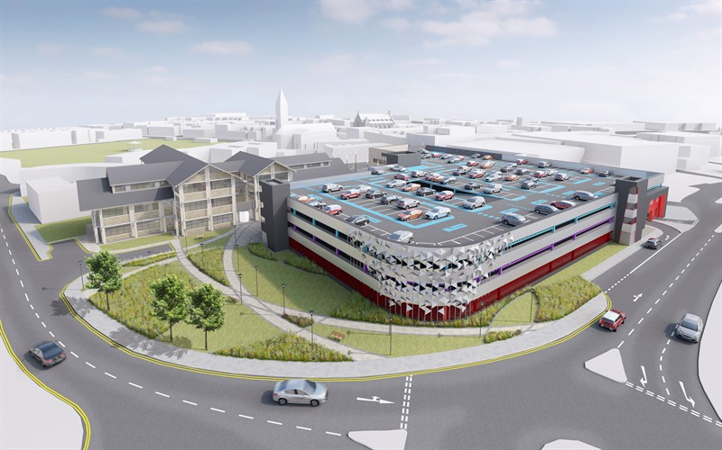

Parking Services

Annual Report

2023 - 2024

I n d e x

Page No.

1. Introduction 3-4

2. Aim and Objectives 5

3. History and Current Operations 5

4. Car Parks 6

5. Safer Parking 7

6. Innovation & Technology 7

7. Statistics 8-9

8. Appeals and Challenges 9

9. Traffic Enforcement Centre 10

10. Income and Expenditure 10

11. Training 10

12. Acknowledgements 11

1 Introduction

Neath Port Talbot is a county borough and one of the [unitary authority areas](http://en.wikipedia.org/wiki/Local_government_in_Wales) of [Wales](http://en.wikipedia.org/wiki/Wales). Neath Port Talbot is the 8th most [populous county](http://en.wikipedia.org/wiki/List_of_Welsh_principal_areas_by_population) in Wales and the third most populous county borough.

The county borough borders the other [principal areas](http://en.wikipedia.org/wiki/Principal_areas_of_Wales) of [Bridgend](http://en.wikipedia.org/wiki/Bridgend_(county_borough)) and [Rhondda Cynon Taff](http://en.wikipedia.org/wiki/Rhondda_Cynon_Taff) to the east, [Powys](http://en.wikipedia.org/wiki/Powys) and [Carmarthenshire](http://en.wikipedia.org/wiki/Carmarthenshire) to the north and [Swansea](http://en.wikipedia.org/wiki/Swansea) to the west. Its principal towns are [Neath](http://en.wikipedia.org/wiki/Neath), [Port Talbot](http://en.wikipedia.org/wiki/Port_Talbot) and [Pontardawe](http://en.wikipedia.org/wiki/Pontardawe).

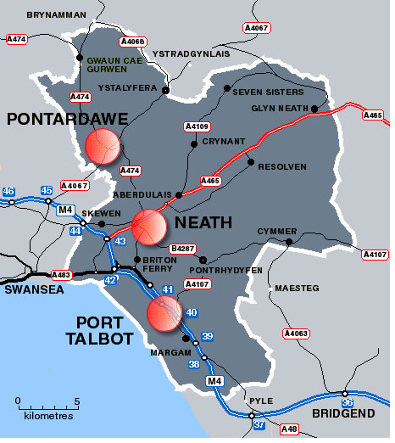

Neath Port Talbot County Borough Council were the first to introduce Decriminalised Parking Enforcement under the Road traffic Act 1991 in Wales. The enforcement of road traffic regulation orders by the authority came in to effect on 1st June 1999.

On 31st March 2008 the Road Traffic Act 1991 was replaced by the Traffic Management Act 2004, and all authorities currently enforcing traffic orders under the 1991 Act automatically became Civil Enforcement Areas under the new Traffic Management Act.

Enforcement of the on and off street traffic regulation orders comes under the Traffic management Act 2004.

(Section 78 of the Traffic Management Act 2004 and Regulation’s 9 and 10 of the Civil Enforcement of Road Traffic Contraventions (General Provisions) (Wales) Regulations 2013).

Civil Enforcement of Parking Contraventions (Representations and Appeals) (Wales) Regulations 2008.

Civil Enforcement of Parking Contraventions (Penalty Charge Notices, Enforcement and Adjudication) (Wales) Regulations 2008.

There is a requirement set out in the Statutory Guidance provided pursuant to the Traffic Management Act 2004 is for Local Authorities to produce and publish an annual report on parking enforcement activities.

Neath Port Talbot is committed to providing a fair, consistent and transparent Parking Service. Publishing clear statistical and financial information will help achieve this. This report includes information about the level of parking enforcement activity for the period 2023/2024, as well as the income and expenditure recorded in our ‘parking account’.

2 Aim and Objectives

The overall aim of the Authority is to provide a Parking Service that supports residents, visitors and businesses within Neath Port Talbot. We set out to achieve this through the following objectives:

* Improve road safety and access to services for all road users including pedestrians
* Support the local economy by ensuring a turnover of vehicles in short stay parking bays

3 History and Current Operation

In 1999 the authority tendered two contracts one for the enforcement of on and off street parking and the other for the notice processing. The two contracts were won by Sureway Parking Services, which changed its name during the contract period to Vinci Parking Services.

Following a Member review, when the contracts were due to expire the authority brought both contracts back in-house in April 2007, transferring the Vinci personnel over to the authority.

Parking Services were initially based in Port Talbot town centre up until August 2013. This allowed for a shop facility for the public to purchase permits and pay parking fines. New software was purchased in 2013 which allowed residents to purchase or renew parking permits online. This meant there was no longer the need for a parking shop. Members of the public are still able to contact parking services with any queries via e-mail, telephone or in writing.

Parking Services operate from The Quays, in Baglan Energy Park and employs 18 members of staff. Enforcement is operational seven days a week. Seven beats cover the Borough, three in Neath, one in Port Talbot, one in Skewen, one in Pontardawe and one mobile patrol covering the rural areas. In addition to this two Mobile CCTV vehicle are deployed to assist in the enforcement of more rural areas and to keep up with demand for a presence outside schools.

Those people who have been issued with a Penalty Charge Notice are able to pay either over the telephone payment line, online, by post or in person at either of our Civic Centres. All appeals have to be in writing to Parking Services.

4 Car Parks

Neath Port Talbot Council operate most of the car parks in the Borough. Cashless payment is available in all car parks by means of card readers installed into the Pay and Display Machines, as well as pay by phone.

The car parks operated by Neath Port Talbot Council have 2,967 spaces as detailed below.

| **Car Park** | **Location** | **Capacity** |
| --- | --- | --- |
| [High Street Car Park](http://www.npt.gov.uk/default.aspx?page=2753&cid=14#details) | Neath | 37 |
| [Milland Road Car Park](http://www.npt.gov.uk/default.aspx?page=2753&cid=11#details) | Neath | 450 |
| [Neath Multi-Storey Car Park](http://www.npt.gov.uk/default.aspx?page=2753&cid=12#details) | Neath | 600 |
| [Rosser Street Car Park](http://www.npt.gov.uk/default.aspx?page=2753&cid=13#details) | Neath | 33 |
| [Herbert Street Lower Car Park](http://www.npt.gov.uk/default.aspx?page=2753&cid=21#details) | Pontardawe | 19 |
| [Herbert Street Upper Car Park](http://www.npt.gov.uk/default.aspx?page=2753&cid=20#details) | Pontardawe | 37 |
| [Pontardawe By-Pass Car Park](http://www.npt.gov.uk/default.aspx?page=2753&cid=22#details) | Pontardawe | 44 |
| [Bay View](http://www.npt.gov.uk/default.aspx?page=2753&cid=16#details) | Port Talbot | 68 |
| [Bethany Square Car Park](http://www.npt.gov.uk/default.aspx?page=2753&cid=8#details) | Port Talbot | 166 |
| [Harbourside - Parkway](http://www.npt.gov.uk/default.aspx?page=2753&cid=19#details) | Port Talbot | 167 |
| [Ocean Way](http://www.npt.gov.uk/default.aspx?page=2753&cid=15#details) | Port Talbot | 282 |
| [Port Talbot Civic](http://www.npt.gov.uk/default.aspx?page=2753&cid=17#details) | Port Talbot | 80 |
| Victoria Road | Port Talbot | 20 |
| [Port Talbot Multi-Storey Car Park](http://www.npt.gov.uk/default.aspx?page=2753&cid=10#details) | Port Talbot | 705 |
| [Scarlet Avenue Car Park](http://www.npt.gov.uk/default.aspx?page=2753&cid=23#details) | Port Talbot | 111 |
| [St Mary's Car Park](http://www.npt.gov.uk/default.aspx?page=2753&cid=9#details) | Port Talbot | 41 |
| [Station Road Car Park](http://www.npt.gov.uk/default.aspx?page=2753&cid=7#details) | Port Talbot | 107 |

5 Safer Parking

The Safer Parking Scheme is an initiative of the Association of Chief Police Officers aimed at reducing crime in parking facilities.

Thirteen of the car parks managed by Parking Services have achieved Safer Parking status. Park Mark® is awarded to car parks that have met the requirements of a risk assessment conducted by the police.

For customers using a Park Mark® car park, it reduces the fear of crime by showing that measures are in place to create a safer environment. More information and a list of accredited car parks can be found on the safer parking website - <http://www.saferparking.com>.

6 Innovation and Technology



Pay by Phone was introduced in our seafront car parks during 2021/22 in order to make it easier for customers to park without having to queue during peak periods. This was rolled out during 2022/23 to our town centre car parks and has proven very popular with customers with 75% of transactions now being cashless.

This payment method combined with the ability to pay by cash or card at our pay and display machines now gives customers three payment options when using our car parks.

7 Statistics

In the financial year 2023/24, 11,544 Penalty Charge Notices were issued, 8,424 on street and 3,120 off street.

The table below shows the split of Penalty Charge Notices issued between 01st April 2023 and 31st March 2024.

|  |  |
| --- | --- |
| Number of Higher Level PCN's Issued | 6,649 |
| Number of Lower Level PCN's Issued | 4,895 |
| Total Number of PCN's Issued | 11,544 |
| Number of PCN's Paid at Discount | 7,058 |
| Number of PCN's Paid at Non - Discount | 1,201 |
| Total Number of PCN's Paid | 8,259 |
| Number of PCN's Appealed Against | 3,374 |
| Percentage of PCN's Appealed Against | 29% |
| Number of PCN's Cancelled as a Result of an Appeal | 1,720 |
| Percentage of Successful Appeals | 51% |
| Numbers of PCN's cancelled for other reasons | 57 |
| Number of Vehicles Immobilised | N/A |
| Number of Vehicles Removed | N/A |

A total of 1,777 or 15% of all Penalty Charge Notices issued were cancelled for a variety of reasons. Each case is considered on merit with all mitigating circumstances taken into account.

At the time of reporting the remaining 1,508 Penalty Charge Notices are at various stages of recovery. Therefore the figures are subject to variation.

The table below shows the split of Penalty Charge Notices and the total of deployed hours on a monthly basis between 1st April 2023 and 31st March 2024.

|  |  |  |
| --- | --- | --- |
| MONTH | PCN ISSUED | HOURS DEPLOYED |
| APRIL | **886** | **806** |
| MAY | **802** | **864** |
| JUNE | **862** | **988** |
| JULY | **1045** | **1027** |
| AUGUST | **834** | **838** |
| SEPTEMBER | **1102** | **1098** |
| OCTOBER | **1208** | **1131** |
| NOVEMBER | **1117** | **1098** |
| DECEMBER | **858** | **858** |
| JANUARY | **1004** | **1049** |
| FEBRUARY | **1045** | **1111** |
| MARCH | **781** | **720** |
| TOTALS | **11544** | **11588** |

8 Appeals and Challenges

All members of the public have the right to challenge a Penalty Charge Notice.

This can be done informally by writing to NPTCBC within 28 days of the issue of the Penalty Charge Notice or formally by making representation to NPTCBC after a Notice to Owner has been served on the person or company registered with the DVLA as the owner of the vehicle.

There is also recourse to appeal to The Traffic Penalty Tribunal which is an independent adjudication service if they are not happy about a decision that has been reached by Neath Port Talbot Council in regard to the Penalty Charge Notice.

26 appeals were made to Traffic Penalty Tribunal during 2023/24.

Further information on appeals to the Traffic Penalty Tribunal can be found at [www.trafficpenaltytribunal.gov.uk](http://www.trafficpenaltytribunal.gov.uk).

9 Traffic Enforcement Centre

When all attempts to recover outstanding charges have failed, Neath Port Talbot Council will apply to the Traffic Enforcement Centre (TEC) for a Warrant of Control. This enables the collection of the unpaid debt to the Authority. These warrants are then issued to Enforcement Companies to recover the outstanding debt at no cost to the Authority.

Further information about the Traffic Enforcement Centre can be found at:

<https://courttribunalfinder.service.gov.uk/courts/traffic-enforcement-centre-tec>

The Authority regrets that this action became necessary to collect outstanding charges; however, it is only taken when all other attempts to collect outstanding Penalty Charge Notices have failed. During 2023/24, 1,056 Warrants of Control were issued.

10 Income and Expenditure

|  |  |
| --- | --- |
| Car Park Income | £1,075,871 |
| Car Park Expenditure | £1,090,726 |
| Car Park Balance | £14,854 |
| Enforcement Income | £542,162 |
| Enforcement Expenditure | £929,108 |
| Enforcement Balance | £386,946 |
| Total Balance | £401,801 |

11 Training

Regular briefings are held with all Civil Enforcement Officers and Parking Assistants to ensure that the enforcement and administration of Parking Services throughout the Borough is fair, transparent and consistent.

During 2023/24, some staff undertook training in Counter Terrorism (1), Violence against Women (3), Welsh Language Awareness (3), GDPR (3), Prevent (4) and Safeguarding (3).

12 Acknowledgements

Leona Moyle (Parking Services)

Melanie Davies (Accounts)

Please contact Ian Rees, Parking Manager by e-mail at [i.rees@npt.gov.uk](mailto:s.cook@npt.gov.uk) if you have any questions in relation to this report.