Winter service operational plan



**RECORD OF CHANGES**

| **DATE** | **PAGE NO.** | **REASON FOR AMENDMENT** | **CHANGED BY** |
| --- | --- | --- | --- |
| 03-12-2017  29-01-2020  17-07-2020  26-09-2024 | 5  All  All  All | Request/Guidance  Review / Gritting Route update  Service review  Service Review | James Michael  Davies  Warren Hudson/ Rhianwen Bailey  Warren Hudson/ Rhianwen Bailey  Daniel Rees |
|  |  |  |  |

Contents

1. Introduction 3

2. Statement of Policy and Standards of service 3

3. Extent and priorities of treated networks 5

7. Resilience and contingency planning 7

8. Weather forecasting and winter service decision making information 7

9. Organisational arrangements and personnel 9

10. Facilities, plant, vehicles and equipment 10

11. Salt and if appropriate, other de-icing materials 10

12. Operational communications 11

13. Information and publicity 12

14. Quality management 13

15. APPENDIX 14

APPENDIX 1 – Plant/ Vehicle Deployment for precautionary salting 14

APPENDIX 2 – Human Resources Deployment for precautionary salting 15

APPENDIX 3 – Cross Boundary Spreading Arrangements 16

APPENDIX 4 – Precautionary Salting Routes – Highways 18

APPENDIX 5 – Minimum Network 34

APPENDIX 6 – Precautionary Treatment Decision Making Guidance 35

APPENDIX 7 – Treatment Matrix Guidance 36

APPENDIX 8 – Post Treatment Salting 37

APPENDIX 9 – Action Sheet 38

APPENDIX 10 – Location of Salt bins 39

# Introduction

The aim of this document is to demonstrate that Neath Port Talbot County Borough Council (NPTCBC), where reasonable meet their statutory duties in respect of the risks to road users posed by snow and ice.

Under SUB- SECTION 41 (1A) of the Highways Act 1980 the ‘highway authority are under duty to ensure, so far as is reasonably practicable, that safe passage along a highway is not endangered by snow or ice.’

The County Borough Council in its capacity as Highway Authority within Neath Port Talbot is responsible for winter service activities on all adopted highways in Neath, Port Talbot and the Upper Lliw Valley.

The South Wales Trunk Road Agency (SWTRA) acting as an Agent Highway Authority to Welsh Government and is responsible for treatment to the M4 motorway, A465 and sections of the A48 Trunk Roads in the County Borough. Neath Port Talbot CBC acts as a term contractor for SWTRA in this respect. SWTRAs Adverse Weather Plan sets out the Welsh Government’s policy and objectives in the context of local service delivery on trunk roads in accordance with Welsh Government’s Trunk Road Maintenance manual 2015 and Winter and Adverse Weather Service.

Section B.7 to Well-Managed Highway Infrastructure, a code of practice covers winter service issues and provides guidance to highway authorities on winter service operations. This code and periodic revisions to it are considered in collaboration with other Welsh Council’s via CSS Wales as part of maintaining this authority’s plan.

All aspects of this plan are reviewed periodically in consultation with key stakeholders, to consider any changing circumstances and requests for additional services. The aim is to continually strive to improve upon the effectiveness of the winter service provided.

# Statement of Policy and Standards of service

The Director of Environment and Regeneration has devolved the planning of the winter service activity to the Highways and Drainage Services Section within Streetcare Services. The service is delivered by a combination of a Highways and Drainage Officer, a standby supervisor and operators from varying sectors using a structured rota system. Section 6 provides full details.

The winter season, or 'risk period' is considered to run from mid-October to mid-April.

At evenings and weekends (out of hours), salting arrangements and any changes to planned action are co-ordinated by the Standby Officer.

Three main priorities are analysed to deliver the service in accordance with the details stipulated in this plan:

* Forecast weather data
* The onset of any hazardous conditions
* The routes effected by those hazardous conditions

Precautionary salting routes are compiled using prioritisation criteria detailed in Section 3 of this document. Prior to the winter season, the council liaises with all neighbouring unitary authorities (Carmarthenshire CC, Powys CC, Rhondda Cynon Taf CBC, CC Swansea and Bridgend CBC) to confirm cross-boundary salting arrangements and also with South Wales Police to confirm contact arrangements in case of emergencies. The cross border salting arrangements can be found in the appendices section.

NPTCBC has a fleet in operation during the winter season. Where appropriate, each item of plant is proved road worthy, then serviced and maintained under strict maintenance schedules. Specialist vehicles are calibrated to a professional standard by ECON.

Winter service on the motorway and trunk roads is carried out in accordance with the South Wales

Trunk Road Agency Adverse Weather Plan and in accordance with Welsh Government’s Statement of Service and Code of Practice. A copy of the Authority’s [Winter Service Policy](https://www.npt.gov.uk/1484) is found on the council’s website.

# Extent and priorities of treated networks

These routes have been compiled in accordance with the Winter Service Review reported to the Council’s Environment and Highways Cabinet Board in July 2014. There has since been minor amendments made to the routes to accommodate newly adopted highways.

All levels of the service networks and routes have been determined following a risk based approach, taking into account the following criteria:

• Motorways and trunk roads [as directed by SWTRA];

• 'A' and 'B' roads carrying industrial traffic, access to hospitals, fire stations and emergency centres;

• Other 'C' and Class III roads connecting villages to the above points.

• Access to key sources of fuel and food;

• Bus routes (including school bus routes). Industrial estate roads;

• Through routes in built up areas;

• "Short cut" routes;

• Lanes serving isolated farms;

• Any other routes deemed necessary at the time.

Five levels of salting network is defined:

1. Precautionary Salting Network

This network is routinely treated throughout the winter season in accordance with our winter service policy. Precautionary Salting network is to be treated throughout the core winter season, when road surface temperatures are expected to fall below 1 °C. Precautionary salting is carried out, such that the identified routes are treated prior to the forecast time for the onset of frost or icy conditions. Furthermore, if icy conditions persist, the routes then continue to be treated as instructed by the Treatment Matrix in appendix 5 and 6. All precautionary treatment routes take approximately 4 hours to complete. Precautionary Salting Routes can be identified in appendix 4 at the end of the document.

No pre-treatment salting is carried out on footways or cycle routes. However, where possible, when icy conditions persist post-treatment salting is carried out on high usage footways, including town centre pedestrian areas and strategic footways near schools, hospitals etc.

1. Secondary Salting Network

This network is activated where hazardous conditions persist, which extends the Precautionary salting network. Salting during periods of prolonged hazardous weather eg. Significant accumulations of snow on the highway. Once the precautionary network is free of hazards, the secondary salting network can be treated. In appendix 7 is a schedule of locations, listed geographically, that have been identified as being appropriate for consideration for post-treatment salting of carriageways and / or footways where appropriate.

1. Snow Response Network

In an event where snowfall is forecast, our priority is to restore the highway on a risk based approach, in response with locations of forecast snowfall and snow hazard.

1. Minimum Winter Network

When severe weather is prolonged over the winter period, this can result in lower levels of resources. This network will allow operations to remain in force during an event of shortages of salt stocks, reduced number of vehicles, staff etc in a way to restore/ conserve resources.

1. Community Self Help

This operates on a localised level, where individuals have access to salt in local communities in order to treat areas of the highway during period of extreme wintry conditions.

Placement of salt bins are to be used during periods of severe weather. Local residents are able to treat parts the local highway in order to allow mobility within local communities. Salt bins are filled before the beginning of the winter season, are monitored and can be replenished when necessary. An inventory is maintained by the Network Management Section of the locations of all the salt bins in the County Borough.

Any post-treatment salting is carried out on a rolling basis using salting vehicles as well as hand salting, again as far as is practical and resources permit.

Level Crossing

It is understood, salting over level crossings can cause signal faults to the rail network. There is one level crossing that forms part of the precautionary salting network, situated in Gwaun-Cae-Gurwen. Treatment will be undertaken up to the stop line either side of the level crossing as per Network Rail guidance.

# Resilience and contingency planning

Winter resilience planning is crucial in preparation for seasonal severe weather conditions. Our top priority is to continue to treat the highway, even during periods of prolonged severe weather conditions.

A minimum network is initiated, should extreme weather conditions persist, resulting in possible shortages of salt stocks, reduced number of vehicles, staff etc. In an event whereby salt stocks become very low, a reduced network is routinely salted in a way to conserve salt available/resources.

Prioritisation of the network will salt principle primary routes in order to maintain accessible road network throughout the authority. It is critical that the minimum network remains accessible for use with the networks of neighbouring authorities. Only the principle route network will be treated.

When snow is forecast, our priority is to restore the highway on a risk based approach, in response with locations of forecast snowfall and snow hazard. During periods where snow and ice is expected, routine precautionary salting is initiated, vehicles will revert to principal road salting and ploughing at the onset of snow to restore the highway and will continue until the situation is under control. In a snow clearance situation more resource can be drawn from across Streetcare Services to assist operations.

Remaining resources will cover other roads including known ‘black spots’ and hand spreading of salt will be carried out, as set out in this plan, as resources permit and as directed by the Duty Officer dependent on demand and information to hand.

Contracted resources will be directed by a designated officer who will keep a log of hours worked etc. 'Road Closed' signs will be kept at the ready for immediate placement.

When snow and icy conditions is expected, service operations will continue on both Motorway and Trunk Roads as directed by SWTRA.

# Weather forecasting and winter service decision making information

In order to monitor weather conditions, the Authority combines data provided by Authorities weather stations and that provided by a metrological contractor.

The Authority has five weather stations, consisting of two fixed road outstations at Abernant and Banwen, allowing data to be received into Campbell’s ‘Konect Global’ Data Service.  In addition, the Council has installed Campbell Scientific remote sensor units, with supporting deep and surface temperature probes, based at Melin Court, Afan Valley and Kenfig Industrial Estate. All five weather stations are maintained prior to the winter season. These weather stations provide live weather information to the Authority’s forecaster.

A detailed daily forecast is received from the County Borough Council's Meteorological Contractor, Metdesk through the winter period. Metdesk’s details can be found below:

MetDesk

Hale Court,

Hale Road,

Wendover,

Buckinghamshire,

HP22 6NJ

weather@metdesk.com

This service is provided by MetDesk consisting of three daily updates; morning, midday and early evening, providing advance warning of adverse weather conditions in order to initiate any contingency plans. Based on the weather forecast, a designated officer from the Highway and Drainage Section makes a decision as to whether precautionary salting is necessary and, if so, what arrangements are to be put in place is then made by the designated officer. Treatment specifics are corresponded to standby supervisors and service crews accordingly.

The Highway and Drainage Section instructs precautionary salting on some, or all of the routes designated in this plan. Treatment rates are determined by the forecasted road surface temperatures, following a guidance matrix as shown in appendix 6. In the case of a prolonged overnight frost a second run or early morning run may be required. The routes listed in this plan cover 35% of the county road network.

This 24 hour service will monitor any changes in weather conditions, officers and standby officers will receive an additional update advising of any changes to adverse weather conditions. On the weekends and public holidays the duty standby officer makes the decision whether or not to carry out precautionary salting along with any consequent arrangements.

The action is then circulated to the distribution list below via e-mail.

|  |
| --- |
| **Organisation** |
| Ambulance Control |
| Bridgend CBC |
| Carmarthenshire CC |
| CC Swansea |
| CCTV NPTCBC |
| Concierge, The Quays |
| Customer Service Centre |
| Director of Environment |
| Head of Streetcare |
| Highways and Drainage Service Manager |
| Network and Programme Manager |
| Senior System Support Officer |
| Street Scene Manager |
| Waste and Neighbourhood Manager |
| Fleet Manager |
| Workshop Manager, Fleet |
| Business Support Officer, Engineering and Transport |
| Dwr Cymru |
| Exactrak |
| Fire Control |
| Metdesk (weather) |
| Powys County Council |
| Rhondda Cynon Taff CBC Standby |
| South Wales Police |
| Standby Supervisors |
| SWTRA |

# Organisational arrangements and personnel

As part of delivering winter service, it is important the staff of the Highways and Drainage Sections have a key understanding of the roles and responsibilities throughout, enabling the Authority to effectively deliver this service. The Standby Officer rota and the service standby rota are completed and maintained by the Highways and Drainage Section within Streetcare Services. The Standby Officer and the service operatives are on standby on a weekly basis. Copies of the rotas are issued to staff as appropriate.

In preparation for the winter season all aspects of health and safety methods and requirements are reviewed against current legislation and guidance. All officers will gain a City and Guilds Unit 621 Supervision and Monitoring Qualification.

All operatives attend risk assessment briefing meetings, where risk assessments are distributed to all operatives identifying the risk and appropriate control measures associated with all operations involved in winter service delivery. A copy of relevant health and safety information is also located in the salt barn at the SRC.

Due to risks associated with lone working, an additional operative is deployed on the higher treatment route that runs over the Bwlch Mountain Road. Drivers in general operate with an additional operative during snow ploughing.

Monitoring of working hours and driving hours during the winter season is managed in line with guidelines of driving hour regulations and are recorded. During periods where more than one run is needed, due to prolonged frost/ ice, monitoring of working hours and driving hours is considered during the decision making process.

All operational records, monitoring of working hours and maintenance are held by the Highways and Drainage service.

Prior to the onset of the winter season, arrangements are made with neighbouring unitary authorities to confirm cross boundary salting arrangements. All contact information is updated prior to the onset of the Winter Service in case of emergencies during the season. Cross boundary salting arrangements can be seen in the appendices 3.

During an event of prolonged hazardous weather such as snow and icy conditions, the Authority ensures consultation with others, including emergency services and relevant authorities. The SRC at The Quays will be staffed continually and a log of reports from supervisors, drivers, police and the public will be kept. 'Road Closed' signs will be kept at the SRC in preparation for use. All calls received will be diverted from the contact centre to the staff at the SRC coordinating service operations.

All officers are trained and have expertise to operate during a power shortage or IT failure. Officers have laptops that allows flexible working and continued monitoring of weather forecast and any changes during this time. Any emergency contact numbers are stored electronically and manually within the offices.

# Facilities, plant, vehicles and equipment

NPTCBC has six primary vehicle size fleet, one of each covers the four precautionary routes. One of the remaining two vehicles is used in reserve in the event of breakdown or failure, and the other dedicated for use to treat the A465 in collaboration with SWTRA’s operational plan.

Appendix 1 is a schedule of plant, vehicles and equipment expected to be available for deployment.

All garaging, servicing and maintenance arrangements are carried out by Fleet Services working out of Tregelles Court, Neath Abbey and fitters are available on a standby basis. The Fleet Manager is responsible for administering any vehicle contract hire arrangements deemed necessary.

Calibration of salt spreading equipment is carried out by ECON, the manufacturers of the vehicles involved in the service operation. Fuel stocks are kept and maintained at The Quays, Briton Ferry and Tregelles Court, Neath Abbey.

# Salt and other de-icing materials

The Welsh Local Government Association recommends that salt stocks are replenished prior to the winter season to levels of 1.5 times the average salt usage over the past 6 years. The Authority recognises the importance of these minimum required levels, which resulted in the construction of a new salt barn located at the Service Response Centre, The Quays. The Highways and Drainage Section manages a planned storage capacity of approx. 7500 tonne of rock salt to be used on County roads.

The rock salt is currently obtained from:

Irish Salt Sales Co.

Fort Road

Carrickfergus

Co. Antrim N. Ireland

BT38 9BT

**Rock salt for use on SWTRA routes is ordered directly by SWTRA and stored at Ynysforgan, Merthyr Tydfil and Pencoed Depots.**

Prior to the onset of the winter season, all stocks are replenished with the appropriate measures set in place. Stock levels are monitored and can be restocked when necessary. Stock levels are monitored throughout the winter season, if required in season restocking of salt stocks can be replenished. Treatment rates to the network is determined by the use of the Treatment Matrix guidance as shown in in Appendix 6. Calibration of salt spreading equipment ensures spreading rates are maintained and are consistent for operation.

Moisture testing is completed before the onset of the winter season, and continued on a monthly basis throughout the winter season. Samples are taken, tested and certified by an independent external contractor, to ensure moisture content levels meet the guidance requirements of between 1.5 - 4%. Testing is completed to BS 3247 standards.

Loading of salt material is only undertaken by those who have received the relevant in house health and safety briefings, and hold competent licenses.

# Operational communications

In preparation for the winter season, a questionnaire is distributed and completed by operatives to initially indicate desire to undertake winter season duties, and to confirm any contact details from previous seasons are still accurate.

During the winter season, a rota is produced and displayed in the SRC for all service operatives.

Details are recorded and updated within the Highways and Drainage section.

Treatment actions are derived from the matrix attached within the appendices. Each operative is contacted via telephone by officers or the standby supervisor, and informed of the action requirements, in a timely manner. Communication to operatives must be given verbally, directly to each operative. No electronic or indirect messages are considered suitable.

Daily action sheets are produced, stipulating full details including time of action, spread rates and number of treatment runs. Copies together with the most recent weather forecast are circulated via email to a key distribution list including local police and other public service departments.

A template copy of the daily action sheet can be found in appendix 8.

All operatives are encouraged to provide feedback to officers and supervisors on operational arrangements so that any potential appropriate alternative or additional action can be carried out.

# Information and publicity

It is key to communicate effectively with the public, key public services and other Highway Authorities. In response to the daily forecast, any decision made in relation to an action or no action is then circulated to a distribution list via e-mail.

The South Wales Police Authority act as a liaison body for the passing of information to broadcasters relating to hazardous road conditions in the County Borough maintenance area.

The main hazards reported are:-

* Ice
* Fog
* Severe frosting
* Snow
* Obstructions e.g. wind, flooding and rockslides.

All information is passed to South Wales Police Headquarters for the attention of the Operations Room Duty Inspector. To avoid duplication, information is only transmitted by the Head of Streetcare or nominated representative. All information must be clear and precise, as it is intended for broadcast word for word to avoid editorial problems.

The Winter Service Operational Plan is a document accessible to the public, which includes plans of the treated network and emergency planning in response to winter conditions. The winter gritting policy and operational plan is available on the councils website; [Winter Service](https://www.npt.gov.uk/1462) Policy.

Appropriate updates will be posted on the Neath Port Talbot Council Website and/ or social media platform during a snow event. Any weather warnings will also be voiced on the local radio station, Swansea Sound. This should enable the presentation of timely and accurate information and advice on the local network condition and use.

Any updates during severe weather conditions, advice and warnings will be displayed on the [severe weather](https://www.npt.gov.uk/6030) page on the council’s website. Information may be released via social media; [Facebook page](http://www.facebook.com/NeathPortTalbotCBC) and twitter accounts @NPTCouncil @CyngorCnPT.

# Quality management

Adequate documentation and record keeping is important in order to demonstrate that winter service policies are reasonable and appropriate and that the service is being delivered in accordance with those policies.

In the event of any litigation matters, the authority will be able to disclose all information available to them, their decision making process and service action pertinent to the time in question.

Hard copies of daily action sheets and weather forecasts are filed throughout the season. Electronic versions are also stored with the Highways Drainage Department and through a service specific portal on Met Desk website.

Exactrack in cab monitoring systems will also track vehicle locations against specific times to be documented.

Weekly and fortnightly cumulative salt stock recordings are taken and circulated to ensure stock levels are compliant with Welsh Government guidelines.

All record and documentation keeping will be handled by the Highways and Drainage department.

# APPENDIX

## APPENDIX 1 – Plant/ Vehicle Deployment for precautionary salting

|  |  |  |  |  |  |
| --- | --- | --- | --- | --- | --- |
| **DEPOT** | **ROUTE** | **WELSH GOVERNMENT SPREADERS** | **NPTCBC SPREADERS** | **SNOW BLOWERS** | **LOADER** |
| Ynysforgan | Route - YG01 | KU69 YOA |  | OBO 515X (W.O.) Schmit | CE52 OCG |
| Route - YG02 | KU69 YOH |  |
| Route - YG03 | KU69 YOJ |  |
| Reserve | CE52 NHO Scania |  |
| Service Response Centre | High Route1 |  | CN20 ZHA | Snowcutter attachment for JCB | Telehandler |
| Low Route 1 |  | CN20 ZHB |
| High Route 2 |  | CN20 ZHC |
| Low Route 2 |  | CN20 ZHD | NCY 678X (C.B.C.) Rolba |
| Reserve |  | CP15 LCZ |

## APPENDIX 2 – Human Resources Deployment for precautionary salting

|  |  |  |  |
| --- | --- | --- | --- |
| **HUMAN RESOURCES** | **WELSH GOVERNMENT** | **NPT COUNTY BOROUGH COUNCIL** | **TOTAL** |
| YNYSFORGAN | SRC |
| DRIVER | 4 | 4 | 8 |
| MATE |  | 1 | 1 |
| LOADER |  | 1 | 1 |
| HOPPER LOADER | 1 |  | 1 |

## APPENDIX 3 – Cross Boundary Spreading Arrangements

### 3.1 – Bridgend CBC

B4282 Bryn to Maesteg

NPTCBC to treat and turn at county boundary.

B4283 Water Street, Margam

NPTCBC to treat and turn at county boundary.

A48 Margam to Pyle

NPTCBC to treat and turn at county boundary.

A4107 Bwlch mountain road Abergwynfi to Nantymoel

Bridgend CBC to treat beyond county boundary to turn at picnic area.

### 3.2 – Powys CC

Rhos Common – Crynant to Glanrhyd road

NPTCBC to treat approximately a length of 100m out of the county boundary to the junction with the road entering Crynant forestry (forestry commission land).

A4109 Onllwyn to Coelbren

Powys CC to treat beyond county boundary to junction with A4109. Turn right and free run to junction with C0197. Turn right onto C0197 and commence salting to county boundary.

Pontneathvaughan

NPTCBC to treat B4242 Pontneathvaughan Road beyond county boundary and turn left to treat into Ystradfellte Road and turn at entrance to Glynneath Golf Club.

A4067 Ystalfera by-pass

NPTCBC to treat beyond county boundary to Gurnos roundabout.

B4599 to Gurnos Road and Ystalfera

NPTCBC to treat from junction of B4599 and Gurnos Road (Tesco R/A) to county boundary.

### 3.3 – Carmarthenshire CC

A4068 Cwmllynfell to GCG

NPTCBC treat Gwilym Road to county boundary at Cefn Bryn Brain before travelling to recommence saltting at county boundary by the Brynamman Rugby Club.

A474 GCG to Garnant

NPTCBC treat and turn at county boundary.

### 3.4 – Rhondda Cynnon Taf CBC

C239 Pontwalby to Cefn Rhigos

RCTCBC to treat beyond boundary to turn in lay-by in NPT.

### 3.5 – City and County of Swansea

A483 Fabian Way

NPTCBC to treat westbound carriageway beyond county boundary to Docks entrance, turn left and treat around bend and past Gower Chemicals then return and treat eastbound carriageway back to and beyond county boundary and into NPT.

## APPENDIX 4 – Precautionary Salting Routes – Highways

### 4.1 – High Route 1

(I.e. Cymmer, Croeserw, Glyncorrwg, Abercregan, Gwynfi, Pontrhydyfen, Tonmawr, A4107, Cwmavon, Bryn, Goytre, Cimla, Tonna, Resolven.)

**A**

Abercregan Road C320

Afan Road A4107

Afan Valley Road A4107

Afan Valley Road B4287

Alban Terrace

Avon Street C250

Avondale Terrace C250

**B**

Bridge Street C250

Bryngyrnos Street B4282

Brynheulog

Brynna Road

Brytwn Road A4107

**C**

Castle Drive

Cavell Street

Cefncoed Road

Chapel Terrace

Church Street

Cimla Road B4287

Commercial Road B4287

Commercial Street

Coronantion Avenue

Craig y Fan Terrace C320

Cwmclais Road

Cymmer Road C250

**D**

Dan y Coed

Danyffynon A4107

Depot Road B4286

Dulais Fach Road B4434

Dunraven Street

Dyffryn Road

**E**

Easton Avenue

**G**

Glannant Way

Glyncorrwg Link Road

Gnoll Park Road B4434

Graig Road A4107

Greenwood Drive (P.O)

Goytre Road

**H**

Henfaes Road B4434

Heol Camlas

Heol Cwm Mawr

Heol Jiwbili

Heol Mabon

Heol Tewgoed

Heol y Bwlch

Heol y Glyn C250

Heol y Parc

High Street A4107

High Street B4286

**J**

Jersey Road C260

Jersey Terrace

John's Terrace

**L**

Llantwit Road B4434

Lletty Dafyod B4434

Llettyharri A4107

Lloyds Terrace A4107

London Row (P.O)

**M**

Mackworth Drive

Maesteg Road A4063

Maesteg Road B4282

Maesteg Road C250

Maesteg Road Lane Link

Main Road B4287

**N**

Neath Road B4434

**P**

Park Street B4434

Park Street (P.O)

Pen - y- Cae Road A4107

Pen Twyn Road A4107

Pen y Bryn

Pen y Mynydd

Prosser’s Terrace C320

**Q**

Queen Street B4287

**R**

Railway Terrace C320

**S**

Salem Road B4286

School Road

South Avenue

St Anne’s Terrace B4434

Station Road A4107

Station Road C260

**T**

Tabernacle Terrace

Tanygroes Place

Tonclwyda B4434

Tonna Uchaf B4434

Tonmawr Road C179

Ty'r Owen Row B4286

**V**

Varteg Road

Varteg Row

Victoria Gardens B4434

**Y**

Y Bellan

Ynysgwas Hill

#### **NPTCBC - High route 1 gritted roads**

### 4.2 – Low Route 1

(I.e. Port Talbot, Taibach, Margam, Aberavon, Baglan, Briton Ferry, Neath, Cimla.)

**A**

Abbey Road A4107

Afan Way

Alford Street

Alfred Street

**B**

Baglan Way

Briton Ferry Road A474

Brunel Way

Brynawel

Brynhyfryd Road

Burnside

Bus Station (P.T and Neath)

**C**

Cae Rhys Ddu

Cimla Crescent

Cook Rees Avenue

Commercial Road A48

Croft Road B4434

Cryddan Road

Cwmavon Road B4286

**D**

Dan Y Graig Road

Dalton Road

Dan y Bryn Road

Dinas Baglan Road A48

Dyffryn Road

**E**

Eastland Road B4434

**F**

Fair lawns

Forge Road

**G**

Giant’s Grave Road

Glan Hafren

Green Street

Groves Road

**H**

Harbour Way A4241

Heilbronn Way A48

High Street B4286

Hill Side

**K**

Kingdom Own Road (P.O)

**L**

Llansawel Crescent

Lodge Drive

London Road

London Row

**M**

Maes Ty Canol

Margam Road A48

Margam to Pyle Road A48

Moorland (P.O)

**N**

Neath Road A474

Neath Flyover A474

New Street

**O**

Old Road (Baglan)

Old Road (Briton Ferry)

Orchard Street

**P**

Pantyrheol A474

Pentwyn Baglan Road A48

Pentyla Baglan Road A48

Peripheral Distrbutor Road A4241

Princess Margaret Way C290

Prior Street

Prince of Wales Drive

**Q**

Quays Car Park

Queen Street

**R**

Riverside Drive B4434

**S**

Sarnfan Baglan Road A48

School Road

Seaway Parade A4241

Shelone Terrace C

SRC Car Park

St Illtyds Drive

Sunny Mount

**T**

Talbot Road A48

Tanygroes Place

Tanygroes Street

The Parade

The Ropewalk

Tyn y Twr

Ty'r Owen Row B4286

**V**

Victoria Gardens B4434

Victoria Road C290

**W**

Water Street A4241

Water Street B4283

West End Access Road

Willow Grove

Willow Way

Wind Street

Windsor Road B4434

**Y**

Ynysmaerdy Road

Ynys Street

#### **NPTCBC - Low route 1 gritted roads**

### 4.3 – High Route 2

(I.e. Rhydyfro, GCG, Tairgwaith, Brynamman, Cwmllynfell, Rhiwfawr, Ystalyfera, Crynant, Seven Sisters, Banwen, Glynneath, Pontneddfechan, Cwmgwrach, B4242, Cilfrew.)

**A**

Aberdale Road

Alltygrug Farm Road

Alltygrug Road

Amman Road A4069

**B**

Blaengwrach Road B4242

Brecon Road B4603

Bridge Street C175

Bron yr Grug

Brook Terrace

Bryn Road C174

Brynhyfryd Terrace A4109

Brynamman Road A4069

**C**

Cannon Street A4069

Chain Walk B4242

Church Road A4109

Church Road C154

Coedffaldau C174

Commercial Street

Commercial Road A474

Commercial Street C154

Crynant Common Road C153

Cyfyng Road C154

**D**

Dulais Road A4109

**E**

Edward Street

Empire Avenue

**F**

Fothergrill Road (P.O)

**G**

Gelligron Road A474

Glyn Neath Road B4242

Golwg Y Bryn A4109

Graig Road (P.O) A474

Gurnos Road B4599

Gwilym Road (P.O) A4068

**H**

Heol Cae Gurwen A474

Heol Gaer A4109

Heol Heddwch

Heol Hen

Heol y Goedlan C175

Heol y Gors A474

Heol Wenallt

Heol Y Glyn

High Street (P.O)

High Street A4109

**I**

Inervalley Road A4109

**L**

Launderdale Road (P.O)

Llwyncelyn Road (P.O)

**M**

Main Road

Main Road A4109

Main Road A4230

Main Road C182

Merthyr Road

**N**

Neath Road A4109

Neath Road B4242

New Road B4603

New Road (Godre'r Graig)

**O**

Oakview C182

Onllwyn Road A4109

**P**

Parish Road

Park Avenue B4242

Park Street A4069

Penscynor

Pen yr Allt (P.O)

Penywern Road

Pontardawe Road A474

Pontneathvaughan Road B4242

**R**

Rhiw Road C175

Rhiwfawr Road C175

Roman Road

**S**

School Road

St Davids Road

**W**

Waun Penlan

Wembley Avenue A4109

Wern Road C154

**Y**

Ynysgerwen Avenue B4242

Ynysydarren Road B4599

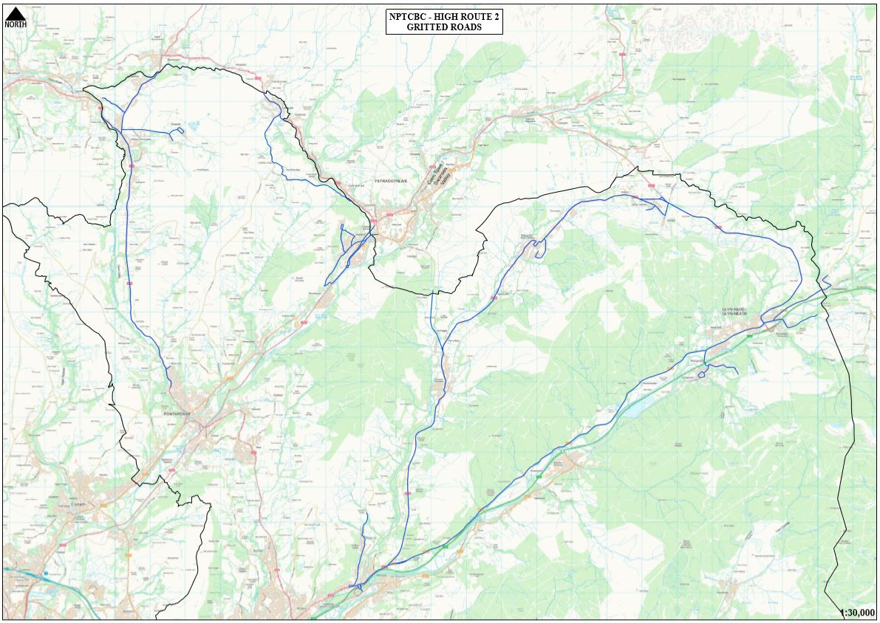

### 4.4 – Low Route 2

(I.e. Fabian Way, Llandarcy, Jersey Marine, Skewen, Neath Abbey, Bryncoch, Rhos, Alltwen, Trebanos, Pontardawe, Cilmaengwyn, God-re-graig, Ynysmeaudw.)

**A**

Alltywern

Alltwen Hill C155

Alloy Industrial Estate

Allt y cham Drive (P.O)

Arthur Terrace

Ashleigh Terrace B4290

**B**

Brecon Road B4603

Bryn Llewelyn

Brynawel

Burrows Road B4290

**C**

Cefnllan Road (P.O)

Cilmaengwyn

Cwmdu Road

Cadoxton Road A474

Christopher Road

Crymlyn Road C110

Cloda Avenue (P.O)

**D**

Darcy Business Park

Delffordd

Drumau Road

Dwr Y Felin Road

**F**

Fabian Way A483

Farmers Road C163

Ffordd Amazon

Ffordd Parc Ynysderw

Ffordd Cwmtawe

**G**

Gelligron Road A474

Gnoll Road

Glais Road C155

Graig Road A474

Grove Road

Gwyn's Place C155

Gwyn's Street C155

**H**

Herbert Street Bypass A474

Herbert Street C360

High Street B4603

Holy Street C360

Heol y Nant

Heol Escyn

Heol Penlan

**J**

James Street

**L**

Longford Road C163

**M**

Maesycoed Road

Main Road C163

**N**

Neath Road

New Road B4603

New Road A474

New Road A4230

New Road B4290

Neath Abbey Road

**O**

Old Road B4290

**P**

Park Avenue A4230

Penyheol B4290

Penywern Road

Pen Yr Alley Avenue

Pen Yr Alltwen

Pontardawe Road B4603

**R**

Rhyd Hir

**S**

Siding Terrace A4230

St. Johns Terrace

Stanley Road

Swansea Road (P.O) A474

**T**

Ty’n Yr Heol Road

**W**

Wern Road C11

Winifred Road

**Y**

Ynys-Meudwy Road B4603

Ynys y Mond Road C155

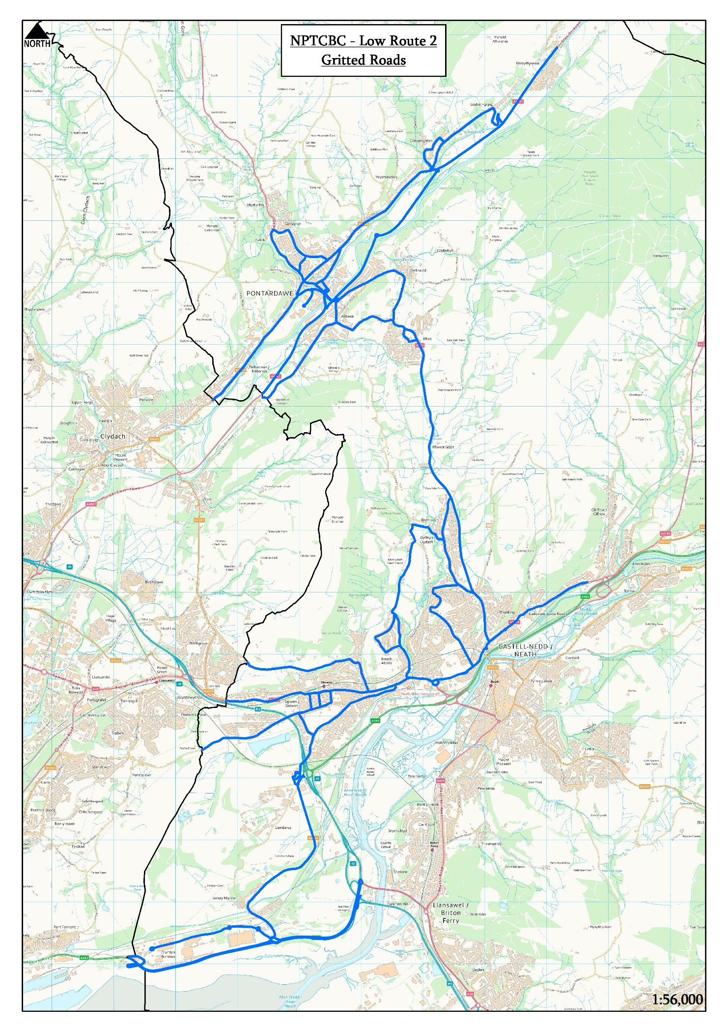

## APPENDIX 5 – Minimum Network

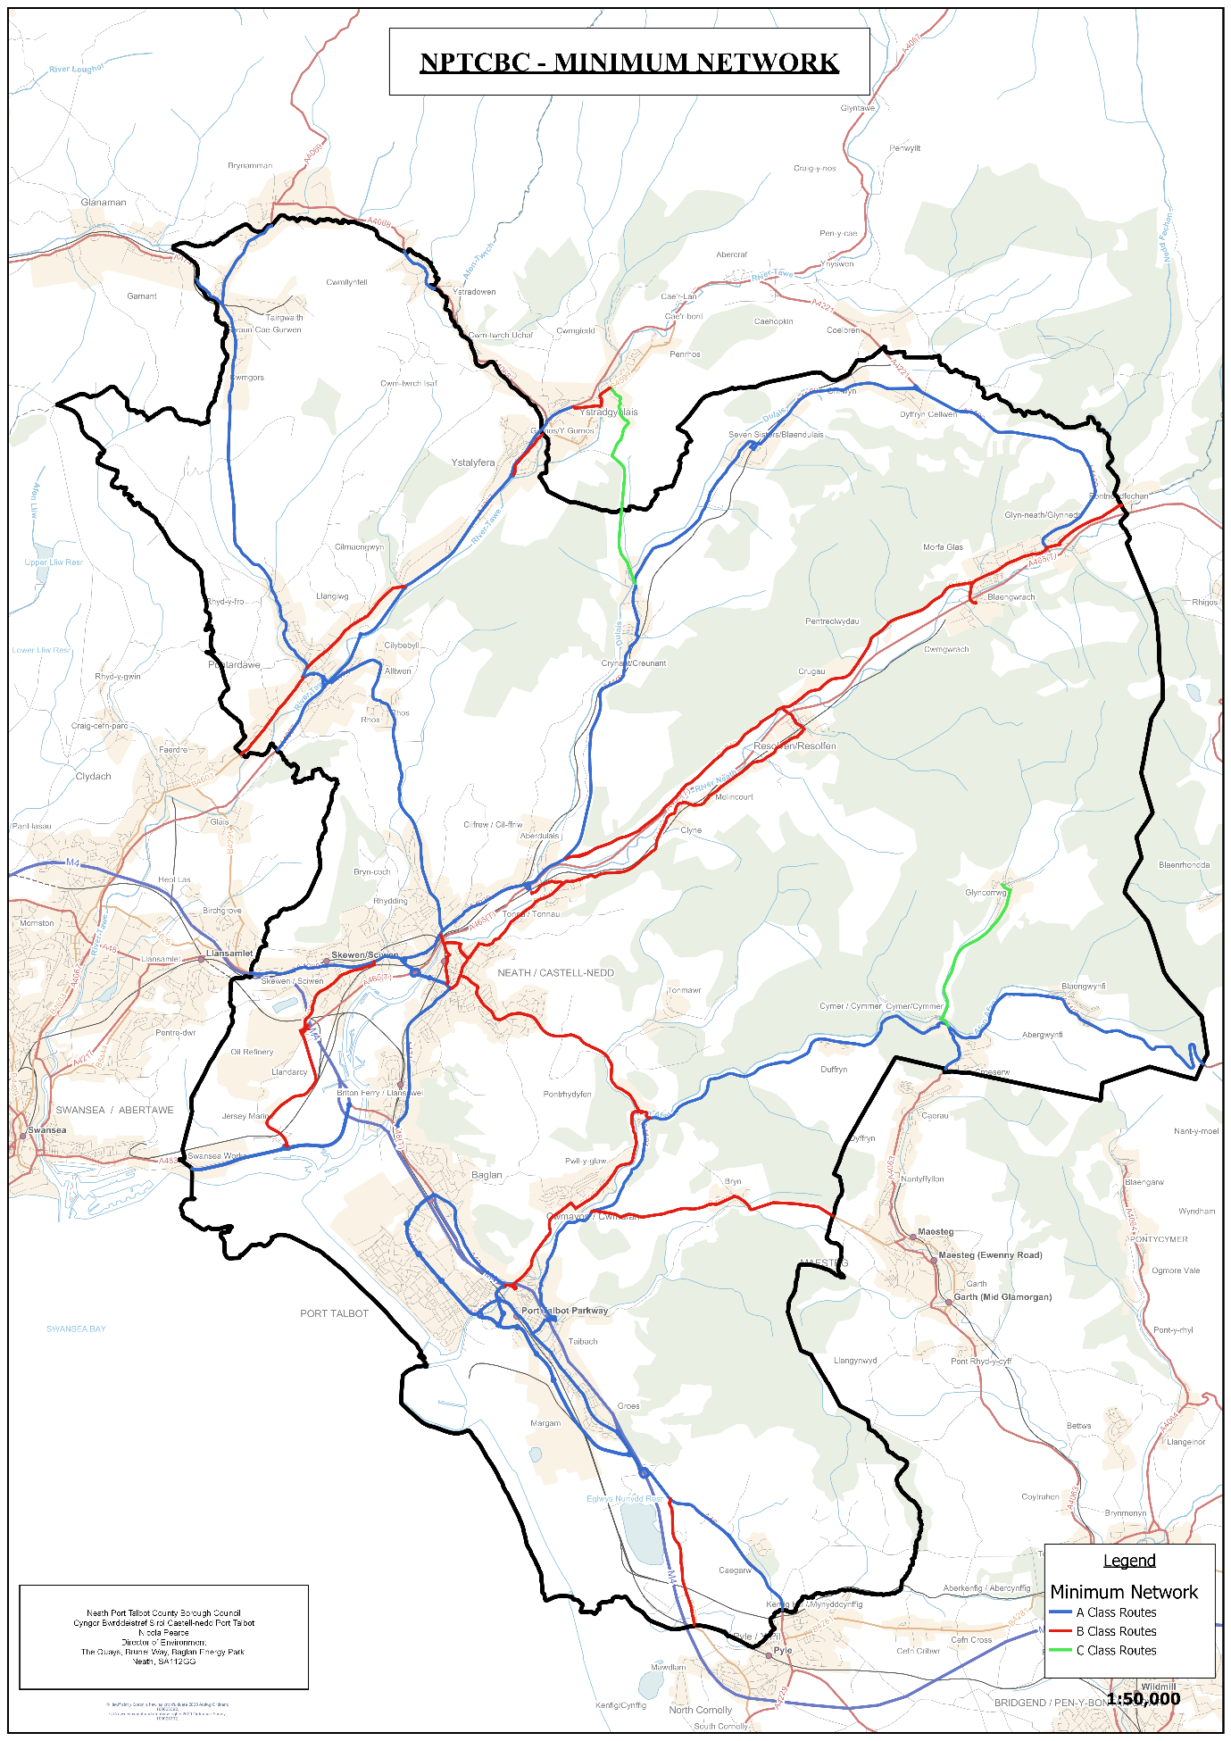

## APPENDIX 6 – Precautionary Treatment Decision Making Guidance

|  |  |  |  |  |
| --- | --- | --- | --- | --- |
| **NPT - Precautionary Treatment Decision Guide** | | | | |
| **Road Surface Temperature** | **Precipitation** | **Predicted Road Conditions** | | |
| **Wet** | **Wet Patches** | **Dry** |
| May fall below 1°C | No rain | Salt before frost | Salt before frost | No action likely, monitor weather |
| No hoar frost |
| No fog |
| Expected to fall below 1°C | No rain |
| No hoar frost |
| No fog |
| Expected hoar frost | Salt before frost | |
| Expected fog |
| Expected rain BEFORE freezing | Salt after rain stops | | |
| Expected rain DURING freezing | Salt before frost, as required during rain and after rain stops | | |
| Possible rain | Salt before frost | | Monitor weather conditions |
| Possible hoar frost |
| Possible fog |
| Expected snow | | Salt before snow fall | | |
| The decision to undertake precautionary treatments should be, if appropriate, adjusted to take account of residual salt. | | | | |
| All decisions should be evidence based, recorded and require continuous monitoring and review. | | | | |
| Decision on treatment timing should account for traffic and road surface wetness at time of treatment and after, as well as forecast conditions. | | | | |

## APPENDIX 7 – Treatment Matrix Guidance

Treatment matrix guide

## APPENDIX 8 – Post Treatment Salting

| **Ward** | **Road Name** |
| --- | --- |
| Aberavon | Newton Avenue, Nobel Avenue  Pendarvis Terrace |
| Abergwynfi/ Bleangwynfi | Western Terrace |
| Alltwen | Heol Phillip, Lon Tanyrallt, Derwen Road |
| Baglan | Elmwood Road |
| Brynamman | Barry Road, Glyn Road |
| Bryncoch | Cwmbach Road, Farmers Road, Furzeland Drive,  Llygad yr Haul. |
| Cadoxton | March Hywel Estate |
| Cilmaengwyn | Cilmaengwyn Road, Tanydarren |
| Cilybebyll | Wigfa Road, Plas Road, Church Road |
| Croeserw | Bryn Siriol Lane |
| Crynant | School Road |
| Cwmavon | Bwlch Road, Lane off Station Road |
| Cwmgwrach | School Street |
| Glyncorrwg | Heol Yr Afon, Road Cymmer to Glyncorrwg |
| Glynneath | Fire Station access road, Whitting Street, New Street, Lancaster Close |
| Margam | Bertha Road |
| Neath | Dwr Y Felin Road, St Davids Street, Woodland Road, Wellfield Avenue |
| Pontardawe | New Road, Waun Penlan, Ffordd Parc Ynysderw, High Street |
| Port Talbot | Corporation Road |
| Resolven | Waterfall Road, Tan Y Rhiw Road |
| Rhiwfawr | Rhiw Road, Gwrhyd Road, Coedfadlau Road |
| Rhos | Delfordd Road, Plas Road |
| Sandfields | South Down Road, Dew Road |
| Seven Sisters | Bryndulais Row, Bryn Bedd |
| Tonna | School Road, Fairyland Road |
| Ystalyfera | Ynysydarren Road, Rhiw Road to Gwrhyd, Heol Las to Gwrhyd Road, Church road, Gwrhyd Road. |

## APPENDIX 9 – Action Sheet

