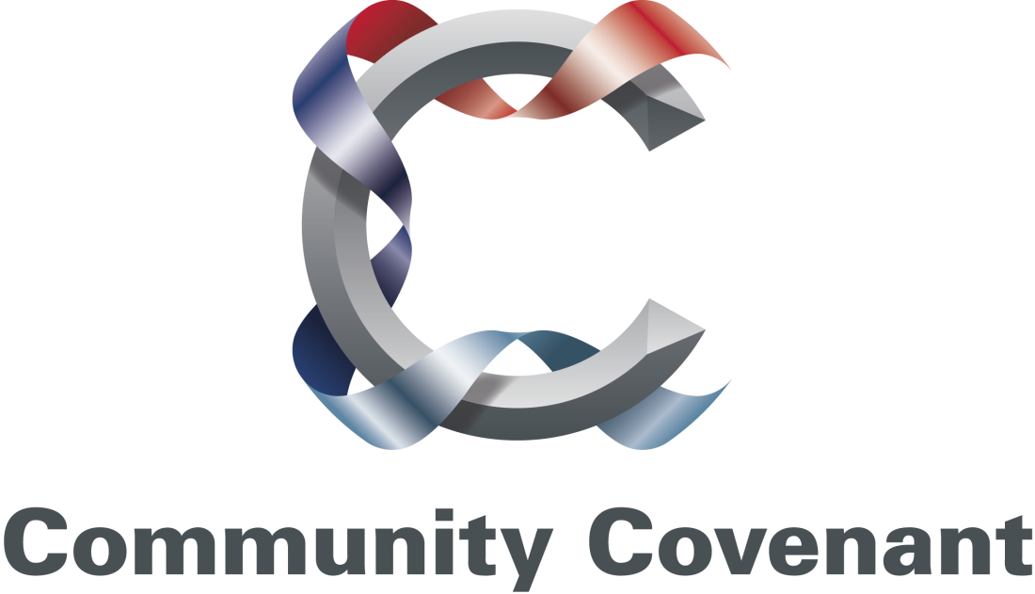

AN ARMED FORCES COMMUNITY COVENANT

BETWEEN

NEATH PORT TALBOT COUNTY BOROUGH COUNCIL

AND

THE CIVILIAN COMMUNITY OF NEATH PORT TALBOT

AND

MEMBERS OF THE NEATH PORT TALBOT LOCAL SERVICE BOARD (SIGNATORIES TBC)

AND

THE ARMED FORCES COMMUNITY IN THE COUNTY BOROUGH OF NEATH PORT TALBOT

We, the undersigned, agree to work and act together to honour the Armed Forces Community Covenant.

## Signatories

Date: Monday 24th June 2013

Signed on behalf of Neath Port Talbot

County Borough Council:

Name: Cllr A.H. Thomas

Position Held: Leader, NPTCBC & Armed Forces Champion

Signed:

Signed by:

Name: D Byron Lewis Esq, CStJ FCA

Position Held: Her Majesty’s Lord Lieutenant of West Glamorgan

Signed:

Signed on behalf of Armed Forces and the Army:

Name: Lt Col NR Blenkinsop RLC

Position Held: Armed Forces Lead and Commanding Officer, Welsh Transport Regiment RLC(V)

Signed:

Signed on behalf of the Royal Navy:

Name: Capt BJ Thorne RD DL RNR

Position Held: Royal Navy Regional Representative

Signed:

Signatories

Date: Monday 24th June 2013

Signed on behalf of Royal Air Force:

Name: Sqn Ldr (Rtd) A Fox RAF

Position Held: Royal Air Force Community Relations Officer for Wales

Signed:

Signed on behalf of Armed Forces Community:

Name: Noel Duston

Position Held: District Chairman for SWW Region Royal British Legion

Signed:

Signed on behalf of Armed Forces Community:

Name: David Singletary

Position Held: Chairman, SSAFA

Signed:

Signatories

Date: Monday 24th June 2013

Signed on behalf of NPT Council for

Voluntary Service (CVS):

Name: Gaynor Richards MBE

Position Held: Director, NPT Council for Voluntary Service

Signed:

Signed on behalf of DWP (Jobcentre Plus):

Name: Steve Lewis

Position Held: Employment & Partnership Manager for NPT

Signed:

Signed on behalf of Wales Probation Trust:

Name: Dawn Blower

Position Held: Assistant Chief Executive

Signed:

Signed on behalf of Mid and West Wales Fire & Rescue Service:

Name: Chris Margetts

Position Held: Group Manager

Signed:

Signed on behalf of Natural Resources Wales

Name: Mary Youell

Position Held: Operations Manager

Signed:

Signed on behalf of Abertawe Bro Morgannwg University Health Board

Name: Karl Murray

Position Held: Locality Director NPT

Signed:

## SECTION 1: PARTICIPANTS

1.1 This Armed Forces Community Covenant is made between the serving and former members of the Armed Forces (veterans) and their families working and residing in Neath Port Talbot County Borough (hereinafter referred to as Neath Port Talbot), the people of Neath Port Talbot and representative local bodies.

## SECTION 2: PRINCIPLES OF THE ARMED FORCES COMMUNITY COVENANT

2.1 The Community Covenant is a voluntary statement of mutual support between a civilian community and its local Armed Forces Community. It is intended to complement the Armed Forces Covenant, which outlines the moral obligation between the Nation, the Government and the Armed Forces, at the local level.

2.2 The purpose of this Community Covenant is to encourage support for the Armed Forces Community working and residing in Neath Port Talbot and to recognise and remember the sacrifices made by members of this Armed Forces Community, particularly those who have given the most. This includes in-Service and ex-Service personnel whether Regular or Reserve, their families and widow(er)s in Neath Port Talbot.

2.3 For the people of Neath Port Talbot and the organisations who are signatories, the Community Covenant presents an opportunity to bring their knowledge, experience and expertise to bear on the provision of help and advice to members of the Armed Forces Community. It also offers an opportunity to build upon existing good work.

2.4 For the Armed Forces Community, the Community Covenant encourages the integration of Service life into civilian life and encourages members of the Armed Forces community to help their local community.

## SECTION 3: OBJECTIVES AND GENERAL INTENTIONS

3.1 The Community Covenant complements the principles of the Armed Forces Covenant which defines the enduring, general principles that should govern the relationship between the Nation, the Government and the Armed Forces Community. It is therefore a statement of our shared aspirations and will not have a legal effect in compelling the creation of legal obligations between partners.

3.2 It aims to encourage all parties within a community to offer support to the local Armed Forces Community and make it easier for Service personnel, families and veterans to access the help and support available from the MOD, from statutory providers and from the Charitable and Voluntary Sector.

3.3. The scheme is intended to be a two-way arrangement and the Armed Forces Community are encouraged to do as much as they can to support their community and promote activity which integrates the Service community into civilian life.

## SECTION 4: Measures

We will work together to:

* Recognise and respect military service;
* Honour the commitment and sacrifice of the Armed Forces Community;
* Provide easy access to information about local services that can provide help and support for the Armed Forces Community;
* Identify and address areas where members of the Armed Forces Community may experience disadvantage.

In support of the above we will:

* Develop an on-line Directory of Support available locally to provide assistance to people from the Armed Forces Community to access the help and support they need. This Directory will also be used by our staff as a signposting resource.
* Deliver awareness training for key front line staff to promote the Community Covenant.
* Promote local Armed Forces activities to encourage community involvement in events that commemorate and recognise the contributions made by our Armed Forces.
* Improve the information we hold about the needs of our Armed Forces Community by recording the volume and type of requests for services that are made.
* Identify barriers faced by our Armed Forces Community and explore how these might be overcome.
* Explore opportunities to develop and submit appropriate projects to the Community Covenant Grant Scheme.
* Invite other local organisations to support the Community Covenant as part of our commitment to partnership and collaborative working across the county borough.

Governance

We will establish an Armed Forces Covenant Forum, led by the County Borough Council to meet a minimum of four times a year to:

* Consider any proposals that could benefit from the Community Grant Scheme.
* Monitor and revise the Community Covenant.
* Develop a shared understanding of the key issues facing the Armed Forces Community.

Contact Details

MOD Covenant Team Email address: [covenant-mailbox@mod.uk](mailto:covenant-mailbox@mod.uk)

Neath Port Talbot Armed Forces Community Covenant:

Telephone:

E-Mail:

Website:

*THE ARMED FORCES COVENANT*

*An Enduring Covenant Between*

*The People of the United Kingdom*

*Her Majesty’s Government*

* *and –*

*All those who serve or have served in the Armed Forces of*

*the Crown*

*And their Families*

*The first duty of Government is the defence of the realm. Our Armed*

*Forces fulfil that responsibility on behalf of the Government, sacrificing some civilian freedoms, facing danger and, sometimes, suffering serious injury or death as a result of their duty. Families also play a vital role in supporting the operational effectiveness of our Armed Forces. In return, the whole nation has a moral obligation to the members of the Naval Service, the Army and the Royal Air Force, together with their families. They deserve our respect and support, and fair treatment.*

*Those who serve in the Armed Forces, whether Regular or Reserve, those who have served in the past, and their families, should face no disadvantage compared to other citizens in the provision of public and commercial services. Special consideration is appropriate in some cases, especially for those who have given most such as the injured and the bereaved.*

*This obligation involves the whole of society: it includes voluntary and charitable bodies, private organisations, and the actions of individuals in supporting the Armed Forces. Recognising those who have performed military duty unites the country and demonstrates the value of their contribution. This has no greater expression than in upholding this Covenant.*

## MINISTRY OF DEFENCE

## COMMUNITY COVENANT GRANT SCHEME

HOW IT WORKS AND CRITERIA FOR FUNDING

INTRODUCTION

1. This guidance provides information on the Community Covenant and how to access funds to support projects via the Community Covenant Grant. The process, criteria and associated documents will be kept under review and amended as necessary with the latest version being available on the Ministry of Defence (MOD) website [www.mod.uk/covenant](http://www.mod.uk/covenant).

THE COMMUNITY COVENANT

1. A Community Covenant is a voluntary statement of mutual support between a civilian community and its local Armed Forces Community, defined as Serving personnel, Veterans, and their families. The aims of the Community Covenant are listed in full in this document. The Community Covenant is signed by the local Armed Forces and Local/Unitary Authorities but may also additionally be signed by charities, volunteer groups and other parties in the local community keen to support the principles of the Community Covenant. It is intended to complement, at local level, the Armed Forces Covenant, which outlines the moral obligation between the Nation, the Government and the Armed Forces. The Community Covenant scheme aims to build on this local level of support, and not to replace it. Please see www.mod.uk/covenant, which provides guidance on how to establish a Community Covenant in your area.

THE COMMUNITY COVENANT GRANT SCHEME

1. The Community Covenant Grant Scheme delivers financial support to projects at the local level, which strengthen the ties or the mutual understanding between members of the Armed Forces Community and the wider community in which they live. An application for funding can be submitted by any part of the community; this might include volunteer groups, charities, public bodies such as schools, and so on. Bids will be considered in the first instance by the Community Covenant Partnership (1) at a local level. Bids that the Partnership are happy to endorse will be submitted to the MOD to be considered by the Community Covenant

Grant Panel. Existing structures and chains of communication should be used as the Scheme is intended to be as bureaucratically ‘light’ as possible.

HOW IT WORKS

1. Completed application forms are considered by a panel led by MOD officials which also includes outside members (e.g. a representative of local government and one of the Families Federations) whilst recognising that final decisions need to be made by officials responsible to the Accounting Officer in MOD. The panel meets quarterly in March, June, September and December. Deadlines for bidding panels will be published online at ww.mod.uk/covenant. The panel considers each bid against the criteria set out below. MOD reserves the right not to approve funding for a project and will provide an explanation for its decision should a project not be supported.
2. Once funds are agreed, funding for the project will be released from MOD to the relevant Local Authority who will manage the finances. Where sums are large, or the project is dependent on particular milestones being met, we may agree with you to phase release of funds to ensure that the project is on track to deliver.
3. The Community Covenant Partnership will be responsible for ensuring that:

the grant is used for the purpose stated in the business case; funds are managed prudently and deliver value for money; a full account of expenditure is retained for accounting purposes; and that they are satisfied the project manager has the required skills to manage the project. Ultimately, the MOD is responsible for accounting for money released via this scheme. It is therefore necessary to put a number of steps in place, including reporting requirements outlined in the Terms and Conditions, to ensure that we are able to fulfil this duty.

1. MOD will regularly review how the scheme is administered and we welcome feedback on this guidance and process.

THE AIMS OF THE COMMUNITY COVENANT

* Encourage local communities to support the Armed Forces Community in their areas;
* Nurture public understanding and awareness amongst the public of issues affecting the Armed Forces Community;
* Recognise and remember the sacrifices faced by the Armed Forces Community;
* Encourage activities which help to integrate the Armed Forces Community into local life;
* Encourage the Armed Forces Community to help and support the wider community, whether through participation in events and joint projects, or other forms of engagement.

COMMUNITY COVENANT GRANT - CRITERIA AND GUIDANCE

* Applications should meet at least one of the aims of the Community Covenant;
* Bids may only be submitted from areas which have already established a

Community Covenant in their area;

* There needs to be a clear demonstrable benefit to Armed Forces Community and their local community;
* Applications should be genuinely local projects, designed by local organisations (not national programmes) to meet local needs;
* Applications must demonstrate value for money;
* Applications should not ‘gap fill’ a service that is or should be provided by others (e.g. other Government Department, local authority, existing MOD provision);
* Projects submitted must not generate a profit, top-up an existing Grant-in-Aid or raise funds the for charitable sector;
* MOD can only provide one off funding so where there is an ongoing cost – such as maintenance or staff costs, we will look for the non-Service element of the partnership to commit accordingly;
* The application is more likely to be successful if the non-Service element of the partnership (e.g. Local Authority, or charity) also commit to incurring expenditure;
* Applications are invited for sums from £100 to £250,000 (although bids for amounts greater than this may also be considered in exceptional circumstances);

EXAMPLES OF PROJECTS COULD INCLUDE (BUT NOT RESTRICTED TO):

* Bringing together Armed Forces dependants with others in the local community activities through community activities in rural, isolated areas;
* One-off activities, such as an activity camp involving the Armed Forces and local young people, in which the Scheme would meet the travel and subsistence costs of the Service participants;
* An exhibition at a local library/town hall etc, explaining what a local Armed Forces unit has recently been doing (eg in Afghanistan);
* An “oral history” project, where the local branch of a regimental association, locally based Armed Forces personnel or a specific group of Armed Forces personnel recorded their experiences or discussed them with local schoolchildren;
* Enhancement of existing community facilities used by both local and Armed

Forces communities to enable new activities that will lead to greater integration;

THE TYPES OF PROJECT THAT WE WILL BE UNABLE TO FUND:

As a Government Department, there are some activities that it would not be appropriate for MOD to fund, this may include (but is not restricted to) the following:

* Topping up existing grants and aids where they come from another Government

Department;

* Where money only benefits one person;
* Repeat or regular projects that require a source of uncommitted funding;
* Monuments or memorials;
* Research;
* Investments;
* Paying for on-going costs of existing partnership activity;
* Fundraising activities;
* Staff costs beyond a 12 month period;
* Endowments (to provide a source of income);
* Projects or activities that the state has a legal obligation to provide;
* The provision of medical treatment;
* Retrospective funding for projects that have already taken place;
* Wage subsidy;
* Contingency costs;
* As part of scrutiny for value for money we are unlikely to fund management or

Professional fees

ANNEX A

## FLOW DIAGRAM OF BID PROCESS

Project idea generated by any member of the

community and written up on MOD application form

Proposal considered by Community Covenant

Partnership

Endorsed proposal (signed by Local Authority and

Armed Forces member of partnership) sent to

MOD Covenant Team

Panel meets (quarterly) to consider bids and agree

on distribution of funds

Covenant Team notifies bidders of outcome and

sends out Terms and Conditions for signature

Signed Terms and Conditions returned to MOD

with invoice from Local Authority. Funds released

to Local Authority (for phased release if high value)

Project evaluated by Community Covenant

Partnership after xx months as per Terms and

Conditions

ANNEX B

## Terms and Conditions for accepting funding from the

## Community Covenant Grant scheme

Project Reference:

Project Lead:

Local Authority:

Amount of Grant Funding Awarded:

1. The nominated individual(s)/parties to the bid on the application form are responsible for managing the project.
2. It is the responsibility of the Community Covenant Partnership to ensure value for money.
3. It is the responsibility of the Community Covenant Partnership to ensure that the proposed activity appropriately delivers the stated benefit.
4. The parties to the bid agree to commit to spend any associated ongoing costs identified in the business case.
5. A full account of expenditure must be retained by the Community Covenant Partnership for audit purposes. This includes retaining receipts and invoices for six years.
6. If the project begins to experience financial difficulties which impact implementation MOD must be informed straight away.
7. The parties to the bid agree to report on the project to MOD no later than one month after completion (or phased completion depending on project). Confirming benefit achieved and how much money was spent. Further reports are welcomed where the benefits accrue over time.
8. The parties to the bid must inform MOD of any delay to timescales or milestones as set out in the project bid as soon slippage is identified.
9. If the bid seeks funding for a project to work with children, young people or vulnerable adults, it is the bidders responsibility to ensure acceptable safeguarding policies and procedures are in place.
10. Depending on the type of project there may be a requirement for public liability insurance or qualified leaders – it is the bidder’s responsibility to ensure that there is adequate insurance in place.
11. If funding is for a consumer durable, MOD accepts no liability for misuse or maintenance. It is not liable for consumables (such as staff costs) unless specifically stated in the business case.
12. MOD will retain relevant data to share best practice with other areas who wish to bid for funding.
13. The MOD is not responsible for ensuring appropriate planning permission nor its associated costs.
14. MOD are not liable for overrun of project costs.
15. Unspent funds must be returned in full.

16. Where the funding is for a building, the cost and depreciation do not reside on MOD’s balance sheet.

17. MOD retains the right to tell others about the project in order to promote the scheme.

18. Accepting these terms and conditions does not confer any further contractual obligation on MOD.