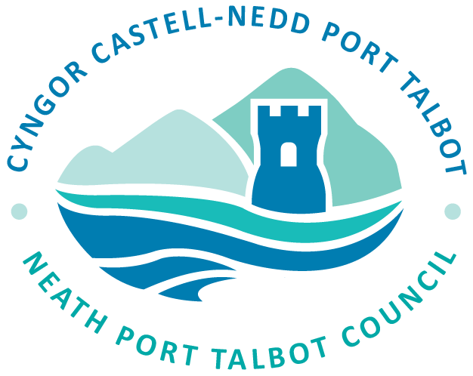

**Easy Read Version**

**of**

**Neath Port Talbot Council’s Social Services**

**Strategic Plan for Neurodivergence 2024-2027**

**What is the Strategic Plan about?**

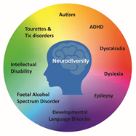

|  |  |
| --- | --- |
| pink brain | The Strategic Plan describes how Neath Port Talbot Council will help people who are neurodivergent.  Neurodiversity or **ND** is where the brain works in different ways to most other people. |
|  |  |
|  | The Strategic Plan tells us how the Council will make sure neurodiverse children, young people, adults and families have their needs understood and get the right support.  We will also help people within the County understand neurodiversity. |
|  |  |
|  |  |

**What does Neath Port Talbot Council want out of the Strategic Plan?**

We want to make sure that all neurodiverse individuals and families across Neath Port Talbot have their needs recognised, understood and the right support is provided to them when they need it.

The Strategic Plan is set out along four broad themes:

1. **Improve our understanding of neurodiversity**

We will listen to the voice of neurodiverse people to meet their needs, and follow the recommendations of the Autism Code of Practice.

1. **Improve access to services for neurodivergent people**

We want to deliver the right support and services to people. We will review the services and make changes whenever necessary to keep supporting the community.

1. **Development of a workforce training plan**

All staff in Social Services will have training on neurodiversity, especially Autism. This will be done to make sure that all staff understand the different needs of neurodiverse people.

1. **Support accessing community services and the community as a whole**

We will work with community groups to understand neurodiversity. We will work with projects to improve volunteering and work opportunities for neurodiverse people

**Our Aim**

The Council wants to help neurodiverse children, young people, adults and families get the right support when they need it.

Our goal is to ensure that neurodiverse people in Neath and Port Talbot have their needs understood, and are supported in the way that suits them most. We will work together with our partners across the community to make sure the needs of neurodiverse individuals are recognised, understood and supported.

We want Neath Port Talbot to be an inclusive County for all.

**Who will be affected by this Strategic Plan?**

Neurodivergent children, young people, adults and families living in Neath Port Talbot who would benefit from formal or informal social care and support.

This means that neurodivergent people and families currently receiving support and those who might need support in the future will be affected by this Strategic Plan.

**How will the Council collect views and opinions?**

|  |  |
| --- | --- |
| **""** | The Council will be collecting views and opinions on this Strategic Plan in different ways: |
|  |  |
| MC900433934[1] | Focus group meetings will be arranged during the consultation. It will be an opportunity to find out more about the Strategic Plan, ask questions and give your views. |
|  |  |
|  |  |
|  |  |
| Computer1 | On the Council’s website:  Have your say: [Consultations – Neath Port Talbot Council (npt.gov.uk)](https://www.npt.gov.uk/5907) |
| Pen | You can write to us at the address below, or email us at: [CCU@npt.gov.uk](mailto:CCU@npt.gov.uk) |

**Neath Port Talbot County Borough Council**

**Social Services Commissioning Unit**

**Neath Civic Centre**

**Neath SA11 3QZ**